FOR IMMEDIATE RELEASE

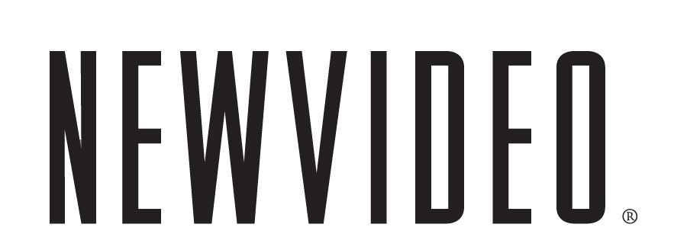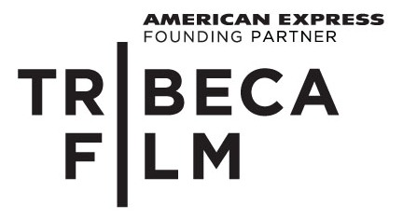

METROPIA’S GRIPPING SCI-FI VISION BRINGS YOU TO THE NOT-SO-DISTANT FUTURE

COMING TO YOU ON DVD NOVEMBER 16; THE FIRST ANIMATED FEATURE FROM TRIBECA FILM AND NEW VIDEO
***
Groundbreaking Animation Brought to Life by the Voices of
Vincent Gallo, Juliette Lewis and Alexander Skarsgård
***
“A haunting animated sci-fi thriller that’ll get inside your head.” -Time

NEW YORK, September 21, 2010 – You have never experienced anything like Metropia, the noir vision of Europe in 2024 by animator, writer and director Tarik Saleh. Vincent Gallo (Buffalo ’66), Juliette Lewis (Cape Fear), Stellan Skarsgård (Mamma Mia!), Alexander Skarsgård (True Blood), and Udo Kier (Shadow of the Vampire) voice the inhabitants of the future Continent, connected by an Orwellian web of underground railways and blind alleys.
The world is running out of oil. The underground train systems have been connected, creating a gigantic network beneath Europe. In a suburb of Stockholm, Roger (Gallo) avoids the underground because every time he enters it, he hears a stranger’s voice in his head. Is someone trying to control him? To help him escape this disturbing web, he looks to the mysterious Nina (Lewis) but the farther they travel, the deeper he becomes involved in a dark conspiracy.
See the visually-arresting film that captured the Future Film Digital Award at the prestigious Venice Film Festival in 2009 and has captivated audiences around the world with its singular look and feel.
“The animation is mesmerizing to watch…It’s a world populated by people with eyes so startling you won’t want to look away,” says the Los Angeles Times. “Metropia feels like a mash-up of scenes, ideas and metaphors from all over the sci-fi universe,” marvels Salon’s Andrew O’Hehir. “[It] seems channeled straight from the 21st century's collective subconscious.” Film School Rejects hails the film’s unique approach as “a stroke of genius” and The New York Times calls it “technically innovative.”
The single disc comes with a revealing interview with director Tarik Saleh and members of Metropia’s indelible cast.
Metropia is one of 10 Tribeca Film titles scheduled to be distributed by New Video in 2010 and 2011. Tribeca Film is a distribution platform acquiring and releasing films year-round and is supported by Founding Partner American Express. The films range from award-winning dramas and revealing documentaries to uproarious comedies and stunning animated features, many of which premiered at the 2010 Tribeca Film Festival prior to theatrical runs in New York and Los Angeles. The films from the Tribeca Film slate were also available on video on demand in 40 million U.S. homes simultaneously with their Festival screenings through relationships with leading telecom, cable and satellite providers.
New Video plans to release one to two titles per month leading up to the 2011 Tribeca Film Festival.
Special Features
- Trailers
- Interviews with Director and Cast

METROPIA

Street Date: Nov. 16, 2010
Pricing: $24.95 U.S. (DVD)
Runtime: 86 minutes, plus bonus features
Rating: N/A
Catalog #: NNVG231530
Language: English
Color: Color
Audio Format: Stereo
Genre: Sci-Fi, Thriller, Animation
Distributor: Tribeca Film/New Video

About Tribeca Film
Tribeca Film is a comprehensive distribution platform dedicated to acquiring and marketing independent films across multiple platforms, including video-on-demand, theatrical and home video. It is an initiative from Tribeca Enterprises designed to provide new platforms for how film can be experienced, while supporting filmmakers and introducing audiences to films they might not otherwise see. American Express continues its support of Tribeca and the independent film community by serving as the Founding Partner of Tribeca Film.
About New Video®
New Video is a leading independent privately-held distributor bringing you quality entertainment via DVD, Blu-ray, download and streaming platforms and cable VOD. We are the proud home to some of the most prestigious names in the industry like A&E®, HISTORY™, Lifetime®, Major League Baseball®, Scholastic Storybook Treasures™, Arthouse Films and Tribeca Film as well as our own lines Docurama Films®, and the newly launched Flatiron Film Company®. Since 1991, our mission has been to unearth first-rate content and deliver them to audiences through traditional platforms and evolving new media. We selectively handpick our library while collaborating directly with our brand partners and filmmakers to cultivate a superior product and fresh new viewing experiences for our audiences. We are headquartered in New York City, but have an international presence in 45 territories.

Press Contacts:
Sommer Hixson, New Video
646-259-4138/ shixson@newvideo.com

Dade Hayes, Rubenstein Communications
212-843-8022 /dhayes@rubenstein.com

Tammie Rosen, Tribeca Enterprises
212-941-2003/trosen@tribecaenterprises.com

