

For Immediate Release:

DOCURAMA FILMS DEBUTS
“SOUNDTRACK FOR A REVOLUTION”

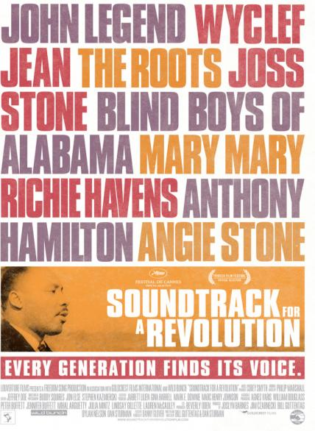

Academy Award® Short-Listed Documentary Available on DVD, VOD and Digital on September 28

They could take away everything else except our songs, which meant we kept our souls. – Bernard Lafayette, Freedom Rider. A fresh and exhilarating take on one of the most important social movements in American history, SOUNDTRACK FOR A REVOLUTION explores the civil rights struggle through the powerful and stirring songs that inspired a generation. Directed by Bill Guttentag and Dan Sturman (Nanking), produced by Louverture Films, and executive produced by Danny Glover, SOUNDTRACK FOR A REVOLUTION is a vibrant blend of heart-wrenching interviews, dramatic images and thrilling contemporary performances – an award-winning film of energy and significance.

SOUNDTRACK FOR A REVOLUTION conveys the power of music: the freedom songs protestors sang on picket lines, in mass meetings, in police wagons, and in jail cells, as they fought for justice and equality. The film features new performances of iconic songs, such as “We Shall Overcome” and “Wade in the Water,” by top contemporary artists including John Legend, Wyclef Jean and The Roots, alongside interviews with civil rights foot soldiers and leaders, including Congressman John Lewis, Harry Belafonte, Julian Bond, and Ambassador Andrew Young.

Bonus materials from Docurama Films feature full musical performances by John Legend (“Woke Up This Morning”), Wyclef Jean (“Here’s To The State of Mississippi”), Mary Mary (“We Shall Not Be Moved”), Blind Boys of Alabama & Anthony Hamilton (“This May Be The Last Time”), Richie Havens (“Will the Circle Be Unbroken”), The Roots (“Ain’t Gonna Let Nobody Turn Me ‘Round”), Joss Stone (“Eyes on the Prize”) and Angie Stone (“Wade in the Water”)– plus a bonus musical performance from The Carlton Reese Memorial Unity Choir and song leader Mamie Brown Mason (“I’m On My Way”). The DVD also features a behind-the-scenes photo gallery, scenes and interviews not included in the theatrical release, and all of the artists singing “We Shall Overcome.”

Freedom songs evolved from slave chants, from the labor movement, and especially from the black church. The music enabled African Americans and others to sing words they could not always say, and it was crucial in helping protesters as they faced down brutal aggression with dignity and violence. The infectious energy of the songs swept people up and empowered them to fight for their rights.

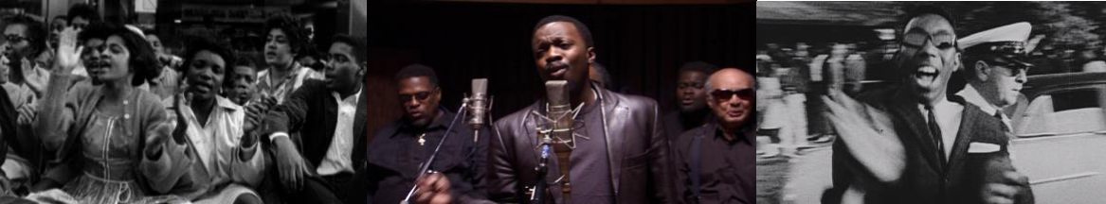

"It's the kind of film that will have audiences clapping and singing along." –The New York Times "…illuminating and sometimes devastating ... may very well be the finest, broad history on film of the Southern Freedom Movement" –Seattle Times

Bill Guttentag is a two-time Oscar®-winning documentary and feature film writer-producer-director. His films include the documentary features Nanking, which premiered at the 2007 Sundance Film Festival, and SOUNDTRACK FOR A REVOLUTION, which had its international premiere at the 2009 Cannes Film Festival. He wrote and directed the dramatic feature Live! starring Eva Mendes and Andre Braugher. In 2003 he won an Oscar® for the documentary Twin Towers. Other honors include three additional Academy Award® nominations, two Writers Guild Award nominations, three Emmys, and a Peabody Award. His first novel, Boulevard, was published by Pegasus Books/W.W. Norton in 2010. He created and executive produced the NBC series Law & Order: Crime & Punishment, which ran for three seasons (2002-2004). He also teaches at Stanford University.

Together with Bill Guttentag, Dan Sturman wrote and directed the Sundance, Emmy, and Peabody award- winning documentary film Nanking and produced the Academy Award®-winning documentary Twin Towers. His work has appeared on ABC, CBS, Comedy Central, VH1, Channel 4, Cinemax and NBC, where he produced three seasons of the primetime series Law & Order: Crime & Punishment. Prior to making documentaries, Sturman worked as a broadcast journalist, reporting and producing for ABC News, CBS News, and the BBC while based in Los Angeles; for Reuters and NBC News while based in London; and for ABC News 20/20 in New York.

SOUNDTRACK FOR A REVOLUTION will be distributed day-and-date with the DVD (September 28) on video-on-demand (VOD) and on digital platforms via New Video’s partners.

About Louverture Films
Louverture Films is dedicated to the development and production of films of historical relevance, social purpose, commercial value
and artistic integrity. Taking its name and inspiration from the great leader of the Haitian Revolution, Toussaint Louverture - famous for always creating an "opening" in the face of enormous obstacles - Louverture Films partners with progressive filmmakers and producers around the world and particularly from the global South, and pro-actively supports the employment and training of cast and crew from communities of color in the United States. http://www.louverturefilms.com/ss

About New Video
New Video is the world’s leading independent Blu-ray, DVD and digital distributor specializing in cutting-edge documentaries, independent films, cult hits, collectible television series, sports and classic kids programming. Home to some of the most prestigious names in entertainment, including A&E®, HISTORY™, Lifetime®, Major League Baseball®, Major League Soccer®, Scholastic Storybook Treasures™, Arthouse Films, Docurama Films®, NEWVIDEO NYC, and Flatiron Film Company, New Video
showcases over 5,000 titles in its catalog. As the digital distributor arm, New Video Digital provides over 11,000 hours of film
and television programming from more than 120 trusted brands to download and streaming platforms including iTunes, Hulu, Netflix, Xbox, Sony PlayStation and Amazon. Since 1990, the company’s mission has been to further the goal of providing
audiences with top-notch special interest content. www.newvideo.com

About Docurama Films
Docurama Films is dedicated to making critically acclaimed and cutting-edge documentaries available digitally and on home video. In 1999, New Video launched Docurama Films with the release of the first feature documentary on DVD, D.A. Pennebaker’s Bob Dylan: Don’t Look Back. Over a decade later and a line of over 250 award-winning and highly acclaimed documentary titles, Docurama continues its mission to unearth and release the great classic documentaries of the last fifty
years while spreading the word about filmmakers who are taking the form to new heights. The Docurama catalog features a
wide span of titles from varying genres including the arts, history/politics, environmental, ethnic interest, LGBT, music, and socio-cultural as well as theatrical fan-favorites like The Wild Parrots of Telegraph Hill and Andy Goldsworthy: Rivers and Tides.
Releases in 2010 include the screwball comedy The Yes Men Fix the World, the empowering music celebration Soundtrack for a
Revolution and the crowd-pleasing Yoo-Hoo Mrs. Goldberg. www.docuramafilms.com
For further information, please contact:

Sommer Hixson
New Video
646-259-4138
shixson@newvideo.com

Download High-Res DVD Box Art here:

http://www.newvideo.com/docurama/soundtrack-for-a-revolution/

