FOR IMMEDIATE RELEASE



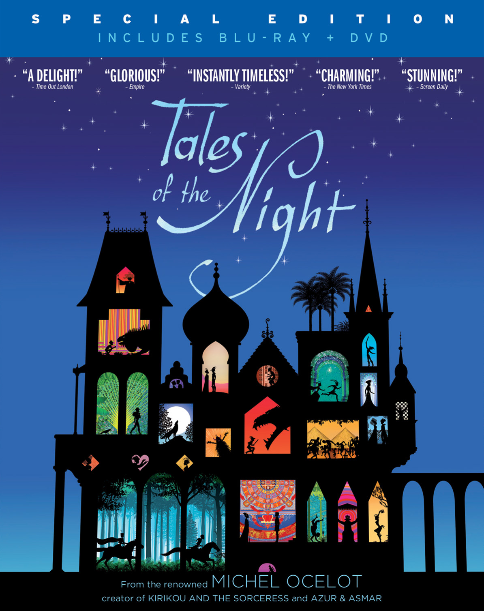

CINEDIGM TO RELEASE GKIDS’ CRITICALLY ACCLAIMED ANIMATED FILM
“TALES OF THE NIGHT” FROM DIRECTOR MICHEL OCELOT
JANUARY 29 ON DVD

Early VOD and Digital Release January 8

“Abundant pleasures…Silhouettes evoke shadow plays, and often brilliant palettes reflect the cultures presented.” – The New York Times Critics’ Pick

“The designs do all the work for you, casting spell after spell with their beauty.”
– Chicago Tribune

“Instantly timeless…a triumph.”
– Variety

NEW YORK, NY (December 11, 2012) – TALES OF THE NIGHT, a stunning new feature film by French filmmaker Michel Ocelot (“Kirikou and the Sorceress;” “Azur & Asmar”), will now be available to audiences of all ages at home. Through an agreement with the film’s theatrical distributor, GKIDS, Cinedigm Entertainment Group (CEG) will release the English-language version of TALES OF THE NIGHT on January 29 on DVD/Blu-ray, preceded by an early cable VOD and digital release on January 8.



TALES OF THE NIGHT extends the shadow puppet style of Ocelot’s earliest works, with black silhouetted characters set off against exquisitely detailed Day-Glo backgrounds bursting with color and kaleidoscopic patterns. The film weaves together six exotic fables each unfolding in a unique locale, from Tibet, to medieval Europe, to the Land of the Dead:

- The Werewolf - Two sisters are in love with the same dashing young man. The older girl wins the young man’s heart through deceit, leaving her younger sister in despair. But this perfect man has a terrible secret.
- Ti Jean and the Belle-Sans-Connaître - In the Antilles, a carefree boy breezes along whistling. He enters a cave and goes down, down, down, deeper than he could ever imagine. Will nothing strike fear into his heart or break his stride?
- The Chosen One And The City Of Gold - Amidst grand ceremony, a girl is given in sacrifice to a strange beast, and in exchange her people will receive much gold. The girl has a sweetheart who opposes the arrangement – but the creature is invincible!
- Boy Tam-Tam - A boy taps away all day long, on anything he can find, driving everyone crazy. He’d love to own a real drum, or better still, the magic tam-tam, which can make anyone dance.
- The Boy Who Never Lied - A horse that can speak is a rarity, but not so rare as a boy who never lies. The King of Tibet makes a bet that no one can make his stable boy tell a lie. His cousin accepts the bet – but he has a formidable secret weapon.
- The Doe-Girl And The Architect’s Son - A young man sees his beloved transformed into a doe before his own eyes by a jealous sorcerer. The elusive Caress Fairy is the only one able to help him, but she’s so very hard to find.

“Storytelling is my language. When I do it, I’m in my element,” says Ocelot, who has won several major awards for his animated films. “I’ve always made little things in relief, cut-outs, collages, and so on. Technological advancements enabled me to return to a certain enchantment in my early work.” TALES OF THE NIGHT was nominated for a Golden Berlin Bear at the 2011 Berlin International Film Festival before opening theatrically in 3D in the U.S. in September 2012.

The release of TALES OF THE NIGHT on home entertainment platforms marks the continuation of a longstanding partnership between GKIDS and New Video (now Cinedigm Entertainment Group), which has previously distributed GKID’s Oscar®-nominated films “The Secret of Kells,” “A Cat in Paris,” and “Chico & Rita.”

DVD and Blu-ray bonus features include: an interview with Michel Ocelot; a featurette with Ocelot titled “The Festival of Color: Storytelling through Animation;” the original French audio track with English subtitles; and a U.S. theatrical trailer. Written and directed by Michel Ocelot; Christophe Rossignon and Philip Boëffard, producers; Eve Machuel, associate producer; music by Christian Maire.

Pricing: $29.95 DVD; $34.95 BD/DVD
Runtime: 84 mins. + extras
Rating: N/A
DVD Catalog #: NNVG282831
BD Catalog #: NNVG282840
Language: English, bonus includes French version with English subtitles
Color: Color
Audio Format: Dolby Digital 5.1 Stereo
Genre: Animation, Kids & Family

About GKIDS
GKIDS is a distributor of award-winning filmed entertainment specializing in animation for both adult and family audiences. The company has scored three Best Animated Feature Oscar® nominations in the past three years, with “The Secret of Kells” in 2010 and both “A Cat in Paris” and “Chico & Rita” in 2012 – marking the first time an independent distributor has had two simultaneous nominations in the category. GKIDS also handles North American theatrical distribution for Oscar® winner Hayao Miyazaki's famed Studio Ghibli library of films, one of the world’s most coveted animation collections with titles “Spirited Away,” My Neighbor Totoro,” “Princess Mononoke” and others. GKIDS is longtime producer of the New York Int’l Children’s Film Festival, an Oscar®-qualifying event and North America’s largest festival of film for children and teens. NYICFF jury members include Uma Thurman, Susan Sarandon, Matthew Modine, Jeffrey Wright, Gus van Sant, Christine Vachon, John Canemaker, Evan Shapiro and James Schamus. www.gkids.com

About Cinedigm Entertainment Group
Cinedigm Entertainment Group (CEG), a division of Cinedigm Digital Cinema Corp. (NASDAQ: CIDM), is an end-to-end digital distribution company delivering content in theaters, across digital and on-demand platforms, and on DVD/Blu-ray. CEG reaches a global digital audience through partnerships with iTunes, Netflix, Amazon, Google, Hulu, Vudu, Xbox, Playstation, and others. The company’s library of over 5,000 titles includes award-winning documentaries from Docurama Films®, next-gen indies from Flatiron Film Company® and acclaimed independent films and festival picks through partnerships with the Sundance Institute and Tribeca Film. CEG is proud to distribute many Oscar®-nominated films including Hell and Back Again, GasLand, Waste Land, Paradise Lost 3: Purgatory, A Cat in Paris and Chico & Rita. Current and upcoming CEG multi-platform releases include The Invisible War, Citadel, In Our Nature, 22 Bullets and Don’t Stop Believin’: Everyman’s Journey. [CIDM-G] www.cinedigm.com.

# # #
For more information, contact:
Danielle Garnier, danielle@garnierpr.com, 773.276.0232
Sommer Hixson, shixson@newvideo.com, 646.259.4138

