FOR IMMEDIATE RELEASE


“TRUE ADOLESCENTS,” STARRING MARK DUPLASS,
AVAILABLE AUGUST 30 ON VOD, DIGITAL AND DVD

New Video’s Flatiron Film Company Presents Theatrical Release
at New York’s reRun Theater, Beginning July 29

“Smart and fun, with a killer performance by Mark Duplass.” – IndieWire
“Duplass shines like a sea-scrubbed Rainier Beer can.”—Austin Chronicle
“An acerbic but realistic coming-of-age story.”—Cinematical

June 28, 2011 – Meet Sam Bryant. He's a 34-year-old Seattle rocker with no job, no record deal, no girlfriend and no place to stay, until he finds room at his Aunt Sharon’s house in the suburbs. He's also the last guy anyone would pick to take two teens camping for some quality dude time.

Mark Duplass (Humpday, The League), Oscar®-winner Melissa Leo (The Fighter), Bret Loehr (Identity), and newcomer Carr Thompson star in Craig Johnson’s feature directorial debut, releasing on VOD, digital platforms and DVD on August 30.

TRUE ADOLESCENTS follows an unlikely trio of two adolescent boys and one immature grown-up into the rugged Pacific Northwest, where unforeseen revelations and transformations force them to face adulthood—filmed on location in Washington State’s scenic Cascade Mountains and the Olympic Peninsula. Set to an indie rock soundtrack featuring Band of Horses, The Black Keys and Devendra Banhart, among others, the film reminds us that sometimes you need to get lost to truly find yourself.

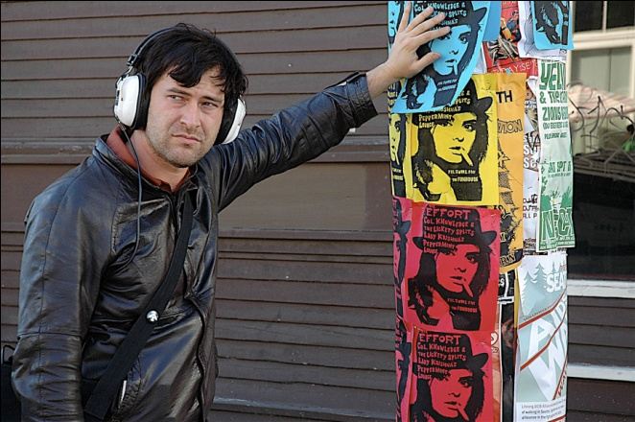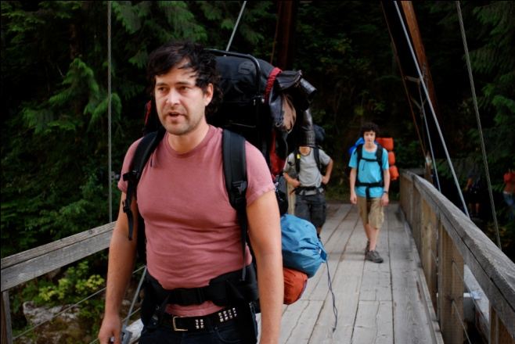

Ahead of the film’s platform release, Flatiron Film Company will present TRUE ADOLESCENTS in a limited theatrical run at Brooklyn’s reRun Theater in New York, beginning Friday, July 29, with a special Q&A with the filmmakers following the 7:00pm and 10:00pm premieres.
TRUE ADOLESCENTS premiered at the SXSW Film Festival in 2009 and was an official entry in several festivals including The Seattle International Film Festival, Nashville Film Festival, Raindance International Film Festival, and Sidewalk Film Festival.

Film credits:
Writer & Director: Craig Johnson
Producer: Thomas Woodrow
Co-Producers: Jennifer Lee, Stu Pollard
Executive Producer: Gill Holland, Emanuel Michael
Cinematographer: Kat Westergaard
Editor: Jennifer Lee
Original Music by: Peter Golub

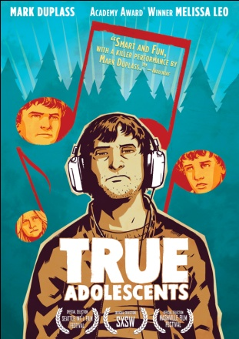

True Adolescents (DVD single):
$26.95 U.S.; $29.95 CAN
88 mins. + extras
Catalogue: NNVG248111
Extras include: Commentary with writer/director Craig Johnson, producer Thomas Woodrow, and co-producer/editor Jennifer Lee; Commentary with actor Mark Duplass; Deleted scenes with commentary; Behind-the-scenes feature.

About New Video
Celebrating its 20th anniversary in 2011, New Video is a leading entertainment distributor and the largest aggregator of independent digital content worldwide. Headquartered in New York City, with an international presence in 45 territories, the company delivers feature films, TV programs and web originals via digital download, streaming media, video-on-demand, Blu-ray and DVD, and theatrical release. New Video streamlines the distribution and marketing process for filmmakers, producers and brand partners to bring a wide variety of fresh content to new audiences. The company’s library includes original TV series and movies from A+E® Home Entertainment, HISTORY™, and Lifetime®, unforgettable games and trophy sets from Major League Baseball®, storybook treasures from Scholastic®, award-winning documentaries from Docurama Films®, Arthouse Films, and Plexifilm, next-gen indies and web hits from Flatiron Film Company®, the best in Chinese cinema from China Lion, and festival picks from Tribeca Film. New Video is proud to distribute the 2011 Oscar®-nominated films Gasland, Waste Land and, on digital, Restrepo.

About reRun
In March 2011, Entertainment Weekly called reRun one of 8 nationwide theaters "redefining the moviegoing experience." Featuring 60 stadium-style seats (mostly reclaimed from minivans), an all-digital 1080p HD projector coupled with a JBL 7.1 surround pro-audio sound system, a 12-foot screen, a full bar with two rotating beer taps and a gourmet snack counter, reRun offers the kind of intimate art-house theater experience you'd expect from the creators of the funky gastropub reBar (just down the hall at 147 Front Street, mezzanine level, Brooklyn). reRun is curated by film journalist Aaron Hillis (Village Voice, GreenCine Daily). Traditional and creative snacks created by reBar's Executive Chef Jeremy Leech and Executive Pastry Chef Megan A. Hilbert. Website: http://www.reruntheater.com

For box art and more product information, please visit:
http://www.newvideo.com/flatiron-film-company/true-adolescents/

For more information, please contact:
Sommer Hixson, shixson@newvideo.com, 646.259.4138

For more information on reRun, please contact:
Aaron Hillis, aaron@reruntheater.com

