FOR IMMEDIATE RELEASE


presents

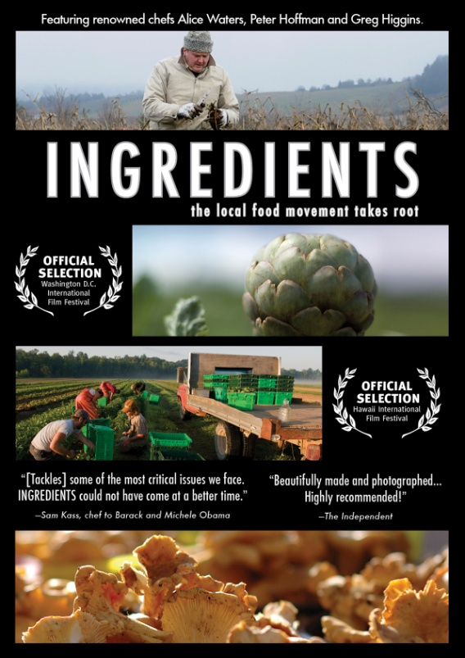

DISCOVER THE ROOTS OF HEALTHY FOOD: INGREDIENTS,
TO BE RELEASED DAY-DATE ON DVD, VOD AND DIGITAL ON MARCH 29

A Lively Report on the Country’s Expanding Local Food Movement
“Through beautiful imagery and thoughtful interviews, INGREDIENTS reminds us that the most delicious food is prepared with seasonal, ripe, fresh ingredients and raised by people who care for the land.” - Alice Waters, Chez Panisse
February 9, 2011 – Rich with information and inspiring, INGREDIENTS tells the story of America’s local food movement and the chefs, farmers and activists who are revitalizing our broken food system. From innovative farm-to-table programs in New York to picturesque sheep farms in Oregon, INGREDIENTS gets to the roots of an alternative food system – healthy and sustainable.
American food is in a state of crisis. Health, food costs and our environment are all in jeopardy, but a movement is steadily emerging: What began 30 years ago with chefs demanding better flavor has inspired consumers to seek relationships with nearby farmers. Narrated by award-winning actress Bebe Neuwirth, INGREDIENTS illustrates how advocates coast-to-coast are working to bring good food back to the table and educate our communities about the nutritional, economic and social benefits of eating food grown close to home.

Some of the most passionate and dedicated participants from within the local food movement are the storytellers for INGREDIENTS, including: Greg Higgins (Higgins Restaurant and Bar);
Peter Hoffman (Savoy, Back Forty); Jean-Paul Courtens (Roxbury Farms); Frank Morton (Wild Garden Seed); Gary Paul Nabhan (Renewing America’s Food Traditions - RAFT); Joan Dye Gussow (Columbia University); and Alice Waters (Chez Panisse).
“Local food is the most interesting trend of our time–towards the real, away from the fake; towards work, away from convenience; towards satisfaction, away from gratification. This film captures the intrigue,” said Bill McKibben (Deep Economy).
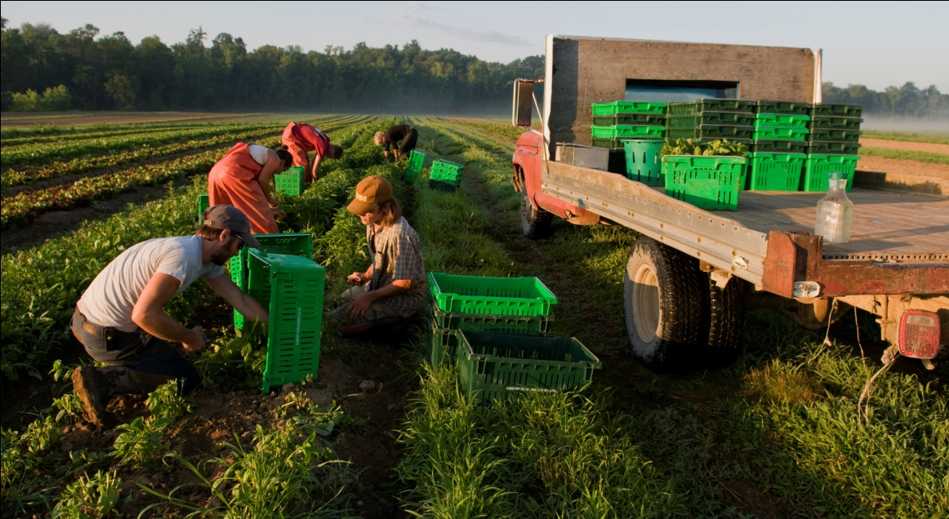
INGREDIENTS has been an official selection at several international film festivals, including The Colorado Environmental Film Festival, the Cleveland International Film Festival, the Kansas International Film Festival, the Princeton Environmental Film Festival and the Washington, D.C. Environmental Film Festival, Hawaii International Film Festival, and Hot Springs Documentary Festival. The DVD features an extended interview with Alice Waters, slow food vs. fast food analysis, and four seasonal stories.
INGREDIENTS is directed by Robert Bates; produced by Brian Kimmel; written and edited by Robert Bates. Corinne Bourdeau and Mary Elizabeth Murphy, executive producers.
Pricing: $29.95 US
Runtime: 67 mins., plus extras
Rating: N/A
Catalog #: NNVG238390
Language: English
Color: Color
Audio Format: Dolby Digital 2.0 Stereo
Genre: Documentary

About Docurama Films
Docurama Films is dedicated to making critically acclaimed and cutting-edge documentaries available digitally and on home video. In 1999, New Video launched Docurama Films with the release of the first feature documentary on DVD, D.A. Pennebaker’s Bob Dylan: Don’t Look Back. More than a decade later and a library of more than 250 award-winning, highly acclaimed documentary titles, Docurama continues its mission to unearth and release the great classic documentaries of the last fifty years while spreading the word about filmmakers who are taking the form to new heights. The Docurama catalog features a roster of titles from genres including the arts, history, politics, environmental, ethnic interest, LGBT, music, and socio-cultural, as well as theatrical fan-favorites like The Wild Parrots of Telegraph Hill and Andy Goldsworthy: Rivers and Tides. Recent releases include Gasland, The Age of Stupid and Best Worst Movie. www.docuramafilms.com

About New Video
New Video is a leading independent privately-held distributor of quality entertainment via DVD, Blu-ray, download and streaming platforms, and cable VOD. We are the proud home to some of the most prestigious names in the industry like A&E®, HISTORY™, Lifetime®, Major League Baseball®, Scholastic Storybook Treasures™, Arthouse Films and Tribeca Film as well as our own lines Docurama Films®, and the newly launched Flatiron Film Company®. Since 1991, our mission has been to discover first-rate content and deliver to audiences through traditional platforms and evolving new media. We selectively handpick our library while collaborating directly with our brand partners and filmmakers to cultivate a superior product and fresh new viewing experiences for our audiences. We are headquartered in New York City, but have an international presence in 45 territories. www.newvideo.com.

For more information, please contact:
Sommer Hixson
646-259-4138
shixson@newvideo.com

For box art, please visit:
http://www.newvideo.com/docurama/ingredients/

Or visit the Press Room at:
http://www.newvideo.com/pressroom/

