FOR IMMEDIATE RELEASE


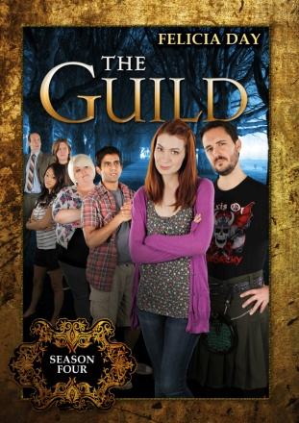

OMG!! THE REAL WORLD AND IN-GAME POLITICS COLLIDE:
SEASON 4 OF THE GUILD AVAILABLE FEBRUARY 22

New DVD Release of Felicia Day’s Wildly Popular Web Series

December 21, 2010 − Hot off the cliffhanger to Season 3, Codex (Felicia Day) scrambles to justify her impetuous encounter with Rival Guild Leader, Fawkes (Wil Wheaton), to herself and her Guild. It’s Guildie vs. Guildie when Vork announces a fundraising competition for design rights to the new Guild Hall. Meanwhile, Zaboo and Vork deal with a real-world house guest, Tink and Clara pair up to make some quick cash, and Codex's computer problems force her to work at a real job (OMG) with Bladezz (OMFG!).

With more than 65 million views web-wide, THE GUILD’s popularity continues to grow (Ms. Day boasts more than 1.7 million followers on Twitter). The original comedic web series has won numerous awards, including the SXSW, YouTube and Yahoo Web Series Awards in 2008, and 3 Streamy Awards in 2009: Best Comedy Web Series, Best Ensemble, and Best Actress for Ms. Day. Most recently, THE GUILD expanded into a graphic novel series from Dark Horse Comics, and a new trade paperback (all three issues in one bound edition, with added features) was recently released in November 2010.

Felicia Day is known for her roles in Joss Whedon’s hugely popular Dr. Horrible’s Sing-Along Blog and Buffy The Vampire Slayer. Next spring, she will appear for the first time in the SyFy Channel’s hit TV series, Eureka. Produced by Kim Evey (Gorgeous Tiny Chicken Machine Show,) and directed by Sean Becker (Emmy award-winning short film, Parallel/Parallel), THE GUILD also stars Vincent Caso as “Bladezz,” Jeff Lewis as “Vork,” Amy Okuda as “Tinkerballa,” Sandeep Parikh as “Zaboo,” and Robin Thorsen as “Clara.” (http://www.watchtheguild.com).

The unrated DVD from New Video’s Flatiron Film Company includes all 12 episodes from Season 4, the hit music video “Game On!,” behind-the-scenes footage of the making of “Game On!,” cast interviews, audio commentary with the cast, creator, director and producer, and a gag reel.

THE GUILD: SEASON 4

Pricing: $14.95 SRP, $16.95 CAN
Runtime: 96 minutes, plus extras
Rating: N/A
Catalog #: NNVG238380
Language: English
Color: Color
Genre: Comedy, Web Series

About New Video
New Video is a leading independent privately-held distributor of quality entertainment via DVD, Blu-ray, download and streaming platforms, and cable VOD. We are the proud home to some of the most prestigious names in the industry like A&E®, HISTORY™, Lifetime®, Major League Baseball®, Scholastic Storybook Treasures™, Arthouse Films and Tribeca Film, as well as New Video’s own Docurama Films® and Flatiron Film Company®. Since 1991, our mission has been to discover and deliver first-rate film and video content to audiences via traditional linear platforms as well as new and evolving digital media. We selectively handpick our library while collaborating directly with our brand partners and filmmakers to cultivate a superior product and fresh new viewing experiences for our audiences. We are headquartered in New York City, but have an international presence in 45 territories.

For more information, please contact:

Sommer Hixson
646-259-4138
shixson@newvideo.com

Please visit the Press Room at:
http://www.newvideo.com/pressroom/

