FOR IMMEDIATE RELEASE

NEW VIDEO’S DOCURAMA FILMS DEBUTS “BEST WORST MOVIE”
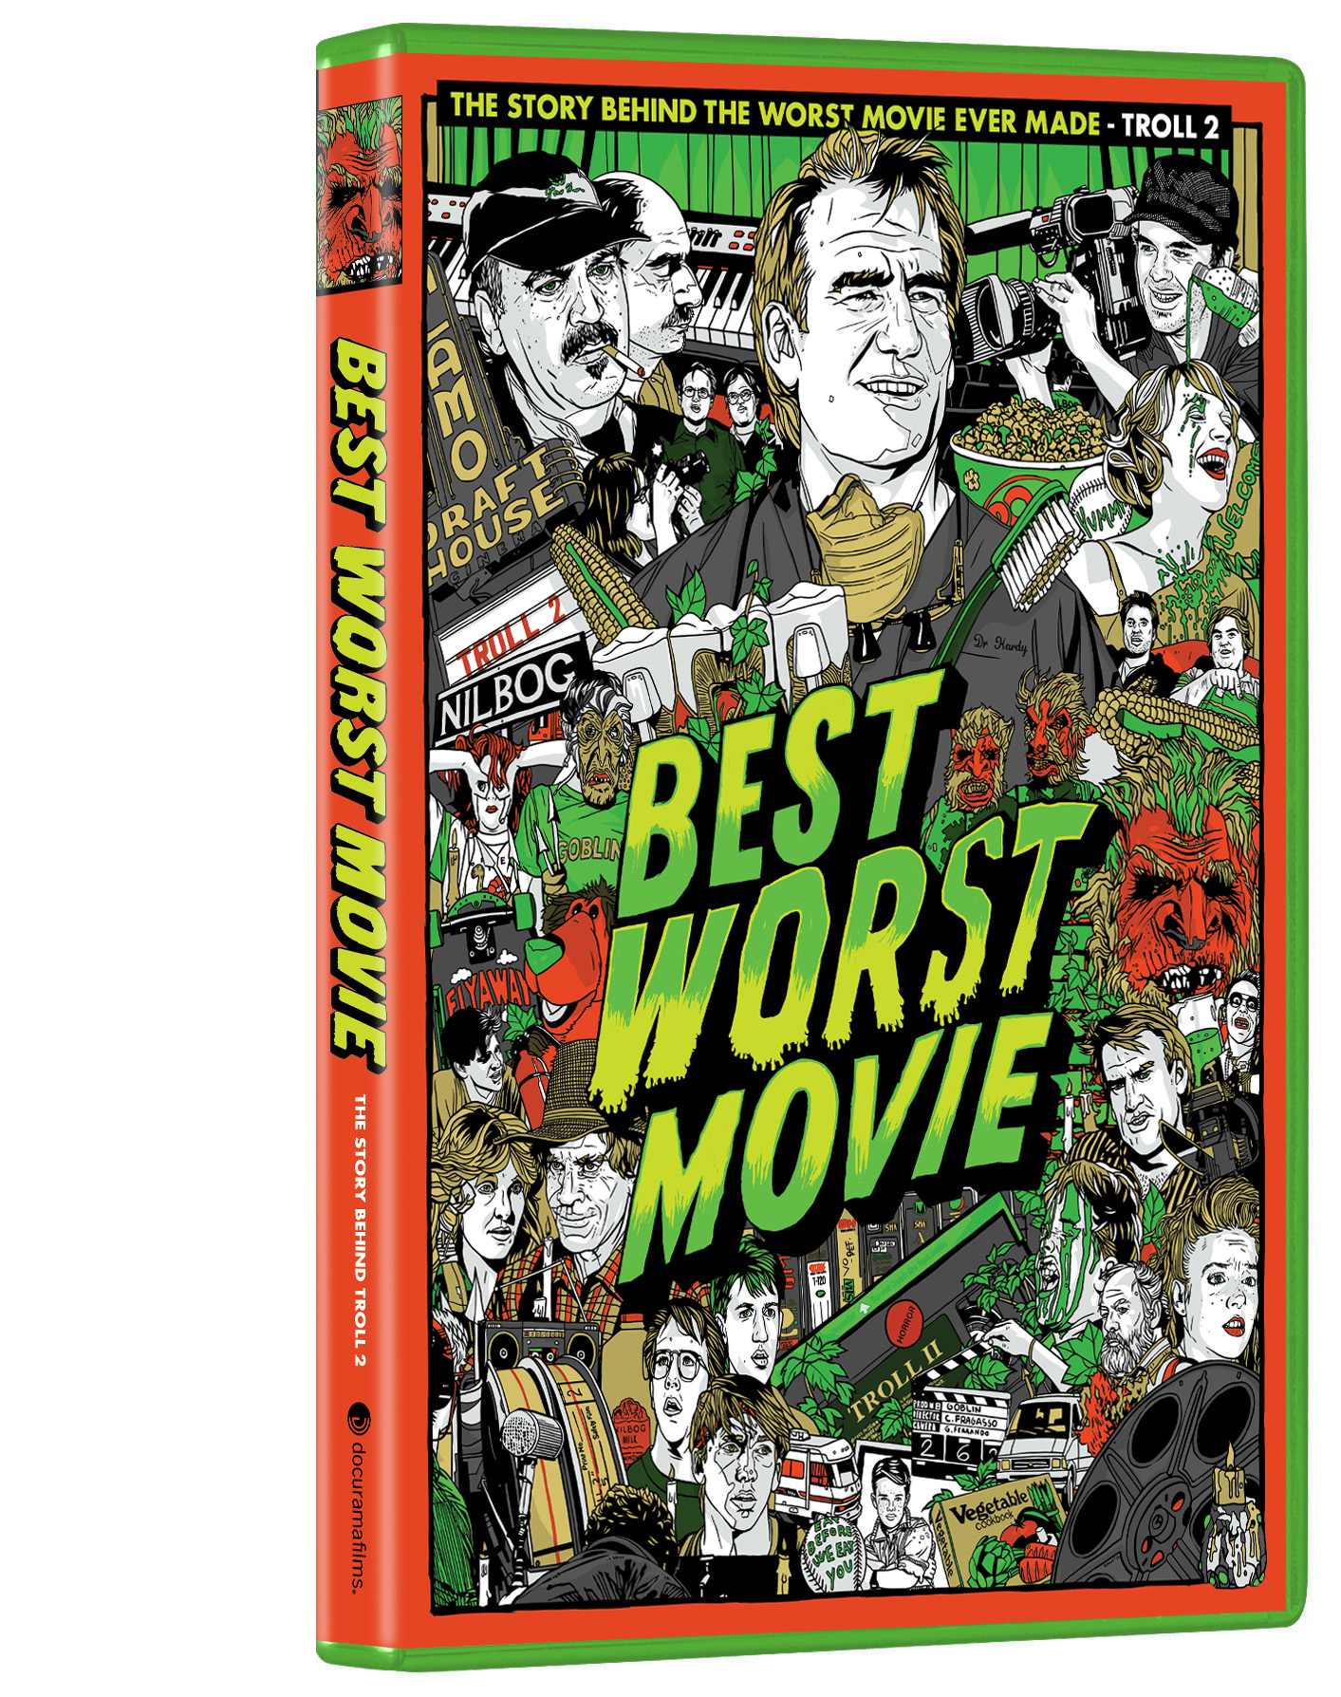

Critic’s Choice and Festival Award-Winning Documentary

About the Single Greatest Bad Movie Available on DVD and Digital on November 16

“Top 10 Movies of the Year.” – USA Today-Pop Candy

"A raging success. Infectiously fun, energetic, and crazily enthusiastic.” - The Onion A.V. Club

How many people can claim they starred in the worst movie ever made? Michael Paul Stephenson might be forever be known as the screaming, whining, ten year-old boy who saves his family by urinating on their dinner. Today, he is the director and producer of BEST WORST MOVIE, a critically-acclaimed, award-winning documentary inspired by his role in what has been crowned the worst movie of all time: Troll 2.

In this hilarious and heartfelt story about the strange nature of celebrity, a sunny Alabama dentist (Dr. George Hardy, DMD) and a self-deluded Italian filmmaker (Claudio Fragasso) struggle to come to grips with their role in the worst movie ever made. The result is a tender offbeat journey that pays homage to lovers of bad movies and the people who make them, while investigating a deeper story about the catharsis of redemption and the humanity that exists in making even the worst movie ever made.

“I ran from Troll 2 and was dreadfully embarrassed by it,” explains director Michael Paul Stephenson. “Intended as a horror film it was indeed frightening but for all of the wrong reasons. Strangely, what began as an earnest horror film gone disastrously wrong blossomed into a cult classic. People genuinely love Troll 2 because it‘s a genuine failure.”

Through a strange twist of irony, this same cinematic car crash lead director Michael Paul Stephenson to direct and produce one of the most critically-acclaimed films of the year. With a current 94% rating on Rotten Tomatoes, BEST WORST MOVIE has been pleasing audiences in theaters throughout the country.

“Curiously Touching” – Roger Ebert

The DVD includes more than an hour of deleted scenes and interviews, including an interview with Claudio Fragasso, the director of Troll 2; fan contributions (music videos and mash-up trailers); Filmmaker Q&A with Creative Screenwriting Magazine, and a provocative message from the original Troll 2’s Goblin Queen, Deborah Reed.

BEST WORST MOVIE is written, directed and produced by Michael Paul Stephenson; produced by Lindsay Stephenson, Brad Klopman and Jim Klopman; cinematography and editing, Katie Graham; editing, Andrew Matthews.

BEST WORST MOVIE will be distributed day-and-date with the DVD (November 16) on digital platforms via New Video’s partners.

BEST WORST MOVIE
Catalogue#: NNVG230320
Length: 93 minutes + extras; Color
Audio: Dolby Digital 2.0 Stereo
$19.95 US

About Docurama Films
Docurama Films is dedicated to making critically acclaimed and cutting-edge documentaries available digitally and on home video. In 1999, New Video launched Docurama Films with the release of the first feature documentary on DVD, D.A. Pennebaker’s Bob Dylan: Don’t Look Back. Over a decade later and a line of over 250 award-winning and highly acclaimed documentary titles, Docurama continues its mission to unearth and release the great classic documentaries of the last fifty years while spreading the word about filmmakers who are taking the form to new heights. The Docurama catalog features a wide span of titles from varying genres including the arts, history/politics, environmental, ethnic interest, LGBT, music, and socio-cultural as well as theatrical fan-favorites like The Wild Parrots of Telegraph Hill and Andy Goldsworthy: Rivers and Tides. Releases in 2010 include the screwball comedy The Yes Men Fix the World, the empowering music celebration Soundtrack for a Revolution and the crowd-pleasing Yoo-Hoo Mrs. Goldberg. www.docuramafilms.com

About New Video
New Video is a leading independent privately-held distributor of quality entertainment via DVD, Blu-ray, download and streaming platforms, and cable VOD. We are the proud home to some of the most prestigious names in the industry like A&E®, HISTORY™, Lifetime®, Major League Baseball®, Scholastic Storybook Treasures™, Arthouse Films and Tribeca Film as well as our own lines Docurama Films®, and the newly launched Flatiron Film Company®. Since 1991, our mission has been to discover first-rate content and deliver them to audiences through traditional platforms and evolving new media. We selectively handpick our library while collaborating directly with our brand partners and filmmakers to cultivate a superior product and fresh new viewing experiences for our audiences. We are headquartered in New York City, but have an international presence in 45 territories. www.newvideo.com.

For further information, please contact:

Sommer Hixson
New Video
646-259-4138
shixson@newvideo.com

Download High-Res DVD Box Art here:
http://www.newvideo.com/docurama/best-worst-movie/

