FOR IMMEDIATE RELEASE


presents

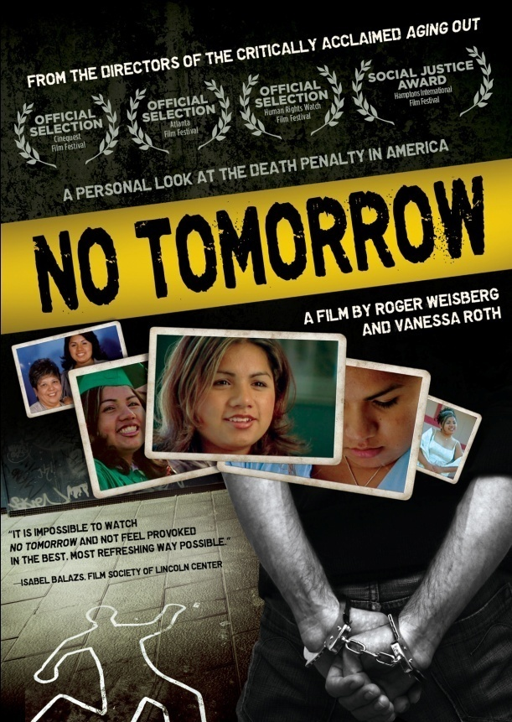

ACCLAIMED DOCUMENTARY NO TOMORROW
TO BE RELEASED ON DVD AND DIGITAL ON JANUARY 25

Provocative, Personal Look at the U.S. Death Penalty
Premieres on PBS in March 2011
“Suspenseful.”- Film Comment Magazine
December 20, 2010 – As profiled in Roger Weisberg and Vanessa Roth’s critically acclaimed film AGING OUT, Risa Bejarano was a foster care success story. Recently graduated from high school, she set out for college with multiple scholarships and a sense of excitement about her future. Then, she was brutally murdered.

Soon, AGING OUT became the centerpiece of Ms. Bejarano’s murder trial, as prosecutors used the film to heighten sympathy for the victim and hatred for the defendant. Troubled that their documentary was being used to advance the prosecutor’s argument for the death penalty, filmmakers Roth (Academy Award® winner, Freeheld) and Weisberg (Academy Award® nominee, Sound and Fury, Why Can’t We Be a Family Again?) made a second film, NO TOMORROW, which focuses on the trial and the unexpected use of AGING OUT as evidence.

In NO TOMORROW, similarities emerge between Ms. Bejarano and her killer, and viewers are forced to question not just whether the accused deserves to die, but whether the state deserves to kill.

Three years after Ms. Bejarano’s murder, Juan Jose Chavez went on trial in front of Judge Lance Ito, who presided over the O.J. Simpson trial. NO TOMORROW covers the trial’s most dramatic moments in Judge Ito’s courtroom, including a heated debate over the prosecutor’s use of AGING OUT in order to persuade the jury to impose the death penalty. Although some viewers may feel that the death penalty is a legitimate emotional response to a heinous crime like Ms. Bejarano’s murder, NO TOMORROW will make them question whether capital punishment is too imperfect, arbitrary, discriminatory, and costly to be a legitimate public policy. Ultimately, the unique film-within-a-film perspective of NO TOMORROW takes viewers inside a suspenseful death penalty trial and challenges their beliefs about capital punishment.

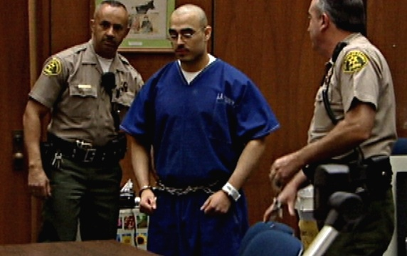

In addition to the filmmakers’ on-screen commentary, NO TOMORROW features in-depth interviews with members of the jury and key participants involved in the trial, plus scholars, judges and activists arguing both sides of the heated issue.

NO TOMORROW was featured in a dozen film festivals and won the Social Justice Prize at the Hamptons International Film Festival. It premieres March 25, 2011, on PBS.

The DVD features READY OR NOT, a 30-minute documentary about Ms. Bejarano’s last year of life, and the theatrical trailer for NO TOMORROW.

NO TOMORROW is directed and produced by Roger Weisberg and Vanessa Roth; edited by Tom Haneke.

Pricing: $29.95 US
Runtime: 86 mins., plus extras
Rating: N/A
Catalog #: NNVG23694-9
Language: English
Color: Color
Audio Format: Dolby Digital 2.0 Stereo
Genre: Documentary
About Docurama Films
Docurama Films is dedicated to making critically acclaimed and cutting-edge documentaries available digitally and on home video. In 1999, New Video launched Docurama Films with the release of the first feature documentary on DVD, D.A. Pennebaker’s Bob Dylan: Don’t Look Back. Over a decade later and a line of over 250 award-winning and highly acclaimed documentary titles, Docurama continues its mission to unearth and release the great classic documentaries of the last fifty years while spreading the word about filmmakers who are taking the form to new heights. The Docurama catalog features a wide span of titles from varying genres including the arts, history/politics, environmental, ethnic interest, LGBT, music, and socio-cultural as well as theatrical fan-favorites like The Wild Parrots of Telegraph Hill and Andy Goldsworthy: Rivers and Tides. Releases in 2010 include the screwball comedy The Yes Men Fix the World, the empowering music celebration Soundtrack for a Revolution and the crowd-pleasing Best Worst Movie. www.docuramafilms.com

About New Video
New Video is a leading independent privately-held distributor of quality entertainment via DVD, Blu-ray, download and streaming platforms, and cable VOD. We are the proud home to some of the most prestigious names in the industry like A&E®, HISTORY™, Lifetime®, Major League Baseball®, Scholastic Storybook Treasures™, Arthouse Films and Tribeca Film as well as our own lines Docurama Films®, and the newly launched Flatiron Film Company®. Since 1991, our mission has been to discover first-rate content and deliver to audiences through traditional platforms and evolving new media. We selectively handpick our library while collaborating directly with our brand partners and filmmakers to cultivate a superior product and fresh new viewing experiences for our audiences. We are headquartered in New York City, but have an international presence in 45 territories. www.newvideo.com.

For more information, please contact:
Sommer Hixson
646-259-4138
shixson@newvideo.com

For box art, please visit:
http://www.newvideo.com/docurama/no-tomorrow/

Or visit the Press Room at:
http://www.newvideo.com/pressroom/

