FOR IMMEDIATE RELEASE


presents

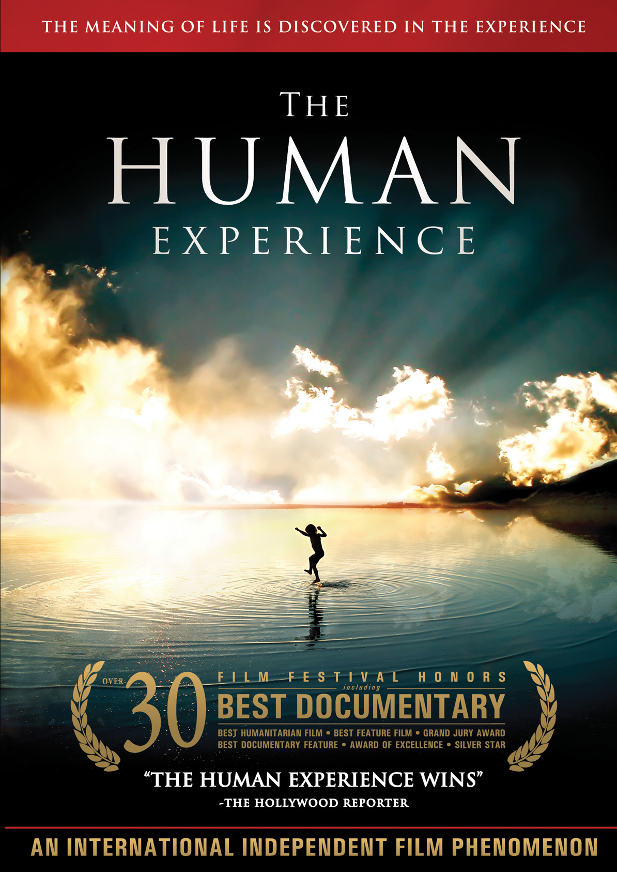

“THE HUMAN EXPERIENCE,” A TRANSFORMATIVE DOCUMENTARY ABOUT SPIRITUAL DISCOVERY, TO BE RELEASED ON DVD & DIGITAL ON MARCH 29

Aired on Cable VOD in November 2010

The Meaning of Life is Discovered in the Experience

“A Doc with so much heart in the right place”—Indiewire
January 19, 2011 – Most of us question our purpose in life. Who am I? Why am I here? These, along with other spiritual and existential questions, are thoroughly explored in THE HUMAN EXPERIENCE.
In a world fraught with hostility and violence, an altruistic group of young men – Clifford Azize, Jeffrey Azize, Michael Campo and Matthew Sanchez – endeavor to understand the true essence of the human spirit by living among the world’s forgotten souls. The documentary highlights three of their profound experiences:
- Experience I: Living Homeless in New York City: Clifford and Jeffrey Azize take to the streets of New York City to live among the homeless without money, shelter or food, during one of the coldest winters on record.
- Experience II: The Lost Children of Peru: In the foothills of the Andes Mountains, Clifford and Jeffrey volunteer at a home for sick, destitute and orphaned children.

- Experience III: Lepers of Ghana: The group interviews AIDS victims and visits a leper colony in West Africa.

By experiencing first-hand that hope and faith prevail in the hearts of our most disenfranchised members of society, these four men emerge from their experiences seeing more beauty in everything and everyone around them.
Narrated by Jeffrey and Clifford Azize, THE HUMAN EXPERIENCE features in-depth interviews with philosophers, humanitarians and religious leaders, including Activist Dr. Alveda King (niece to MLK), Anna Halpine (founder, World Youth Alliance), Rev. Richard Neuhaus and Rabbi Simon Jacobson.
THE HUMAN EXPERIENCE was an official selection at over 30 film festivals and has won 16 awards, including the Audience Choice Award at the American Cinematic Experience at Tribeca (2009 ACEfest) and best documentary at Atlanta International Documentary Film Festival (2009 DocuFest Atlanta). The film also had a successful theatrical run.
An original score composed by Thomas J. Bergersen is featured in THE HUMAN EXPERIENCE along with music from Bob Marley, Jimmy Durante and Enya.
The DVD features the filmmakers’ audio commentary, theatrical trailer and a behind-the-scenes photo gallery.
THE HUMAN EXPERIENCE is directed by Charles Kinnane; produced by Joseph Campo; edited by Charles Kinnane.
Pricing: $24.95 US
Runtime: 90 mins., plus extras
Rating: PG-13
Catalog #: NNVG236690
Language: English; Subtitled in Spanish, Portuguese, Polish, German and French
Color: Color
Audio Format: Digital 5.1 Surround Sound
Genre: Documentary

About Docurama Films
Docurama Films is dedicated to making critically acclaimed and cutting-edge documentaries available digitally and on home video. In 1999, New Video launched Docurama Films with the release of the first feature documentary on DVD, D.A. Pennebaker’s Bob Dylan: Don’t Look Back. More than a decade later and a library of more than 250 award-winning, highly acclaimed documentary titles, Docurama continues its mission to unearth and release the great classic documentaries of the last fifty years while spreading the word about filmmakers who are taking the form to new heights. The Docurama catalog features a roster of titles from genres including the arts, history, politics, environmental, ethnic interest, LGBT, music, and socio-cultural, as well as theatrical fan-favorites like The Wild Parrots of Telegraph Hill and Andy Goldsworthy: Rivers and Tides. Recent releases include Gasland, The Age of Stupid and Best Worst Movie. www.docuramafilms.com

About New Video
New Video is a leading independent privately-held distributor of quality entertainment via DVD, Blu-ray, download and streaming platforms, and cable VOD. We are the proud home to some of the most prestigious names in the industry like A&E®, HISTORY™, Lifetime®, Major League Baseball®, Scholastic Storybook Treasures™, Arthouse Films and Tribeca Film as well as our own lines Docurama Films®, and the newly launched Flatiron Film Company®. Since 1991, our mission has been to discover first-rate content and deliver to audiences through traditional platforms and evolving new media. We selectively handpick our library while collaborating directly with our brand partners and filmmakers to cultivate a superior product and fresh new viewing experiences for our audiences. We are headquartered in New York City, but have an international presence in 45 territories. www.newvideo.com.

For more information, please contact:
Sommer Hixson
646-259-4138
shixson@newvideo.com

For box art, please visit:
http://www.newvideo.com/docurama/the-human-experience/

Or visit the Press Room at:
http://www.newvideo.com/pressroom/

