FOR IMMEDIATE RELEASE
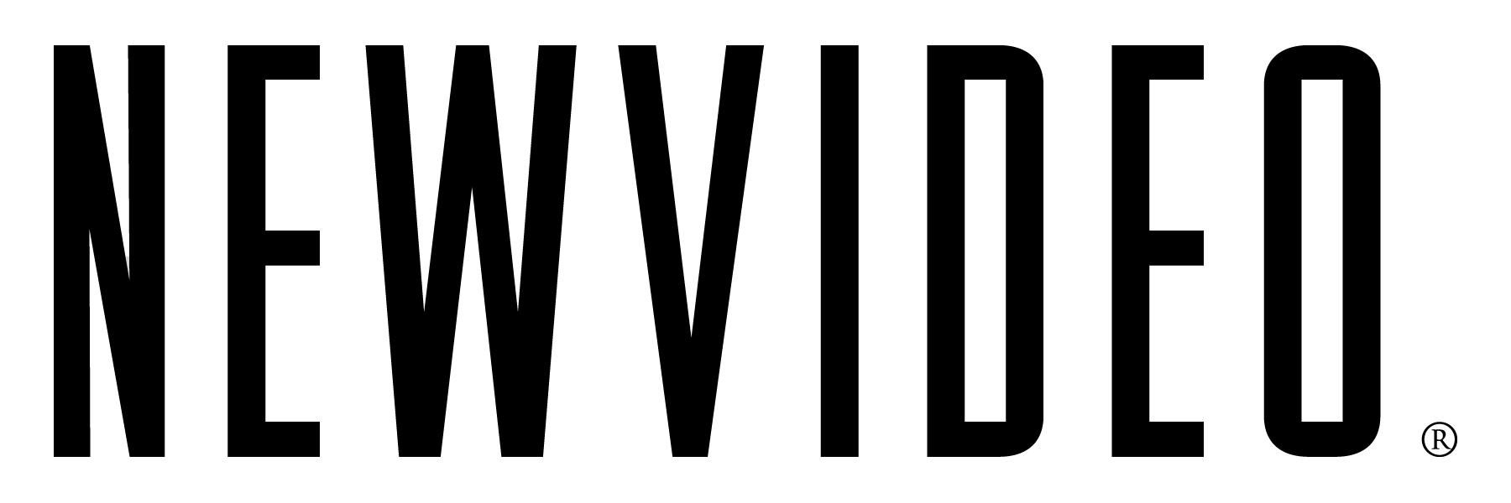

NEW VIDEO ACQUIRES JANET GRILLO’S 2011 SXSW WORLD PREMIERE,
“FLY AWAY,” FOR MULTI-PLATFORM RELEASE

New York, NY – February 3, 2011 – New Video, a leading independent film and TV distributor, announced today that the Company has acquired FLY AWAY, an official entry in the Narrative Feature Competition at the 2011 SXSW Film Festival, for release across Digital, Cable VOD and DVD distribution platforms, with plans for a limited theatrical run.

Award-winning producer Janet Grillo’s debut feature film, FLY AWAY, will world premiere at the 2011 SXSW Film Festival in March, where the film is one of only eight selected for competition from nearly one thousand submissions to the Narrative Feature category. FLY AWAY will be released by New Video’s Flatiron Film Company on April 26. The film is Written, Directed and Produced by Grillo; Co-Producer Pavlina Hatoupis; Executive Producers Catherine Hardwicke, Lee Adhemar G. Feldshon and David F. Schwartz.

FLY AWAY narrates the story of Jeanne (Beth Broderick, Bonfire of the Vanities, Sabrina the Teenage Witch) and her teenage daughter, Mandy (Ashley Rickards, One Tree Hill) who is severely impacted with autism. As Mandy matures, her disability becomes harder to manage, and so does Jeanne’s own life. Jeanne is forced to confront the most difficult choice any parent faces: to let go, allowing a child to grow, but apart, or to hold on tight and fall together. The film also stars Greg Germann (Ally McBeal, Friends with Money) and J.R. Bourne (Little Birds).

Janet Grillo is an Emmy Award® winning producer (Autism: The Musical), an award winning writer and director, and a former studio executive (New Line). The script for FLY AWAY won the Best International Screenplay Award at the Swansea Bay Film Festival in Wales in 2010. Her second short film, Flying Lessons, starring Dana Delany, premiered at the Palm Springs International Film Festival in August of 2008, and went on to win several awards at festivals across the U.S. and Canada.

“After the pleasure and reward of working with Janet on Austism: The Musical, we’re proud to be supporting Janet on her feature debut,” said Susan Margolin, Co-President, New Video. “With refreshing honesty, FLY AWAY speaks to the extra challenges and sacrifices a parent faces with a child on the spectrum, brought to life from Janet’s vision and outstanding performances by the cast.”

“I’m honored and delighted to again collaborate with the extraordinary team at New Video, to share a story born from a particular experience,” said Janet Grillo. “We hope FLY AWAY will resonate as a journey of the heart that every parent travels.”

New Video will collaborate with AUTISM SPEAKS, the leading national advocacy organization, in a comprehensive grassroots outreach campaign to their community during the release.

-more-

About New Video
New Video is a leading independent privately-held distributor of quality entertainment via DVD, Blu-ray, download and streaming platforms, and cable VOD. We are the proud home to some of the most prestigious names in the industry like A&E®, HISTORY™, Lifetime®, Major League Baseball®, Scholastic Storybook Treasures™, Arthouse Films and Tribeca Film as well as our own lines Docurama Films®, and the newly launched Flatiron Film Company®. Since 1991, our mission has been to discover first-rate content and deliver to audiences through traditional platforms and evolving new media. We selectively handpick our library while collaborating directly with our brand partners and filmmakers to cultivate a superior product and fresh new viewing experiences for our audiences. We are headquartered in New York City, and have an international presence in 45 territories. www.newvideo.com.

# # #

For more information, please contact:
Sommer Hixson
New Video Media Relations
(646) 644-1546
shixson@newvideo.com

For the filmmaker, please contact:
Nina Barron
PMK-BNC
(212) 373-6150
nina.baron@pmkbnc.com

