FOR IMMEDIATE RELEASE


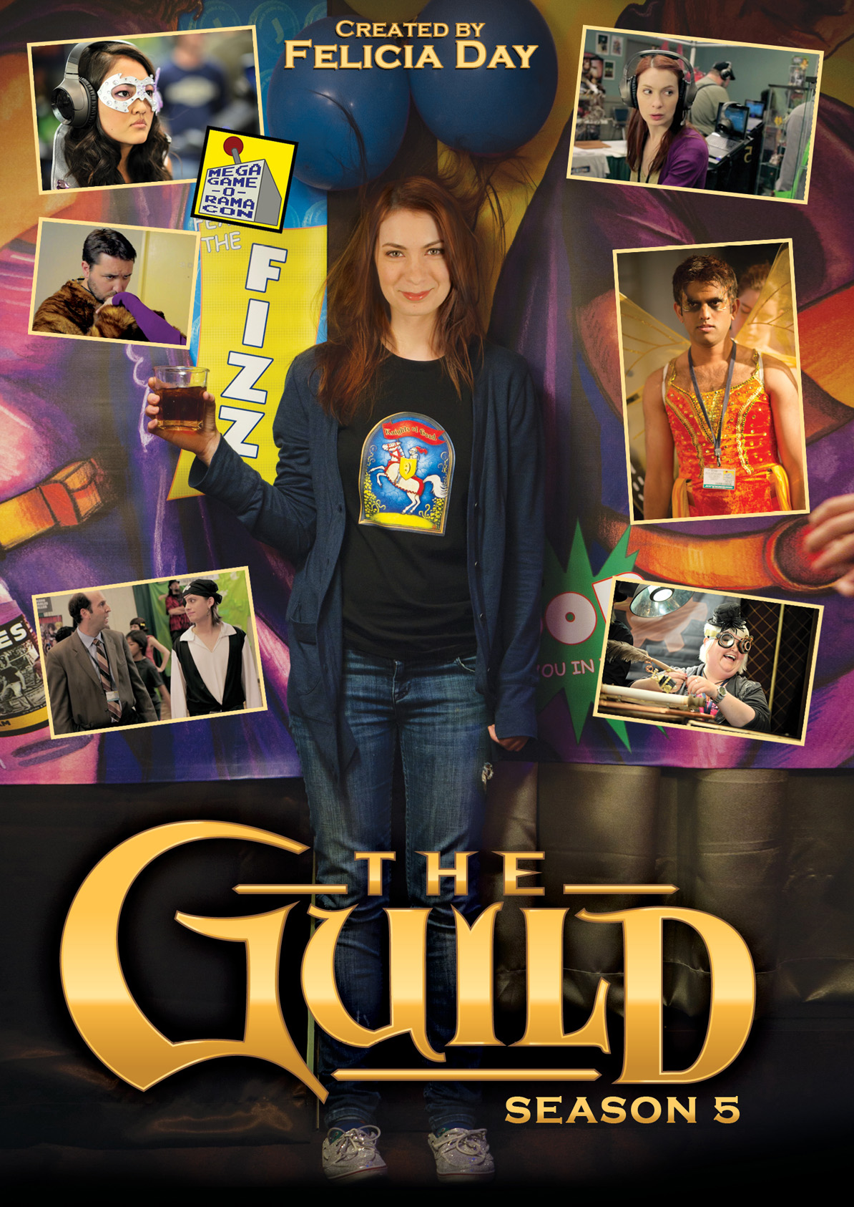

ROAD TRIP! THE GUILDIES ATTEND MEGAGAME-O-RAMACON:
SEASON 5 OF FELICIA DAY’S THE GUILD AVAILABLE ON DVD MARCH 13

February 13, 2012 – In THE GUILD: SEASON 5, for the first time, the Guildies come out from behind their computers and embark on a road trip to an epic fan convention, MegaGame-O-RamaCon. Codex (Felicia Day) tries to rally the Guildies to action when she overhears upsetting news about “The Game.” Bladezz tries to make money with his Cheesybeard’s pirate alter-meme-ego, while Vork is starstruck by his boyhood crush, sci-fi heroine Madeleine Twain (Erin Gray, Buck Rogers in the 25th Century). Meanwhile, Clara tries to make friends with a snooty Steampunk trio, Tink hides from her past and Zaboo joins up with Halo’s Master Chiefs... wha?!

With more than XX million views web-wide for THE GUILD and 1.8 million followers on Twitter, Felicia Day is an entertainment phenomenon. THE GUILD recently expanded into a graphic novel series and new trade paperback from Dark Horse Comics, written by Day. Last October, she premiered a new web original she wrote and produced, DRAGON AGE: REDEMPTION (http://bit.ly/z1KdXZ). Day is also known for her roles in Joss Whedon’s hugely popular Dr. Horrible’s Sing-Along Blog and SyFy Channel’s hit TV series, Eureka.

Produced by Kim Evey (Gorgeous Tiny Chicken Machine Show,) and directed by Sean Becker (Emmy award-winning short film, Parallel/Parallel), THE GUILD also stars Vincent Caso as “Bladezz,” Jeff Lewis as “Vork,” Amy Okuda as “Tinkerballa,” Sandeep Parikh as “Zaboo,” and Robin Thorsen as “Clara.” THE GUILD: SEASON 5, from Flatiron Film Company, includes all 12 episodes featuring special guest stars Erin Gray, Nathan Fillion, Wil Wheaton, and Brent Spiner, plus exclusive bonus material never before seen on the internet.

THE GUILD: SEASON 5

Pricing: $14.95 SRP, $16.95 CAN
Runtime: 96 minutes, plus extras
Rating: N/A
Catalog #: NNVG262800
Language: English
Color: Color
Genre: Comedy, Web Series

About New Video
New Video is a leading entertainment distributor and the largest aggregator of independent digital content worldwide. Headquartered in New York City, with an international presence in 45 territories, the company delivers feature films, TV programs and web originals via digital download, streaming, video-on-demand, Blu-ray, DVD, and theatrical release. In 2011, New Video bowed Oscar®-nominated Hell and Back Again and South American blockbuster Elite Squad: The Enemy Within in US theaters. Through a new partnership with digital exhibitor Cinedigm Entertainment Group, New Video is poised to bring more independent films to theaters nationwide. New Video streamlines distribution and marketing for filmmakers and partners, bringing a wide variety of fresh content to new audiences. The company’s library includes original TV series and movies from A+E® Home Entertainment, HISTORY™, and Lifetime®, unforgettable games and trophy sets from Major League Baseball®, storybook treasures from Scholastic®, award-winning documentaries from Docurama Films®, next-gen indies from Flatiron Film Company®, and acclaimed independent films and festival picks through partnerships with the Sundance Institute and Tribeca Film. New Video is proud to distribute many Oscar®-nominated documentaries including GasLand, Waste Land, Paradise Lost 3: Purgatory and Hell and Back Again.

For more information, please contact:
Sommer Hixson
646-259-4138
shixson@newvideo.com

For more product information:
http://www.newvideo.com/new-video-digital/the-guild-season-5-2/

