FOR IMMEDIATE RELEASE
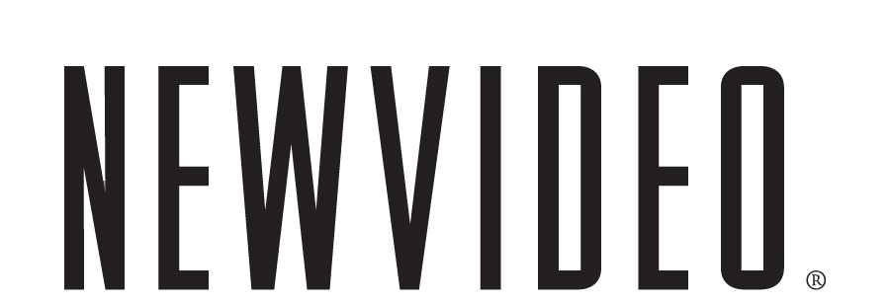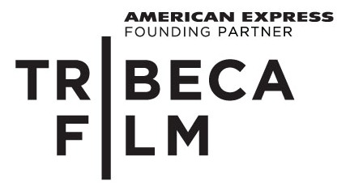

CLIMATE OF CHANGE IS A DAZZLING PORTRAIT OF EARTH IN CRISIS
AND THE PEOPLE WHO ARE WORKING TO SAVE IT

ON DVD FROM TRIBECA FILM AND NEW VIDEO FEBRUARY 22
***
“Tilda Swinton narrates a poetic script” – LA Weekly
***
“Never less than stunning” – The New York Times

NEW YORK, February 4, 2011 – “We are the renters of this world, not its masters,” reminds Pushkar, a precocious 13-year-old member of a youth environmental defense group in India. He and his fellow voraciously energetic students actively rally against the use of plastics. In Africa, a renaissance man teaches citizens to harness solar power to cook food. In Papua New Guinea, villagers practice sustainable logging to save their rainforests. A woman in London uses her PR savvy to start a successful environmental communications firm. Self-described “hillbillies” in Appalachia battle the big business behind strip mining.
From the producers of An Inconvenient Truth and directed by Brian Hill, Climate of Change is a powerful and visually stunning documentary about ordinary people around the world who are taking action in the fight to save our environment. Using beautiful narration written by British poet Simon Armitage and mellifluously voiced by Academy Award® winner Tilda Swinton, Hill and his cinematographers create a real sense of ambience in each of the countries and communities they visit. Conversations with West Virginians are punctuated by footage of mountaintops surrounding their homes being strip-mined; Papua New Guineans talk among the giant trees being decimated by commercial logging. A visit to the Global Seed Vault built in the Norwegian permafrost in Svalbard, Norway is particularly ethereal. Climate of Change is a majestic portrait of our world and an artful call for us to act.
“There's as much beauty in the deeply felt commitment of the film's environmentalists as there is in its visual splendor and in Tilda Swinton’s lyrical narration,” says the Los Angeles Times. Jean Oppenheimer, a critic for public radio program Film Week, calls Climate of Change “one of the better documentaries I have ever seen. It doesn’t go to experts, it goes to people – and the people are wonderful to listen to. It’s just really impressive, it makes you feel like you can go out and do something too.” And Variety marvels, “Half eco-docu, half art, Climate of Change is social-action cinema with a twist -- it suggests that human beings might actually deserve an unspoiled planet.”
Climate of Change is one of a selection of Tribeca Film titles being distributed by New Video in 2010 and 2011. Tribeca Film is a distribution label acquiring and releasing films year-round and is supported by Founding Partner American Express. The films range from award-winning dramas and revealing documentaries to uproarious comedies and stunning animated features, many of which premiered at the 2010 Tribeca Film Festival prior to theatrical runs in New York and Los Angeles. The films from the Tribeca Film slate were also available on video on demand in 40 million U.S. homes simultaneously with their Festival screenings through relationships with leading telecom, cable and satellite providers.
New Video plans to release one to two titles per month leading up to the 2011 Tribeca Film Festival.
Special Features
- My Tribeca Story, Presented by American Express (Interview with Brian Hill)
- An Interview with Brian Hill, Presented by American Express

CLIMATE OF CHANGE

Street Date: February 22, 2011
Pricing: $24.95 U.S. (DVD)
Runtime: 88 minutes, plus bonus features
Rating: N/A
Catalog #: NNVG238370
Language: English
Color: Color
Audio Format: Stereo
Genre: Documentary
Distributor: Tribeca Film/New Video

About Tribeca Film
Tribeca Film is a comprehensive distribution label dedicated to acquiring and marketing independent films across multiple platforms, including video-on-demand, theatrical and home video. It is an initiative from Tribeca Enterprises designed to provide new platforms for how film can be experienced, while supporting filmmakers and introducing audiences to films they might not otherwise see. American Express continues its support of Tribeca and the independent film community by serving as the Founding Partner of Tribeca Film.
About New Video®
New Video is a leading independent privately-held distributor bringing you quality entertainment via DVD, Blu-ray, download and streaming platforms and cable VOD. We are the proud home to some of the most prestigious names in the industry like A&E®, HISTORY™, Lifetime®, Major League Baseball®, Scholastic Storybook Treasures™, Arthouse Films and Tribeca Film as well as our own lines Docurama Films®, and the newly launched Flatiron Film Company®. Since 1991, our mission has been to unearth first-rate content and deliver to audiences through traditional platforms and evolving new media. We selectively handpick our library while collaborating directly with our brand partners and filmmakers to cultivate a superior product and fresh new viewing experiences for our audiences. We are headquartered in New York City, but have an international presence in 45 territories.

Press Contacts:
Sommer Hixson, New Video
646-259-4138/ shixson@newvideo.com

Dade Hayes, Rubenstein Communications
212-843-8022 /dhayes@rubenstein.com

Tammie Rosen, Tribeca Enterprises
212-941-2003/trosen@tribecaenterprises.com

