

hitRECord’s “RECollection: VOLUME 1,”
THE FIRST ANTHOLOGY FROM JOSEPH GORDON-LEVITT’S
OPEN COLLABORATIVE PRODUCTION COMPANY

Collector’s Edition of 36 Short Films and Videos, a 64-Page Hardcover Illustrated Book, and Music CD Available on September 20

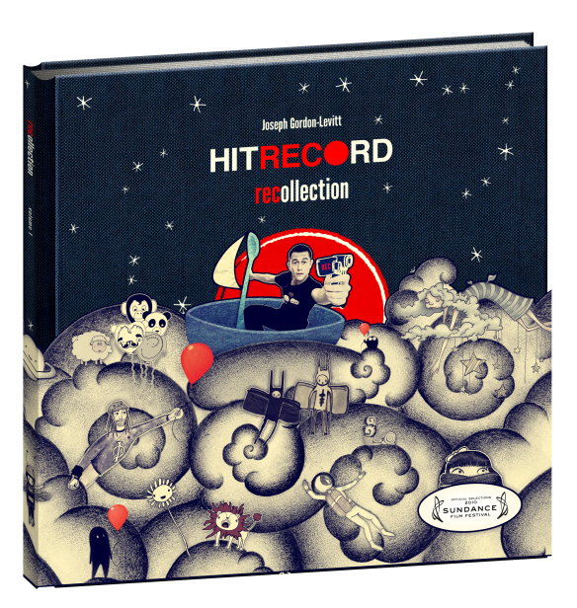

August 31, 2011 – New York, NY – Ladies and Gentlemen, we now bring you hitRECord RECollection: Volume 1, from the open-collaborative production company founded by actor Joseph Gordon-Levitt, aka “RegularJOE.” In one visually stunning collectible edition, RECollection: Volume 1 is the first “tactile” experience from the online community of more than 50,000 artists worldwide who collaborate on short films, music, visual art and literature.

Available September 20, hitRECord RECollection: Volume 1 features more than 2 hours of content spanning several genres, including:

- 36 short-form live-action and animated films, music videos, and “tiny stories” on one DVD;

- The companion CD invites you to join DJ RegularJOE as he hosts his radio show, complete with 17 songs recorded collaboratively by musicians divided by geography, united in harmony;

- The 8.25" x 8.25" hardcover cloth-bound book (in a die-cut jacket sleeve) contains 64 full-color semi-gloss pages of original poetry, prose, photography, drawings and stories.

All components will also be available on September 20 in digital format, with the book and CD combined as a separate download.
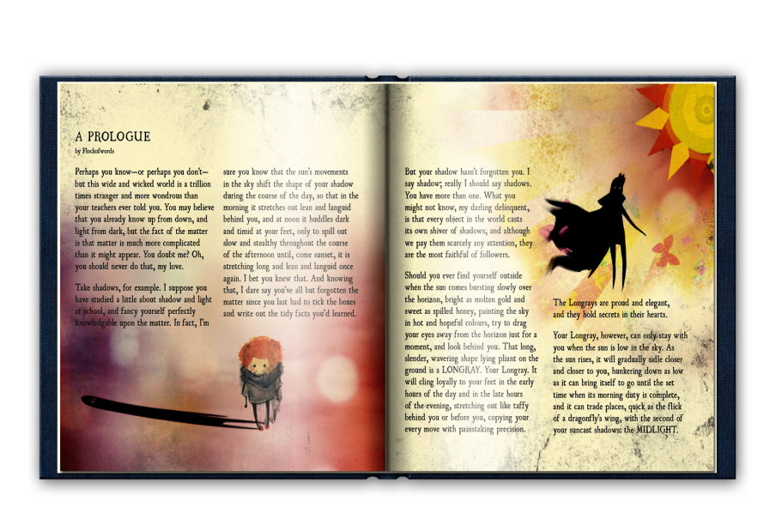
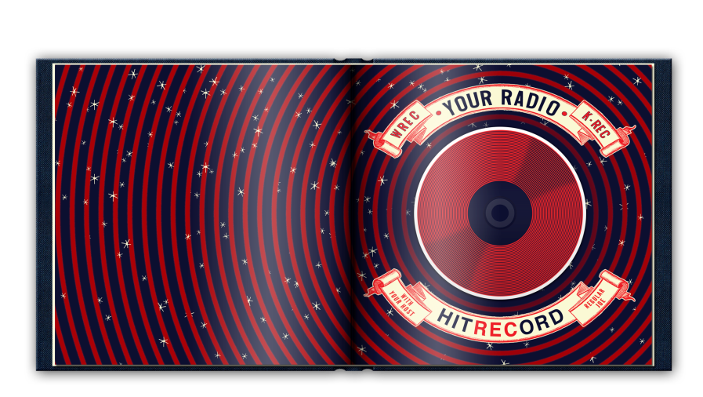

Joseph Gordon-Levitt's acting career has managed to garner a massive popular appeal while maintaining a widely respected artistic integrity. Most recently he starred in Inception and 500 Days of Summer and is currently filming the highly anticipated Dark Knight Rises. The release of RECollection: Volume 1 coincides with the world premiere of 50/50, starring Gordon-Levitt and Seth Rogen, at this year’s Toronto Film Festival, as well as a “Hit RECord at the Movies” event at the Festival.
Gordon-Levitt officially launched hitRECord as a professional open collaborative production company in 2010. With hitRECord.org, the website, serving as the company’s online studio, artists (‘RECorders’) contribute their work in various forms including music, videos, text and drawings. Under Gordon-Levitt’s direction, the artists are encouraged to add, edit, remix, and collaborate with each other to expand and refine each other’s work. The art that’s created and developed at hitRECord’s website is then presented by hitRECord commercially in various formats — as books, as t-shirts, as vinyl, and, the most recent and ambitious example, hitRECord RECollection: Volume 1. hitRECord regularly presents its work at festivals such at Sundance and SXSW as well as venues ranging from rock-dives like Pianos (99 capacity) in NYC to LA’s prestigious Orpheum Theater (2,000 capacity). When productions generate revenue, hitRECord splits the profits 50/50 with everybody who contributed to the final production.

RECollection: Volume 1 is: Joseph Gordon-Levitt, Director; Jared Geller, producer; Marke Johnson, creative director; Dennis Levitt, executive producer, and a world-wide community of over 50,000 RECorders.

SRP $29.95 (U.S.)
www.newvideo.com/flatiron-film-company/hitrecord-recollection-vol-1-dvdcd/

About New Video:
Celebrating its 20th anniversary in 2011, New Video is a leading entertainment distributor and the largest aggregator of independent digital content worldwide. Headquartered in New York City, with an international presence in 45 territories, the company delivers feature films, TV programs and web originals via digital download, streaming media, video-on-demand, Blu-ray and DVD, and theatrical release. New Video streamlines the distribution and marketing process for filmmakers, producers and brand partners to bring a wide variety of fresh content to new audiences. The company’s library includes original TV series and movies from A+E® Home Entertainment, HISTORY™, and Lifetime®, unforgettable games and trophy sets from Major League Baseball®, storybook treasures from Scholastic®, award-winning documentaries from Docurama Films®, Arthouse Films, and Plexifilm, next-gen indies and web hits from Flatiron Film Company®, the best in Chinese cinema from China Lion, and festival picks from Tribeca Film. New Video is proud to distribute the 2011 Oscar®-nominated films Gasland, Waste Land and, on digital, Restrepo.

For additional press information, please contact:
Sommer Hixson, Media Relations, 646-259-4138; shixson@newvideo.com

For more information on hitRECORD, please visit:
http://hitrecord.org/

