FOR IMMEDIATE RELEASE


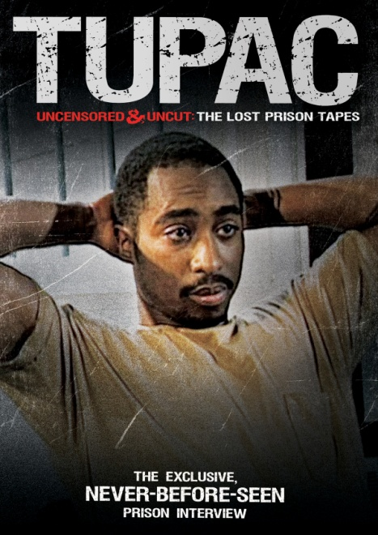

“TUPAC UNCENSORED AND UNCUT: THE LOST PRISON TAPES,”
AN UNGUARDED LOOK AT A LEGEND IN TRANSITION,
AVAILABLE JANUARY 25 ON DVD AND DIGITAL

Never-Before-Seen Interview with One of the
Recording Industry’s Most Enigmatic Stars

December 10, 2010 − In 1995, best-selling rap star and actor Tupac Shakur was serving time in the Clinton Correctional Facility in New York. Within two years he would be murdered. TUPAC UNCENSORED AND UNCUT: THE LOST PRISON TAPES, shot on location at Clinton Max, is unedited and has never before been released in its entirety.

TUPAC UNCENSORED AND UNCUT presents a raw look into Tupac’s world, as the music legend riffs on topics ranging from his involvement with gang life to prisons in America to his relationship with his mother. What emerges is a moving self-portrait of an artist who sees himself as fundamentally misunderstood: He may have diagnosed thug life, but he didn’t invent it, and he is determined to uplift—not destroy—the black community.

Capturing the intensity and passion of a fierce talent, TUPAC UNCENSORED AND UNCUT offers a glimpse inside the mind of the enigmatic artist whose music is, in his own words, “all about life.”

Shortly after leaving prison, Tupac Shakur released his multi-platinum album, Me Against the World. He died a year later. He remains one of the best-selling music artists of all time and the second highest-selling rap artist.

In 2011, Shakur would have been 40 years old. A major motion picture biography of Tupac, directed by Antoine Fuqua, is currently in production. American author and activist Kevin Powell recently announced he will begin writing Shakur’s first authorized biography.

TUPAC UNCENSORED AND UNCUT is directed by Ken Peters.

Pricing: $14.95 US/$16.95 CAN
Runtime: 44 minutes
Rating: N/A
Catalog #: NNVG236991
Language: English
Color: Color
Genre: Music, Documentary

About New Video
New Video is a leading independent privately-held distributor of quality entertainment via DVD, Blu-ray, download and streaming platforms, and cable VOD. We are the proud home to some of the most prestigious names in the industry like A&E®, HISTORY™, Lifetime®, Major League Baseball®, Scholastic Storybook Treasures™, Arthouse Films and Tribeca Film as well as our own lines Docurama Films®, and the newly launched Flatiron Film Company®. Since 1991, our mission has been to discover first-rate content and deliver to audiences through traditional platforms and evolving new media. We selectively handpick our library while collaborating directly with our brand partners and filmmakers to cultivate a superior product and fresh new viewing experiences for our audiences. We are headquartered in New York City, but have an international presence in 45 territories. www.newvideo.com.

For more information, please contact:
Sommer Hixson
646-259-4138
shixson@newvideo.com

For box art, please visit:
http://www.newvideo.com/flatiron-film-company/tupac-uncensored-and-uncut-the-lost-prison-tapes/

Or visit the Press Room at:
http://www.newvideo.com/pressroom/

