FOR IMMEDIATE RELEASE

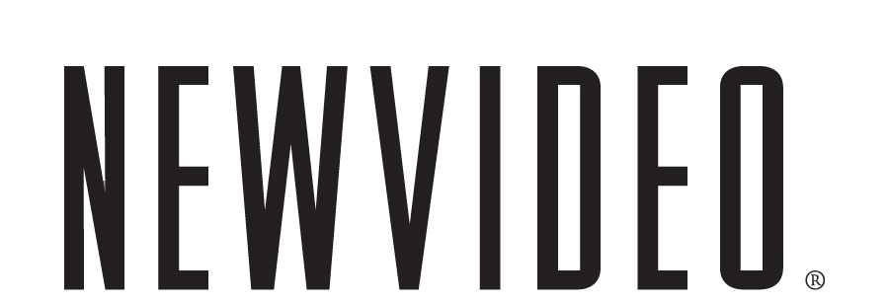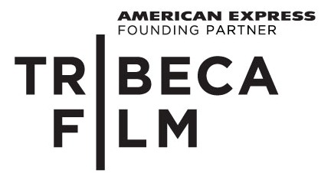

MAN GIVES BIRTH TO ELECTRIC BLUE FISH

THE IMMACULATE CONCEPTION OF LITTLE DIZZLE,
SPECIAL DELIVERY ON DECEMBER 14 FROM TRIBECA FILM AND NEW VIDEO
***
Stellar cast includes Natasha Lyonne (American Pie), Vincent Vieluf (An American Werewolf in Paris), Marshall Allman (True Blood) and Tania Raymonde (Lost)
***
“Like Clerks reimagined by William S. Burroughs. …Off the wall yet completely intelligible, Immaculate Conception mines existential commentary from toilet humor” – The New York Times

NEW YORK, October 21, 2010 – Midnight janitors, illegal focus groups, psychedelic cookies, religious awakenings, and male pregnancy. The Immaculate Conception of Little Dizzle combines all of these elements and more into what the Seattle Post Globe hails as “the most imaginative, disturbing, hilarious, and transcendent underground movie since Eraserhead.”
Dory, a computer programmer experiencing a crisis of faith, is laid off from his suit-and-tie job and must resort to cleaning toilets with a brown-collar band of janitorial misfits. Unbeknownst to him, he is made the subject of a bizarre experiment involving deliciously addictive cookies that simulate “oven freshness” by warming in your mouth when eaten. It turns out that the cookies cause spectacular visions, wild mood swings and quasi-pregnancies in the male janitors. The men must pull together to become midwives for one another as each gives birth to a small, beautiful, immaculately conceived blue fish creature.
Filmmaker David Russo (Blue Man Group: Mind Blast) delivers a quirky, humorous, dark and stylish meditation on the meaning of garbage in our throwaway society. The film features Russo’s unique visual design and animation, as well as a hallucinatory animation sequence by Dutch animator Rosto and a score by the cabaret ensemble Awesome. Edited by Billy McMillin (the Academy Award®-nominated Iraq in Fragments), and featuring a stellar ensemble cast, including Marshall Allman, Natasha Lyonne, Tania Raymonde, Tygh Runyan and Vince Vieluf, Little Dizzle is a bittersweet, post-modern fable.
“Major points for originality,” declares the Los Angeles Times. Campus Circle praises the film’s “spiritually eclectic, dizzyingly comedic narrative … the dark comedy really lets its artsy hair down.” Combustible Celluloid marvels, “Beyond all of this perverse imagination, disturbing imagery and dark laughs, Russo has somehow managed to make his flip-flopped ‘family’ theme work in spite of itself. It’s easy to fall genuinely in love with these poor souls and wish for the best for them, even as you watch them go through the worst.”
See the visually arresting film that premiered as an official selection of the Sundance Film Festival and has captivated audiences around the world with its singular look and feel.
The single disc comes with deleted scenes and interviews and commentaries featuring director David Russo.
The Immaculate Conception of Little Dizzle is one of 10 Tribeca Film titles scheduled to be distributed by New Video in 2010 and 2011. Tribeca Film is a distribution platform acquiring and releasing films year-round and is supported by Founding Partner American Express. The films range from award-winning dramas and revealing documentaries to uproarious comedies and stunning animated features, many of which premiered at the 2010 Tribeca Film Festival prior to theatrical runs in New York and Los Angeles. The films from the Tribeca Film slate were also available on video on demand in 40 million U.S. homes simultaneously with their Festival screenings through relationships with leading telecom, cable and satellite providers.
New Video plans to release one to two titles per month leading up to the 2011 Tribeca Film Festival.

Special Features
- My Tribeca Story with David Russo Presented by American Express
- An Interview with David Russo Presented by American Express
- Deleted Scenes
  - Dumpster
  - Dumpster with Commentary
  - Mini Fridge
  - Mini Fridge with Commentary
  - Bar Scene
  - Bar Scene with Commentary

THE IMMACULATE CONCEPTION OF LITTLE DIZZLE

Street Date: Dec. 14, 2010
Pricing: $24.95 U.S. (DVD)
Runtime: 104 minutes, plus bonus features
Rating: N/A
Catalog #: NNVG231550
Language: English
Color: Color
Audio Format: Single
Genre: Comedy
Distributor: Tribeca Film/New Video

About Tribeca Film
Tribeca Film is a comprehensive distribution platform dedicated to acquiring and marketing independent films across multiple platforms, including video-on-demand, theatrical and home video. It is an initiative from Tribeca Enterprises designed to provide new platforms for how film can be experienced, while supporting filmmakers and introducing audiences to films they might not otherwise see. American Express continues its support of Tribeca and the independent film community by serving as the Founding Partner of Tribeca Film.

About New Video®
New Video is a leading independent privately-held distributor of quality entertainment via DVD, Blu-ray, download and streaming platforms, and cable VOD. We are the proud home to some of the most prestigious names in the industry like A&E®, HISTORY™, Lifetime®, Major League Baseball®, Scholastic Storybook Treasures™, Arthouse Films and Tribeca Film as well as our own lines Docurama Films®, and the newly launched Flatiron Film Company®. Since 1991, our mission has been to discover first-rate content and deliver to audiences through traditional platforms and evolving new media. We selectively handpick our library while collaborating directly with our brand partners and filmmakers to cultivate a superior product and fresh new viewing experiences for our audiences. We are headquartered in New York City, and have an international presence in 45 territories. www.newvideo.com.

Press Contacts:
Sommer Hixson, New Video
646-259-4138/ shixson@newvideo.com

Dade Hayes, Rubenstein Communications
212-843-8022 /dhayes@rubenstein.com

Tammie Rosen, Tribeca Enterprises
212-941-2003/trosen@tribecaenterprises.com

