FOR IMMEDIATE RELEASE

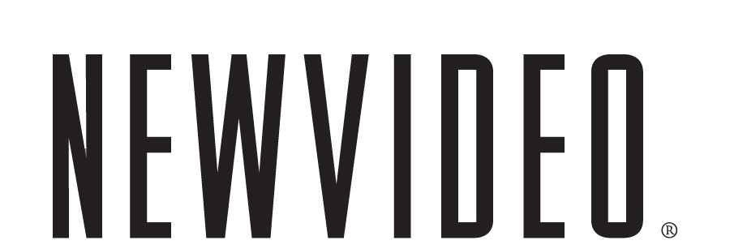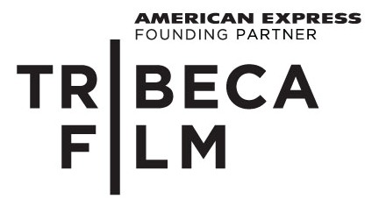

JAY BARUCHEL SEES RED IN THE TROTSKY

A REVOLUTIONARY TEEN FARCE FROM TRIBECA FILM AND NEW VIDEO, RELEASING ON DVD DECEMBER 14
***
The star of Tropic Thunder and Undeclared brings to hilarious life a high schooler who believes he is the reincarnation of Russian leader Leon Trotsky
***
“Even if you aren’t up on your Soviet history, The Trotsky is still hilarious and entertaining.”
-Screen Crave

NEW YORK, NOVEMBER 11, 2010 – An unusually intense teenager gets the idea that his name defines his destiny in the deliriously offbeat comedy, The Trotsky. Leon Bronstein (Jay Baruchel, Tropic Thunder) is a young man who has made the discovery that his birth name is the same as that of Leon Trotsky, the celebrated Russian revolutionary and socialist theorist. This coincidence leads Leon to believe that he is the reincarnation of his “namesake” and it is his destiny to follow the same path—an ironic predicament when you have rich parents and attend an upscale private school in Montreal.
When Leon's father (Saul Rubinek, Warehouse 13) gives his son a part-time job at the family clothing factory, within a day Leon is leading his fellow workers in a sit-down strike. His father isn’t amused so Leon is punished by being sent to public school. There, the aspiring Bolshevik finds new ways to battle fascism—in the form of Principal Berkhoff (Colm Feore, 24) and Mrs. Davis (Domini Blythe), a teacher eager to give detention to her students.
Leon's pursuit of social justice leads him to Frank (Michael Murphy, X-Men: The Last Stand), a burned-out activist turned college professor, and Frank’s thesis student, named Alexandra (Emily Hampshire) like Trotsky's great love, who Leon believes to be his future bride.
The Trotsky is “original and charming,” the Associated Press raves. “Certainly one of the best indie comedies I've seen in a while,” says Scott Weinberg of Cinematical. “… an apt and energetic soundtrack and a spark of witty confidence that most high school comedies don’t even bother with.” Agrees AMC’s Filmcritic.com, “… magnificent sight gags (an anti-fascist costume ball), an excellent cast and, perhaps most important, a refreshing originality that put it heads and shoulders above others of its ilk.”
The single disc comes with a trove of bonus features, including bloopers, deleted scenes, interviews and commentaries featuring director Jacob Tierney.
The Trotsky is one of 10 Tribeca Film titles scheduled to be distributed by New Video in 2010 and 2011. Tribeca Film is a distribution platform acquiring and releasing films year-round and is supported by Founding Partner American Express. The films range from award-winning dramas and revealing documentaries to uproarious comedies and stunning animated features, many of which premiered at the 2010 Tribeca Film Festival prior to theatrical runs in New York and Los Angeles. The films from the Tribeca Film slate were also available on video on demand in 40 million U.S. homes simultaneously with their Festival screenings through relationships with leading telecom, cable and satellite providers.
New Video plans to release one to two titles per month leading up to the 2011 Tribeca Film Festival.
Special Features
- Audio Commentary with Director Jacob Tierney and Editor Arthur Tarnowski
- My Tribeca Story with Jacob Tierney Presented by American Express
- On the Red Carpet with The Trotsky
- Bloopers
  - I Do Not Understand Politics
  - Les Canadiens
  - The Party People
- The Making of the Trotsky
- Deleted Scenes
  - Leon Leaves School (Alt Opening)
  - Extended Meeting Ahmed
  - Dad and Leon Argue
  - Girls' Revolution
  - Plotting the Kidnapping
  - Leon and Sarah Talk
  - Mon and Dad Talk
  - The Marriage Proposal
  - Leon Meets Alexandra (Alt Version)

THE TROTSKY

Street Date: Dec. 14, 2010
Pricing: $24.95 U.S. (DVD)
Runtime: 113 minutes, plus extras
Rating: N/A
Catalog #: NNVG231540
Language: English
Color: Color
Genre: Comedy/Satire
Distributor: Tribeca Film/New Video

About Tribeca Film
Tribeca Film is a comprehensive distribution platform dedicated to acquiring and marketing independent films across multiple platforms, including video-on-demand, theatrical and home video. It is an initiative from Tribeca Enterprises designed to provide new platforms for how film can be experienced, while supporting filmmakers and introducing audiences to films they might not otherwise see. American Express continues its support of Tribeca and the independent film community by serving as the Founding Partner of Tribeca Film.
About New Video®
New Video is a leading independent privately-held distributor of quality entertainment via DVD, Blu-ray, download and streaming platforms, and cable VOD. We are the proud home to some of the most prestigious names in the industry like A&E®, HISTORY™, Lifetime®, Major League Baseball®, Scholastic Storybook Treasures™, Arthouse Films and Tribeca Film as well as our own lines Docurama Films®, and the newly launched Flatiron Film Company®. Since 1991, our mission has been to discover first-rate content and deliver to audiences through traditional platforms and evolving new media. We selectively handpick our library while collaborating directly with our brand partners and filmmakers to cultivate a superior product and fresh new viewing experiences for our audiences. We are headquartered in New York City, but have an international presence in 45 territories. www.newvideo.com.

Press Contacts:
Sommer Hixson, New Video
646-259-4138/ shixson@newvideo.com

Dade Hayes, Rubenstein Communications
212-843-8022 /dhayes@rubenstein.com

Tammie Rosen, Tribeca Enterprises
212-941-2003/trosen@tribecaenterprises.com

