FOR IMMEDIATE RELEASE


presents

“MICHAEL TILSON THOMAS: THE THOMASHEFSKYS”

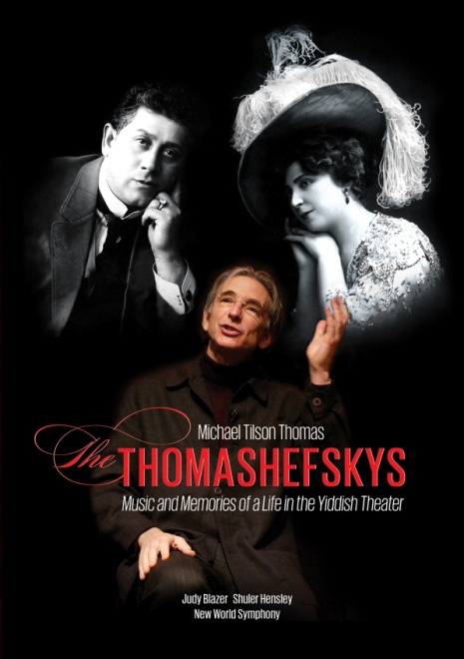

Live Musical Broadcast available April 24 on DVD and Digital Following
PBS “Great Performances” Television Premiere

“Thomas and his collaborators do what Yiddish artists always meant to do. They make you forget your troubles for an evening, plunge into another world and feel your own more fully in the end.” –San Francisco Chronicle

March 21, 2012 – New York, New York –“Tonight we’re here to tell you a story. It’s the story of Boris and Bessie Thomashefsky, two kids from little shtetls in the middle of the Ukrainian nowhere who came to America and became the founders and pioneers of the American Yiddish Theater… they also happened to be my grandparents.”

So begins MICHAEL TILSON THOMAS: THE THOMASHEFSKYS, written, hosted and conducted by Michael Tilson Thomas. A live performance recorded in April 2011 at the New World Center in Miami with the New World Symphony, America’s Orchestral Academy, THE THOMASHEFSKYS presents the life stories of Boris and Bessie Thomashefsky, founding members of the Yiddish Theater in America. The Thomashefskys owned theaters, published their own magazine, wrote columns in the popular Yiddish newspapers, sponsored and encouraged generations of young artists, brought countless Yiddish artists to America, tirelessly raised funds for progressive social causes and, through it all, were adventurous trendsetters.

Created in association with The Thomashefsky Project, THE THOMASHEFSKYS stage show has been performed to sold-out houses in San Francisco, Chicago, Los Angeles, Philadelphia, Miami, at Carnegie Hall in New York, and at the Tanglewood Music Center in Massachusetts. Directed by Broadway veteran, Patricia Birch, who created the work with Tilson Thomas, it features music reconstructed from the original Yiddish theater repertoire interwoven with projected images and dramatized stories from Bessie and Boris’s lively memoirs. Tilson Thomas hosts the performances with personal affection and wry humor that brings his grandparents back to life and salutes their remarkable spirit and legacy.

The story is woven together through the music and songs of the Yiddish theater, showcasing a musical sound that assimilates Eastern European klezmer and cantorial modes with American tones and rhythms. Over time, as the Jewish American music theater writers became absorbed in their new surroundings, they greatly influenced the American Songbook and this legacy is also captured in this stunning performance.

Judy Blazer and Shuler Hensley star as Bessie and Boris Thomashefsky. Ronit Widmann-Levy and Eugene Brancoveanu play supporting roles. The broadcast, The Thomashefskys: Music and Memories of a Life in the Yiddish Theater – premiering on March 29 on PBS’ “Great Performances” series at 8:00 PM (check local listings), is directed by Gary Halverson; Joshua Robison, Michael Bronson and Michael Kantor, producers. DVD extras include additional music performances, an interview with Tilson Thomas, and a feature on the New World Symphony, which was founded in 1987 by Tilson Thomas and Ted Arison.

MICHAEL TILSON THOMAS: THE THOMASHEFSKYS

Pricing: $29.95 US/$34.95 CAN
Runtime: 135 mins. + extras
Rating: NA
Catalog #: NNVG268540
Language: English
Color: Color
Audio Format: Dolby Digital 5.1 Stereo
Genre: Documentary, Music

About Docurama Films
In 1999, NEW VIDEO launched Docurama Films® with the first feature documentary ever available on DVD: D.A. Pennebaker’s Bob Dylan: Dont Look Back. Twelve years and 300 award-winning, highly-acclaimed titles later, Docurama continues to discover and release the greatest non-fiction films of our time while spreading the word about filmmakers who are taking the form to new heights. Docurama’s catalog features an topics including the performing and visual arts, history, politics, the environment, ethnic and gender interests, and all-time favorites including The Wild Parrots of Telegraph Hill, Andy Goldsworthy: Rivers and Tides and King Corn. Recent titles include Oscar®-nominated films GasLand and Hell and Back Again. www.docuramafilms.com

About New Video
New Video is a leading entertainment distributor and the largest aggregator of independent digital content worldwide. Headquartered in New York City, with an international presence in 45 territories, the company delivers feature films, TV programs and web originals via digital download, streaming, video-on-demand, Blu-ray, DVD, and theatrical release. In 2011, New Video bowed Oscar®-nominated Hell and Back Again and South American blockbuster Elite Squad: The Enemy Within in US theaters. Through a new partnership with digital exhibitor Cinedigm Entertainment Group, New Video is poised to bring more independent films to theaters nationwide. New Video streamlines distribution and marketing for filmmakers and partners, bringing a wide variety of fresh content to new audiences. The company’s library includes original TV series and movies from A+E® Home Entertainment, HISTORY™, and Lifetime®, unforgettable games and trophy sets from Major League Baseball®, storybook treasures from Scholastic®, award-winning documentaries from Docurama Films®, next-gen indies from Flatiron Film Company®, and acclaimed independent films and festival picks through partnerships with the Sundance Institute and Tribeca Film. New Video is proud to distribute many Oscar®-nominated documentaries including GasLand, Waste Land, Paradise Lost 3: Purgatory and Hell and Back Again.

For more information, please contact:
Luis Garza; 646-259-4144;
lgarza@newvideo.com

For Box Art:
http://www.newvideo.com/docurama/michael-tilson-thomas-the-thomashefskys/

