FOR IMMEDIATE RELEASE


presents

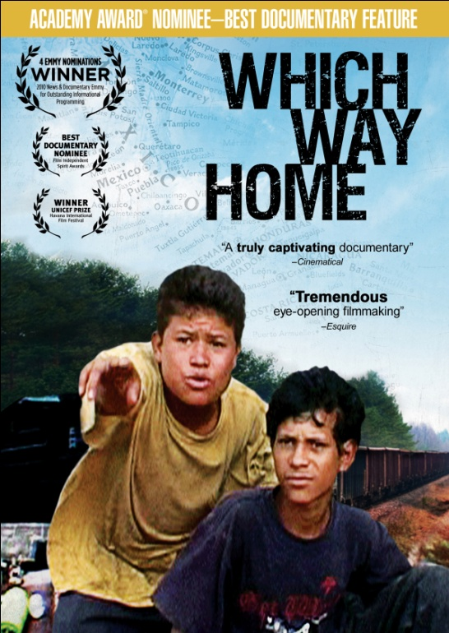

2010 ACADEMY AWARD® NOMINEE FOR BEST DOCUMENTARY,
WHICH WAY HOME, TO BE RELEASED ON DVD, DIGITAL & VOD ON JANUARY 25

“An unflinching look at the world of Central American child migrants.”—
The Wall Street Journal

December 20, 2010 – Traversing more than 1,450 miles upcountry, Mexican freight trains routinely are boarded by migrants hoping to reach the United States. Among the thousands who ride the trains, many are children traveling alone. They come from all over Mexico and Central America, risking everything for the chance of a better life. WHICH WAY HOME, a film by Rebecca Cammisa that follows these children on their journey above freight trains, received rave reviews and numerous awards, including the 2010 Emmy® Award for Outstanding Informational Programming, the Robert F. Kennedy Journalism Award Grand Prize, and was nominated for a 2010 Independent Spirit Award for Best Documentary in addition to three more Emmy® Awards.

These children leave home without saying goodbye to their loved ones or simply leave a written letter stating their purpose of reaching the United States. Kevin, Yurico, Olga, Freddy and others share their ambitions, frustrations disappointments and sorrows as their ride continues over months, sometimes years.
WHICH WAY HOME premiered on HBO in August 2009, and was featured in over 20 film festivals, including the 2009 Tribeca Film Festival and the 2009 Los Angeles Film Festival.

In an HBO interview, Ms. Cammisa explains her motivation for creating the film and what she hopes the audience will take away:

“I want this film to be used as a tool for creating immigration reform in the Unites States and Mexico because children are suffering and even dying while migrating north. What side of the immigration debate you’re on doesn’t really matter to me. What matters is that the public-at-large is provided visual documentation that enables them to really see what is going on. Hopefully once people watch this film, they will gain a clearer understanding and compassion for the people who are trying to get here.”

Breathtaking views of Mexico’s luscious scenery serves as a backdrop for the film as some children travel on top of freight trains, moving toward their final destination. Despite their circumstances, these children remain hopeful, vigilant and determined to risk everything for a better life.

The DVD from Docurama Films features two Spanish versions of the film: one subtitled in English, with English title cards, and one non-subtitled, with Spanish title cards. Menus are also in English and Spanish. Bonus features include deleted scenes and additional information on the National Center for Refugee and Immigrant Children.
WHICH WAY HOME is directed and produced by Rebecca Cammisa; edited by Pax Wassermann and Madeleine Gavin. Executive produced by Lianne Halfon, John Malkovich and Russell Smith of Mr. Mudd.

Pricing: $29.95 US
Runtime: 83 mins., plus extras
Rating: N/A
Catalog #: NNVG237000
Language: Spanish; Spanish with English subtitles
Color: Color
Audio Format: Dolby Digital 2.0 Stereo
Genre: Documentary

About Mr. Mudd
In 1998, Lianne Halfon, John Malkovich and Russell Smith joined together to create the production company Mr. Mudd, whose first production was the notable Ghost World, directed by Terry Zwigoff, based on the comic by Daniel Clowes. Mr. Mudd followed this up with Malkovich’s feature directorial debut, The Dancer Upstairs, starring Academy Award® winner Javier Bardem. Among other credits are the plays Libra (Steppenwolf Theater, Chicago) and The Good Canary (El Teatro de Los Insurgentes, Mexico City). Film credits include: The Libertine, Art School Confidential, How to Draw a Bunny and Juno. Distributed through Fox Searchlight, Juno received an Academy Award® for Best Original Screenplay (Diablo Cody) and three other nominations, for Best Motion Picture, Best Actress (Ellen Page) and Best Director (Jason Reitman). Most recently, Mr. Mudd partnered with Reitman’s Right of Way Films to produce the latest Duplass Brothers comedy, Jeff, Who Lives At Home, starring Jason Segel and Ed Helms, as well as Reitman’s Young Adult, penned by Cody and starring Charlize Theron.
In 2005, Dir. Rebecca Cammisa sent Halfon, Malkovich and Smith footage of nine-year-old Salvadoran, Jose, abandoned by his smugglers and alone at a Mexican detention center. Since then, Mr. Mudd has partnered with Cammisa to produce Which Way Home and leverage the film to spread awareness and facilitate action and advocacy for unaccompanied minor migrants traveling through Latin America.
About Docurama Films
Docurama Films is dedicated to making critically acclaimed and cutting-edge documentaries available digitally and on home video. In 1999, New Video launched Docurama Films with the release of the first feature documentary on DVD, D.A. Pennebaker’s Bob Dylan: Don’t Look Back. Over a decade later and a line of over 250 award-winning and highly acclaimed documentary titles, Docurama continues its mission to unearth and release the great classic documentaries of the last fifty years while spreading the word about filmmakers who are taking the form to new heights. The Docurama catalog features a wide span of titles from varying genres including the arts, history/politics, environmental, ethnic interest, LGBT, music, and socio-cultural as well as theatrical fan-favorites like The Wild Parrots of Telegraph Hill and Andy Goldsworthy: Rivers and Tides. Releases in 2010 include the screwball comedy The Yes Men Fix the World, the empowering music celebration Soundtrack for a Revolution and the crowd-pleasing Best Worst Movie. www.docuramafilms.com

About New Video
New Video is a leading independent privately-held distributor of quality entertainment via DVD, Blu-ray, download and streaming platforms, and cable VOD. We are the proud home to some of the most prestigious names in the industry like A&E®, HISTORY™, Lifetime®, Major League Baseball®, Scholastic Storybook Treasures™, Arthouse Films and Tribeca Film as well as our own lines Docurama Films®, and the newly launched Flatiron Film Company®. Since 1991, our mission has been to discover first-rate content and deliver to audiences through traditional platforms and evolving new media. We selectively handpick our library while collaborating directly with our brand partners and filmmakers to cultivate a superior product and fresh new viewing experiences for our audiences. We are headquartered in New York City, but have an international presence in 45 territories. www.newvideo.com.

For more information, please contact:
Sommer Hixson
646-259-4138
shixson@newvideo.com

For box art, please visit:
http://www.newvideo.com/docurama/which-way-home

Or visit the Press Room at:
http://www.newvideo.com/pressroom/

