**FOR IMMEDIATE RELEASE**



presents

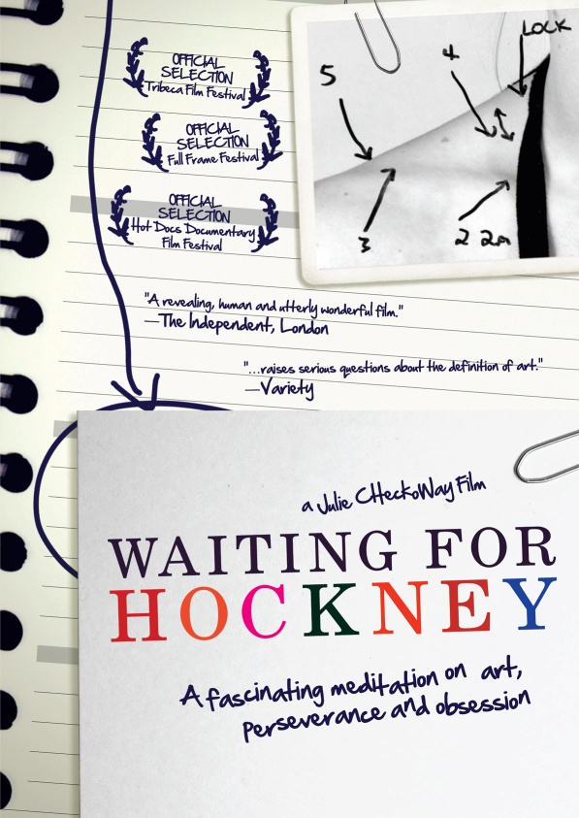

***WAITING FOR HOCKNEY* TO BE RELEASED ON DVD & DIGITAL ON FEBRUARY 22**

**A fascinating meditation on art, perseverance and obsession,**

**directed by NPR and PRI correspondent, Julie Checkoway**

***January 19, 2011*** – One might describe 38-year-old Maryland artist Billy Pappas as stubborn, egotistic or even psychotic. Sure, he might be all three, but there’s one admirable creative quality that shines through the rest: driven.

A lively tribute to art, to dreams and to life, ***WAITING FOR HOCKNEY*** illuminates both the perils and payoffs of one man single-mindedly pursuing his dream to its ultimate conclusion.

Fueled by an intense study on human anatomy and exquisite attention to detail, or as Pappas describes, “working within the area of a period in a newspaper,” he devotes *eight years and five months full-time to a single drawing* hoping to create the “next major art movement in America.” After the completion of his portrait, he reaches out to renowned contemporary artist David Hockney, who Pappas believes is the one person that can determine his success in the art world.

The film is narrated by Pappas and features interviews with friends, family and eccentric characters who support him in his risky endeavor, as well as trusted confidantes to Hockney himself. Because of Checkoway’s profession as a radio producer and reporter, ***WAITING FOR HOCKNEY*** was originally conceived as an audio piece. After consulting with several contacts in the film industry, she decided that the themes in Pappas’s story would be better served by a visual medium.

While working with Pappas, Checkoway felt an instant rapport because of their compatible working-class background.

"It's an amazing thing, but is it art?'" Checkoway said in an interview with *The* *New York Times*. "The film is about that, but more than anything, who cares? Is it beautiful? Is it affecting? Is it worth talking about? I can't answer those questions; it's up to me to raise them in the film.”

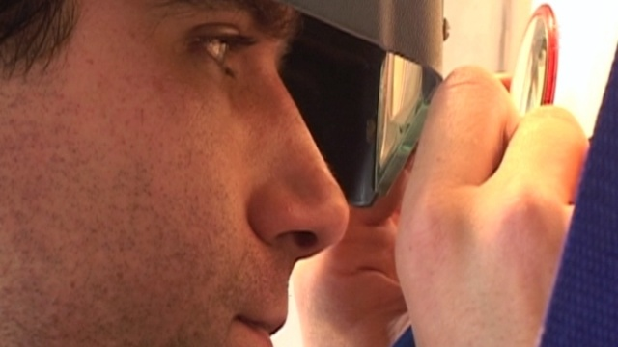

***WAITING FOR HOCKNEY*** premiered on the Sundance Channel in November 2009 and was an official entry in more than a dozen film festivals, including the 2008 Tribeca Film Festival.

*The Independent* of London raves that ***WAITING FOR HOCKNEY*** is, “A revealing, human and utterly wonderful film."*Variety* concurs the film, “...raises serious questions about the definitions of art."

***WAITING FOR HOCKNEY*** is directed and produced by Julie Checkoway; edited by Chris A. Peterson; written by Julie Checkoway, Chris A. Peterson & Neal Checkoway; executive produced by Michael Lesser.

Pricing: $29.95 US

Runtime: 78 mins., plus extras

Rating: N/A

Catalog #: NNVG237321

Language: English

Color: Color

Audio Format: Dolby Digital 2.0 Stereo

Genre: Documentary

**About Docurama Films**

Docurama Films is dedicated to making critically acclaimed and cutting-edge documentaries available digitally and on home video. In 1999, New Video launched **Docurama Films** with the release of the first feature documentary on DVD, D.A. Pennebaker’s Bob Dylan: Don’t Look Back. Over a decade later and a line of over 250 award-winning and highly acclaimed documentary titles, Docurama continues its mission to unearth and release the great classic documentaries of the last fifty years while spreading the word about filmmakers who are taking the form to new heights.  The Docurama catalog features a wide span of titles from varying genres including the arts, history/politics, environmental, ethnic interest, LGBT, music, and socio-cultural as well as theatrical fan-favorites like The Wild Parrots of Telegraph Hill and Andy Goldsworthy: Rivers and Tides. Recent releases include *Gasland*, *The Age of Stupid, Soundtrack for a Revolution* and Best Worst Movie. [www.docuramafilms.com](http://www.docuramafilms.com)

**About New Video**

New Video is a leading independent privately-held distributor of quality entertainment via DVD, Blu-ray, download and streaming platforms, and cable VOD. We are the proud home to some of the most prestigious names in the industry like A&E®, HISTORY™, Lifetime®, Major League Baseball®, Scholastic Storybook Treasures™, Arthouse Films and Tribeca Film as well as our own lines Docurama Films®, and the newly launched Flatiron Film Company®. Since 1991, our mission has been to discover first-rate content and deliver to audiences through traditional platforms and evolving new media. We selectively handpick our library while collaborating directly with our brand partners and filmmakers to cultivate a superior product and fresh new viewing experiences for our audiences. We are headquartered in New York City, but have an international presence in 45 territories. [www.newvideo.com](http://www.newvideo.com).

**For more information, please contact:**

Sommer Hixson

646-259-4138

shixson@newvideo.com

For box art, please visit:

<http://www.newvideo.com/docurama/waiting-for-hockney/>

Or visit the Press Room at:

<http://www.newvideo.com/pressroom/>