**FOR IMMEDIATE RELEASE**



presents



***COLONY*, AN EXAMINATION OF THE MYSTERIOUS WORLD OF BEES,**

**TO BE RELEASED ON DVD & DIGITAL ON MARCH 29**

**Our Survival Depends on Theirs**

**“Filmed with the elegant attention to composition worthy of Terrence Malick.”**

**—*The Washington Post***

***February 3, 2011*** – Few people realize that honey bees pollinate one-third of our fruits and vegetables. In fact, these incredible insects play a vital role in producing our food and ensuring our survival.

Although honey bees are some of the most resilient, efficient and industrious insects, entire colonies are dying off. Why? ***COLONY*** investigates the circumstances and the impacts of “colony collapse disorder” by focusing on beekeepers dealing with the crisis. As these families and individuals struggle to understand this lethal problem, they illuminate the devastating effects of bee extinction not just on bees, but on people.

***COLONY*** documents a time of unprecedented crisis in the world of the honeybee through the eyes of seasoned beekeeper David Mendes and Lance and Victor Seppi, two young brothers getting into beekeeping at a time when most are getting out. As Mendes tries to save the nation’s collapsing hives, the Seppis try to keep their business alive amidst a collapsing economy.

An eye-opening account of a little-known yet essential, sub-culture in America, ***COLONY*** brings to life the fascinating world of bees—and the frightening possibility of their disappearance. Capturing breathtaking views of the countryside and with meticulous attention to detail, ***COLONY*** is cinematography at its best and most dramatic.

***COLONY*** has received numerous awards including the Grand Jury Prize at the Anaheim International Film Festival and the Best First Appearance Award at the International Documentary Film Festival in Amsterdam.

Variety says, "The mischievous genius of '**COLONY**' lies in the fact that bees don't serve as a metaphor for people as much as people serve as a metaphor for bees.”

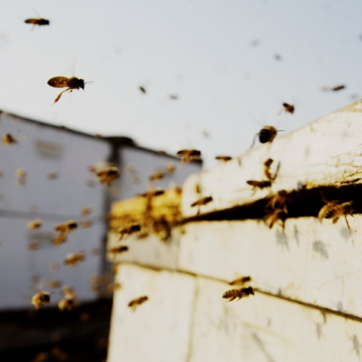

***COLONY*** is directed by Carter Gunn and Ross McDonnell; produced by Morgan Bushe and Macdara Kelleher; edited by Carter Gunn.

Pricing: $29.95 US

Runtime: 88 mins.

Rating: NR

Catalog #: NNVG238400

Language: English

Color: Color

Audio Format: Dolby Digital 2.0 Stereo

Genre: Documentary

**About Docurama Films**

Docurama Films is dedicated to making critically acclaimed and cutting-edge documentaries available digitally and on home video. In 1999, New Video launched **Docurama Films** with the release of the first feature documentary on DVD, D.A. Pennebaker’s Bob Dylan: Don’t Look Back. More than a decade later and a library of more than 250 award-winning, highly acclaimed documentary titles, Docurama continues its mission to unearth and release the great classic documentaries of the last fifty years while spreading the word about filmmakers who are taking the form to new heights.  The Docurama catalog features a roster of titles from genres including the arts, history, politics, environmental, ethnic interest, LGBT, music, and socio-cultural, as well as theatrical fan-favorites like The Wild Parrots of Telegraph Hill and Andy Goldsworthy: Rivers and Tides. Recent releases include *Gasland*, *The Age of Stupid* and Best Worst Movie. [www.docuramafilms.com](http://www.docuramafilms.com)

**About New Video**

New Video is a leading independent privately-held distributor of quality entertainment via DVD, Blu-ray, download and streaming platforms, and cable VOD. We are the proud home to some of the most prestigious names in the industry like A&E®, HISTORY™, Lifetime®, Major League Baseball®, Scholastic Storybook Treasures™, Arthouse Films and Tribeca Film as well as our own lines Docurama Films®, and the newly launched Flatiron Film Company®. Since 1991, our mission has been to discover first-rate content and deliver to audiences through traditional platforms and evolving new media. We selectively handpick our library while collaborating directly with our brand partners and filmmakers to cultivate a superior product and fresh new viewing experiences for our audiences. We are headquartered in New York City, but have an international presence in 45 territories. [www.newvideo.com](http://www.newvideo.com).

**For more information, please contact:**

Sommer Hixson

646-259-4138

shixson@newvideo.com

For box art, please visit:

<http://www.newvideo.com/docurama/colony/>

Or visit the Press Room at:

<http://www.newvideo.com/pressroom/>