**FOR IMMEDIATE RELEASE**



presents

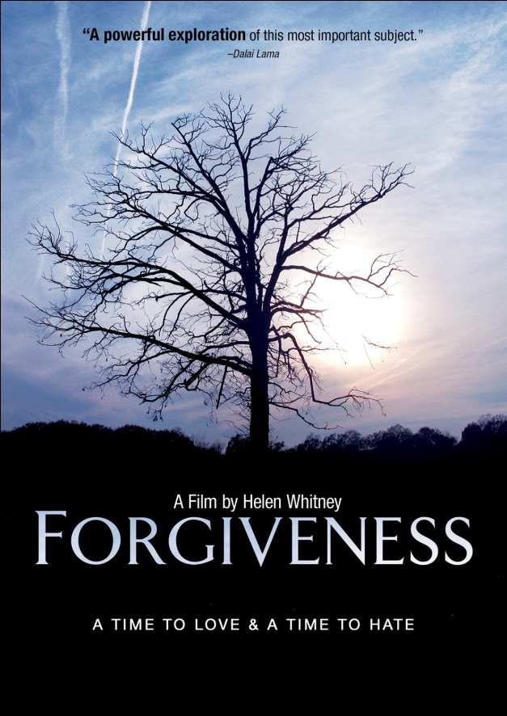

***FORGIVENESS: A TIME TO LOVE & A TIME TO HATE*,**

**AVAILABLE APRIL 26 ON DIGITAL & DVD**

**“Forgiveness is elusive, mysterious, primal… an idea and an ache that is rooted in existential concerns. This film is meant to raise questions, not provide answers.”**

**−Helen Whitney, Oscar**®-**Nominated and Emmy**® **-Winning Director**

***March 30, 2011*** – The new role of forgiveness in the world raises serious and complex questions: Why is it in the air today as never before? Has it been cheapened, or deepened, or both? What does this say about us and the times we live in?

Releasing on Digital and DVD on April 26, ***FORGIVENESS: A TIME TO LOVE AND A TIME TO HATE***, a documentary in two acts, explores the power, limitations and, in rare cases, dangers of forgiveness. Award-winning director Helen Whitney’s comprehensive film covers a range of personal and political stories – from emotional betrayal and physical violence to a nation's struggle to reconcile after genocide. In focusing on specific instances of affliction, ***FORGIVENESS*** hones in on the complexities of these acts and how they affect our lives and our relations with others.

“Whether we believe forgiveness comes from God or man, that it comes with conditions or is freely given, what is indisputable is that its power is real, and that it is sweeping and even immodest in its reach,” says Whitney.

**“A powerful exploration of this most important subject.” – The Dalai Lama**

[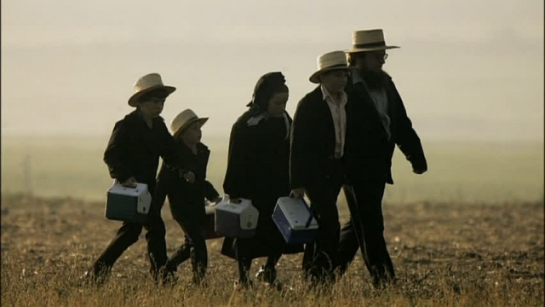](http://www.newvideo.com/docurama/forgiveness/)

The film is divided into two acts:

**Act One:** The private realm: Personal stories include the unconditional forgiveness of the Amish immediately following the shooting at Nickel Mines schoolhouse – and the Jewish response to it; Kathy Power and her struggle to understand and atone for her violent revolutionary actions in the radical era of the 60s; the destructive consequences of a too-easy forgiveness offered by a young victim of a brutal assault; and the forgiveness that “saved the life” of an AIDS victim.

**Act Two:** The political realm. Forgiveness and its close cousins, reconciliation and apology, have an ever growing political dimension: they have migrated into the lives of nations. Act Two explores stories from around the world, including: modern Germany's penitential journey; Rwanda's genocide and attempts to reconcile; South Africa's Truth and Reconciliation commission; Australia's recent and remarkably effective apology to the Aborigines; and Turkey's failure to acknowledge and apologize to the Armenians.

The documentary will air as a two-part series on PBS stations nationwide on Sunday, April 17 and 24 at 10 p.m. ET. A companion book authored by Whitney will publish early April, with a preface by the Dalai Lama.

***FORGIVENESS*** is directed, written and produced by Helen Whitney; executive produced by Paul Dietrich and Ian Watson; edited by Ted Winterburn. The DVD includes extended bonus sequences.

Pricing: $29.95 US

Runtime: 168 mins. + extras

Rating: NR

Catalog #: NNVG242731

Language: English

Color: Color

Audio Format: Dolby Digital 2.0 Stereo

Genre: Documentary

**About Docurama Films**

In 1999, **NEW VIDEO** launched **Docurama Films**® with the first feature documentary available on DVD: D.A. Pennebaker’s *Bob Dylan: Dont Look Back.* Twelve years and 250 award-winning, highly-acclaimed documentary titles later, Docurama continues to discover and release the greatest non-fiction films of our time while spreading the word about filmmakers who are taking the form to new heights.  Docurama’s catalog features an array of topics including the performing and visual arts, history, politics, the environment, ethnic and gender interests, and all-time favorites including *The Wild Parrots of Telegraph Hill*, *Andy Goldsworthy:* *Rivers and Tides* and *King Corn.* Recent releases include *The End of the Line*, *William Kunstler: Disturbing the Universe*, *Best Worst Movie,* the 2011 Oscar®-nominated film*, Gasland,* and the first-ever Blu-ray release of *Dont Look Back*.

**About New Video**

Celebrating its 20th anniversary in 2011, New Video is a leading entertainment distributor and the largest aggregator of independent digital content worldwide. Headquartered in New York City, with an international presence in 45 territories, the company delivers feature films, TV programs and web originals via digital download, streaming media, video-on-demand, Blu-ray and DVD. New Video streamlines the distribution and marketing process for filmmakers, producers and brand partners to bring a wide variety of fresh content to new audiences. The company’s library includes original TV series and movies from A&E®, HISTORY™, and Lifetime®, unforgettable games and trophy sets from Major League Baseball®, storybook treasures from Scholastic®, award-winning documentaries from Docurama Films®, Arthouse Films, and Plexifilm, next-gen indies and web hits from Flatiron Film Company® and festival picks from Tribeca Film. New Video is proud to distribute the 2011 Oscar®-nominated films *Gasland, Waste Land* and, on digital, *Restrepo*.

[www.newvideo.com](http://www.newvideo.com).

**For more information, please contact:**

Sommer Hixson

646-259-4138

shixson@newvideo.com

For box art, please visit:

<http://www.newvideo.com/docurama/forgiveness/>

Or visit the Press Room at:

<http://www.newvideo.com/pressroom/>