**FOR IMMEDIATE RELEASE**



presents

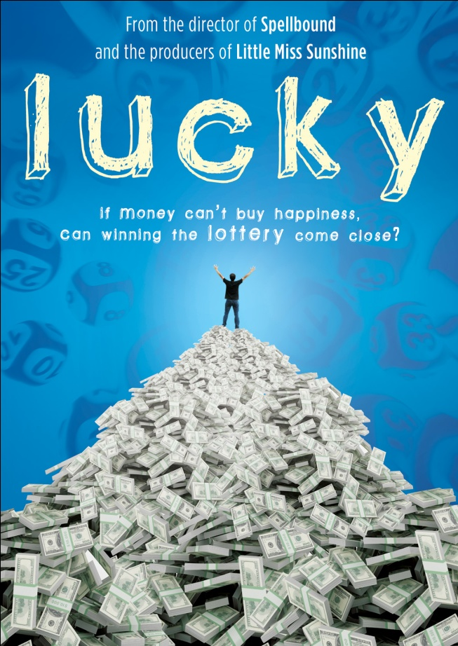

**FROM THE DIRECTOR OF *SPELLBOUND* AND THE PRODUCERS**

**OF *LITTLE MISS SUNSHINE*, *LUCKY* RELEASES APRIL 26**

**A DOCUMENTARY ABOUT THE WORLD OF LOTTERY WINNERS,**

**AVAILABLE ON DVD**

**“A film that glows with optimism even as it reveals the dark side of a miracle.” - *Variety***

***March 3, 2011*** – Americans spend about $62 billion dollars every year on lottery tickets, making the daily ritual the most popular form of paid entertainment. For better or worse, ticket buyers fantasize about winning and the many things money can buy. What they don’t think about as much are the consequences of such a windfall.

From Oscar ® -nominated and Emmy ® -winning director Jeff Blitz (*Spellbound*) and the producers of *Little Miss Sunshine,* ***LUCKY*** tells the story of five lottery winners and the effects of winning the jackpot on their lives:

* Quang – a Vietnamese immigrant and one of eight ConAgra Foods employees in Nebraska who took home $22 million after sharing the winning Powerball ticket worth $365 million, the largest prize ever awarded in 2006.
* James – an unemployed man who spent his last $3 on the Illinois state lottery and won $5.5 million.
* Kristine and Steve – a middle class suburban New Jersey couple who won the Pennsylvania Powerball lottery and took home $110 million.
* Robert – a mathematician with a PhD who won $22 million in the California lottery.
* Buddy – a former carnival-ride operator who won $16 million in the Pennsylvania lottery.

***LUCKY*** also includes interviews with aspiring lottery winners such as Verna from Newark, Delaware who spends nearly $100 a day on lottery tickets. Fascinating facts about the lottery are also revealed in the film – the chances of winning a Powerball jackpot are one in almost 200 million.

P:\Materials\NVG Materials\Materials by Title\Docurama Films\Lucky\HBO Final Art\Links\penssylvaniawhites.tif

***LUCKY*** premiered on HBO in July 2010 to critical attention:

“Such is the seductive nature of the lottery that after watching *Lucky,* an HBO documentary chronicling the many, and often sobering, effects winning a big jackpot can have on a person, it is difficult to resist the temptation to rush out and buy a ticket.” – *Los Angeles Times.*

***LUCKY*** is directed by Jeffrey Blitz and produced by Sean Welch, Jeffrey Blitz, Marc Turtletaub, Peter Saraf and Jeb Brody; executive produced by Rebecca Morton, Liz Manne and Catherine Tait; edited by Yana Gorskaya. The DVD featuresdeleted scenes from the film.

Pricing: $29.95 US

Runtime: 82 mins. + extras

Rating: NR

Catalog #: NNVG241251

Language: English

Color: Color

Audio Format: Dolby Digital 2.0 Stereo

Genre: Documentary

**About Docurama Films**

Docurama Films is dedicated to making critically acclaimed and cutting-edge documentaries available digitally and on home video. In 1999, New Video launched **Docurama Films** with the release of the first feature documentary on DVD, D.A. Pennebaker’s Bob Dylan: Don’t Look Back. More than a decade later and a library of more than 250 award-winning, highly acclaimed documentary titles, Docurama continues its mission to unearth and release the great classic documentaries of the last fifty years while spreading the word about filmmakers who are taking the form to new heights.  The Docurama catalog features a roster of titles from genres including the arts, history, politics, environmental, ethnic interest, LGBT, music, and socio-cultural, as well as theatrical fan-favorites like The Wild Parrots of Telegraph Hill and Andy Goldsworthy: Rivers and Tides. Recent releases include *Gasland*, *The Age of Stupid* and Best Worst Movie. [www.docuramafilms.com](http://www.docuramafilms.com)

**About New Video**

New Video is a leading independent privately-held distributor of quality entertainment via DVD, Blu-ray, download and streaming platforms, and cable VOD. We are the proud home to some of the most prestigious names in the industry like A&E®, HISTORY™, Lifetime®, Major League Baseball®, Scholastic Storybook Treasures™, Arthouse Films and Tribeca Film as well as our own lines Docurama Films®, and the newly launched Flatiron Film Company®. Since 1991, our mission has been to discover first-rate content and deliver to audiences through traditional platforms and evolving new media. We selectively handpick our library while collaborating directly with our brand partners and filmmakers to cultivate a superior product and fresh new viewing experiences for our audiences. We are headquartered in New York City, but have an international presence in 45 territories. [www.newvideo.com](http://www.newvideo.com).

**For more information, please contact:**

Sommer Hixson

646-259-4138

shixson@newvideo.com

For box art, please visit:

<http://www.newvideo.com/docurama/lucky/>

Or visit the Press Room at:

<http://www.newvideo.com/pressroom/>