

**“PICASSO AND BRAQUE GO TO THE MOVIES,” DIRECTED BY ARNE GLIMCHER**

**AND PRODUCED BY MARTIN SCORSESE, RELEASES ON DIGITAL AND DVD MAY 24**

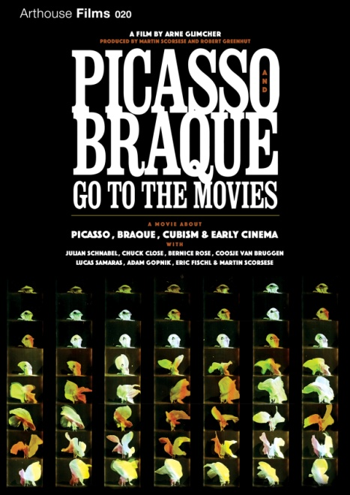

Inspired by a large-scale multimedia exhibit he curated in 2007, legendary Pace Gallery founder and filmmaker, Arne Glimcher (“The Mambo Kings”), joined forces with Oscar®-winning director Martin Scorsese to produce ***PICASSO AND BRAQUE GO TO THE MOVIES***, a discursive documentary about cinema’s influence on the legendary Cubist artists.

Released theatrically in 2010, ***PICASSO AND BRAQUE*** takes viewers on a guided tour led by Scorsese of the effects of the technological revolution, specifically the invention of aviation and the creation of cinema and their interdependent influence on the forefathers of Cubism. Interwoven with a stunning display of iconic art of this period and early cinema clips, the film studies the collision between the two creative forms at the turn of the 20th Century and helps us to realize cinema's continuing influence on the art of our time. This symbiotic relationship is further examined through interviews with scholars, including Adam Gopnik (*The New Yorker*) and Picasso biographer John Richardson, and with artists including Chuck Close, Julian Schnabel and Eric Fischl.

“The deepest resemblances between what Picasso and Braque were doing and what the first filmmakers were doing comes in the sense of permissions given, old restrictions removed, possibilities open.” − Adam Gopnik.

Bonus features on the DVD include more than 80 minutes of classic film, including “Slippery Jim” (1910), “The Great Train Robbery” (1903), and “Frankenstein” (1910).

“Informative and inspirational…a must-see for lovers of both art and film. – *The Daily Beast*

"Transports us to Paris at the turn-of-the-century, when exciting new technology involved new forms of movement.” – *The Wall Street Journal*

Pricing: $29.95 US

Runtime: 62 mins. + extras

Rating: NR

Catalog #: NNVG230330

Language: English

Color: Color/Black and White

Audio Format: Dolby Digital 2.0 Stereo

Genre: Documentary

**About Arthouse Films**

Arthouse Films is an independent production and distribution label based in New York and Los Angeles that acquires, produces, co-produces, markets, and distributes 20-plus titles per year. Current films include the 2011 Oscar®-nominated documentary, *Waste Land*,

*Herb & Dorothy*, *Chuck Close*, *Visual Acoustics: the Modernism of Julius Shulman* and *Jean-Michel Basquiat: The Radiant Child*, among others.

**About New Video**

Celebrating its 20th anniversary in 2011, New Video is a leading entertainment distributor and the largest aggregator of independent digital content worldwide. Headquartered in New York City, with an international presence in 45 territories, the company delivers feature films, TV programs and web originals via digital download, streaming media, video-on-demand, Blu-ray and DVD. New Video streamlines the distribution and marketing process for filmmakers, producers and brand partners to bring a wide variety of fresh content to new audiences. The company’s library includes original TV series and movies from A&E®, HISTORY™, and Lifetime®, unforgettable games and trophy sets from Major League Baseball®, storybook treasures from Scholastic®, award-winning documentaries from Docurama Films®, Arthouse Films, and Plexifilm, next-gen indies and web hits from Flatiron Film Company® and festival picks from Tribeca Film. New Video is proud to distribute the 2011 Oscar®-nominated films *Gasland, Waste Land* and, on digital, *Restrepo*.

[www.newvideo.com](http://www.newvideo.com).

**For more information, please contact:**

Sommer Hixson

646-259-4138

shixson@newvideo.com

For box art, please visit:

<http://www.newvideo.com/arthouse-films/picasso-and-braque-go-to-the-movies/>

Or visit the Press Room at: