

**EXPLORING THE LIFE OF RAY KURZWEIL,**

**“TRANSCENDENT MAN” DEBUTS ON DVD MAY 24**

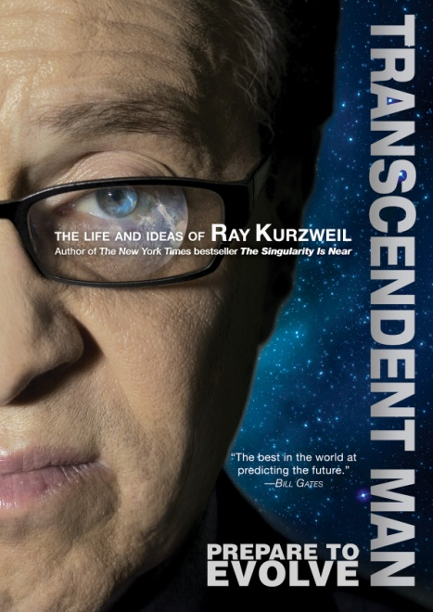

**Inspired by Kurzweil’s Best-Selling Book, “The Singularity Is Near,”**

**New Documentary Explores the Life and Ideas of the Inventor, Futurist, and Author**

***April 22, 2011, New York, NY*** -- In Ray Kurzweil’s post-biological world, boundaries blur between human and machine, real and virtual. World hunger and poverty are solved, human aging and illness are reversed and we vastly extend longevity. Barry Ptolemy’s compelling feature-length documentary, ***TRANSCENDENT MAN***, chronicles the life of one of our most respected and provocative advocates of the role of technology in the future. Docurama Films’ new release will be available for the first time on DVD on May 24, following a worldwide festival tour and a Digital/VOD release in March 2011.

In his film, director Barry Ptolemy follows Kurzweil to more than 20 cities and 5 countries as he presents the daring arguments from his bestselling book, *The Singularity Is Near: When Humans Transcend Biology*. Kurzweil predicts that with the ever-accelerating rate of technological change, humanity is fast approaching an era in which our intelligence will become increasingly non-biological and millions of times more powerful. Within 25 years, computers will have consciousness. Humans will merge with their machines. These predictions make Kurzweil a prophetic genius to some, and a “highly sophisticated crackpot” to others. There is no question, however, that he has predicted the future with more accuracy than anyone else in history.

***TRANSCENDENT MAN*** explores the social and philosophical implications of Kurzweil’s predictions and the potential threats they pose to human civilization through dialogue with Colin Powell; technologists Hugo de Garis, Peter Diamandis, Kevin Warick, and Dean Kamen; journalist Kevin Kelly; musician Stevie Wonder, and William Shatner. Award-winning composer Philip Glass contributes original theme music.

Since its premiere at the 2010 Tribeca Film Festival, ***TRANSCENDENT MAN*** has drawn critical acclaim and profiles of Kurzweil have recently been featured on CNN, NPR, *The Economist* and as the cover story of *TIME*. *Fast Company* describes the film as “prophetic” and “mind-bending.”

**About Ray Kurzweil:**

Ray Kurzweil is one of the world's leading futurists, with a twenty-five year track record of accurate predictions. Called the "restless genius" by *The Wall Street Journal* and "the ultimate thinking machine" by *Forbes*, Kurzweil was selected as one of the top entrepreneurs by *Inc.* magazine, which described him as the "rightful heir to Thomas Edison." Inventor of the first CCD flat bed scanner and many other technology firsts, Kurzweil was inducted into the National Inventors Hall of Fame and has received the National Medal of Technology, the Lemelson-MIT Prize (the world's largest for innovation), 19 honorary doctorates, and awards from three U.S. presidents.

***TRANSCENDENT MAN*** is directed by Barry Ptolemy; produced by Barry and Felicia Ptolomy in partnership with Therapy Studios; Meg Ramsay, editor; Joe DiSanto, John Ramsay, Wren Waters, Doobie White, Drew Dowdle, John Erick Dowdle, and Oliver Luckett, executive producers.

Pricing: $29.95 US

Runtime: 83 minutes, plus extras

Rating: NR

Catalog #: NNVG245031

Language: English

Color: Color

Audio Format: Dolby Digital 2.0 Stereo

Genre: Documentary

**About Docurama Films**

In 1999, **NEW VIDEO** launched **Docurama Films**® with the first feature documentary available on DVD: D.A. Pennebaker’s *Bob Dylan: Dont Look Back.* Twelve years and 250 award-winning, highly-acclaimed documentary titles later, Docurama continues to discover and release the greatest non-fiction films of our time while spreading the word about filmmakers who are taking the form to new heights.  Docurama’s catalog features an array of topics including the performing and visual arts, history, politics, the environment, ethnic and gender interests, and all-time favorites including *The Wild Parrots of Telegraph Hill*, *Andy Goldsworthy:* *Rivers and Tides* and *King Corn.* Recent releases include *The End of the Line*, *William Kunstler: Disturbing the Universe*, *Best Worst Movie,* the 2011 Oscar®-nominated film*, Gasland,* and the first-ever Blu-ray release of *Dont Look Back*.

**About New Video**

Celebrating its 20th anniversary in 2011, New Video is a leading entertainment distributor and the largest aggregator of independent digital content worldwide. Headquartered in New York City, with an international presence in 45 territories, the company delivers feature films, TV programs and web originals via digital download, streaming media, video-on-demand, Blu-ray and DVD. New Video streamlines the distribution and marketing process for filmmakers, producers and brand partners to bring a wide variety of fresh content to new audiences. The company’s library includes original TV series and movies from A&E®, HISTORY™, and Lifetime®, unforgettable games and trophy sets from Major League Baseball®, storybook treasures from Scholastic®, award-winning documentaries from Docurama Films®, Arthouse Films, and Plexifilm, next-gen indies and web hits from Flatiron Film Company® and festival picks from Tribeca Film. New Video is proud to distribute the 2011 Oscar®-nominated films *Gasland, Waste Land* and, on digital, *Restrepo*.

[www.newvideo.com](http://www.newvideo.com).

**For more information, please contact:**

Sommer Hixson

646-259-4138

shixson@newvideo.com

For box art, please visit:

<http://www.newvideo.com/docurama/transcendent-man/>

Or visit the Press Room at:

http://www.newvideo.com/pressroom/