FlatironFilmCo Blk-Red.jpg

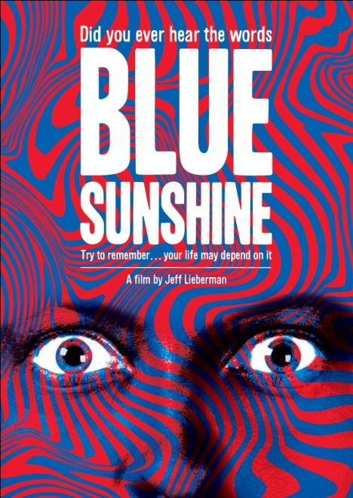

**NEW VIDEO’S FLATIRON FILM COMPANY RELEASES**

**35TH ANNIVERSARY EDITION OF “BLUE SUNSHINE”**

**Jeff Lieberman’s Cult Masterpiece of Suspense and Terror**

**Returns September 20**

“What a wonderfully bizarre wonderful cult film!”—Harry Knowles, *Ain’t it Cool News*

“The most bizarre descendants of the living dead yet to reach the silver screen.”

– *Eat My Brains!*

*August 31, 2011 – New York, NY* -- At a party, someone goes insane and murders three women. Falsely accused of the brutal killings, Jerry Zipkin is on the run. More bizarre killings continue with alarming frequency all over town. Trying to clear his name, Jerry discovers the shocking truth…people are losing their hair and turning into violent psychopaths and the connection may be a hallucinogenic drug, “Blue Sunshine,” that all the murderers took in their younger days.

The decade spanning the mid-1970s through the mid-80s is referred to by film historians as the “Golden Age of Horror.” Lieberman’s feature writing and directing debut, *Squirm* (1976), followed by ***BLUE SUNSHINE*** (1978), place him among icons of the genre including John Carpenter, George Romero, Toby Hooper, Wes Craven, Dario Argento and David Cronenberg. Flatiron Film Company’s 35th anniversary re-release of ***BLUE SUNSHINE*** boasts new poster art, a new 30-minute interview with Lieberman, and a slideshow of images from the film and behind the scenes.

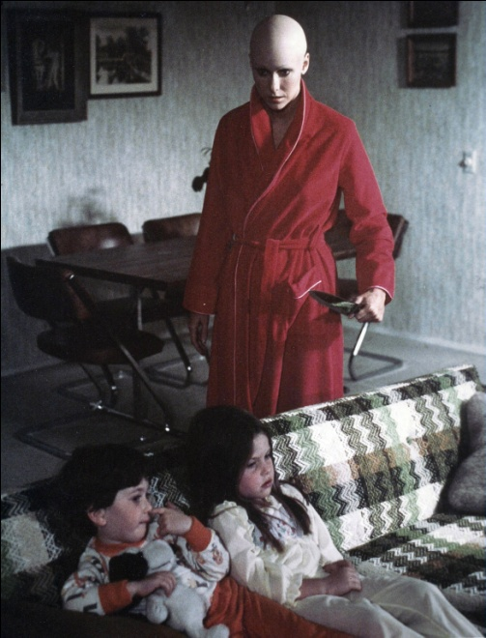

A quirky low-budget film that creatively touches on a variety of genres including straight horror, satire, conspiracy theory and ’60s counter-culture, ***BLUE SUNSHINE*** features an eclectic yet notable cast, including Zalman King as Jerry (*Red Shoe Diaries*, director; *9 ½ Weeks*, producer), Deborah Winters (*The People Next Door*), Robert Waldman (*Happily Divorced*), Mark Goddard (*Lost in Space*), Brion James (*Blade Runner*), Charles Siebert (*Trapper John, M.D.*), and Billy Crystal’s brother, Richard, whose character’s violent and deadly outburst at the opening of the film launches the plot.

**BLUE SUNSHINE 35th ANNIVERSARY EDITION:**

Pricing: $24.95 US  
Runtime: 90 mins., plus extras  
Rating: N/A  
Catalog #: NNVG245570  
Language: English  
Color: Color  
Audio Format: Stereo  
Genre: Horror

**About New Video**

Celebrating its 20th anniversary in 2011, New Video is a leading entertainment distributor and the largest aggregator of independent digital content worldwide. Headquartered in New York City, with an international presence in 45 territories, the company delivers feature films, TV programs and web originals via digital download, streaming media, video-on-demand, Blu-ray and DVD, and theatrical release. New Video streamlines the distribution and marketing process for filmmakers, producers and brand partners to bring a wide variety of fresh content to new audiences. The company’s library includes original TV series and movies from A+E® Home Entertainment, HISTORY™, and Lifetime®, unforgettable games and trophy sets from Major League Baseball®, storybook treasures from Scholastic®, award-winning documentaries from Docurama Films®, Arthouse Films, and Plexifilm, next-gen indies and web hits from Flatiron Film Company®, the best in Chinese cinema from China Lion, and festival picks from Tribeca Film. New Video is proud to distribute the 2011 Oscar®-nominated films Gasland, Waste Land and, on digital, Restrepo.

**For more information, please contact:**

Sommer Hixson

New Video/Flatiron Film Company

(646) 259-4138; [shixson@newvideo.com](mailto:shixson@newvideo.com)

Product information:

http://www.newvideo.com/flatiron-film-company/blue-sunshine/