**FOR IMMEDIATE RELEASE**



**NEW VIDEO DEBUTS FIRST CHINA LION RELEASE, “AFTERSHOCK,”**

**ON VOD, DIGITAL AND DVD**

**China’s Highest-Grossing Domestic Film Launches**

**Day-and-Date on October 18, following Theatrical Release in the U.S. and Canada**

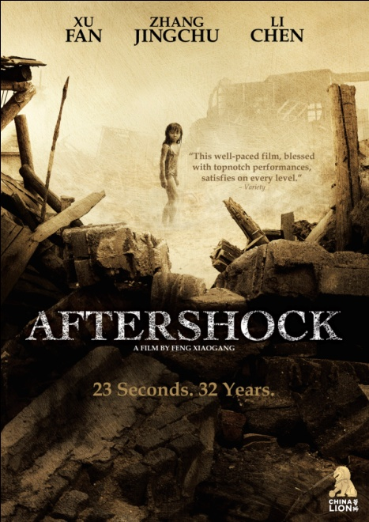

“A touching family drama with an earth shattering historical backdrop.”

– *Hollywood Reporter*

“Stunning special effects are wedded to potent family drama.” – *Variety*

Tangshan, 1976. Two seven-year-old twin children are buried under the rubble of a devastating earthquake. The rescue team explains to their mother, Li Yuanni, that freeing either child will almost certainly result in the death of the other. Forced to make the most difficult decision of her life, she finally chooses to save her son Fang Da, the male twin.

Sichuan, 2008. 32 years later, when the Sichuan earthquake takes more lives, Fang Deng, the daughter, returns to China as a volunteer with a rescue team. The process of witnessing other people's suffering at the time of a natural disaster helps her to overcome her own trauma and forgive her mother. She finally reunites with her family after 32 years apart.

***AFTERSHOCK*** is China’s highest grossing domestic film ever in China and was the country’s official selection for the 2010 Best Foreign Picture Oscar®. Described by *The Hollywood Reporter* as a “Chinese *Sophie’s Choice*,” ***AFTERSHOCK*** tells the story of a fictional family torn apart by the Tangshan earthquake, an actual catastrophe in 1976 that killed at least 240,000 people. Directed by **Feng Xiaogang** (*If You Are the One*), the film is inspired by the novel, "Tangshan dadizhen" ("Great Tangshan Earthquake") by **Zhang Ling**, and stars **Xu Fang** (*The Founding of a Republic*), **Zhang Jingchu** (*Night and Fog*), and **Li Chen** (*Assembly*) as mother, daughter and son. **Chen Daoming** (*Infernal Affairs 3, Hero*) portrays Fand Deng’s devoted step-father, Wang Deqing.

Releasing on Cable VOD, digital platforms and DVD for the first time in North America day-and-date on October 18, ***AFTERSHOCK*** is the first title from New Video’s new partnership with China Lion Film Distribution. Cross-platform releases coming up on November 15 include **If You Are the One: Love & Marriage**, also directed by **Xiaogang**, **What Women Want**, a remake of the Mel Gibson-Helen Hunt film starring **Andy Lau** and **Gong Li**, and ***The Warring States***, starring **Hong-lei** and **Francis Ng**.

***AFTERSHOCK*** is presented by Tangshan Broadcast and Television Media Co., Ltd., China Film Group Corporation, and Huayi Brothers Media Corporation in Association with Shanghai Film Group Corporation, Zhejiang Media Group & Co., Ltd., Media Asia Films Ltd., and Emperor Classic Films Company Limited; a Huayi Brothers Media Corporation, Tangshan Broadcast and Television Media Co., Ltd., and China Film Group Film Production Corporation Production. Feng Xiaogang, director; Lu Yue, cinematographer; Xiao Yang, editor; Wang Liguang, original score; Su Xiaowei, screenplay.

SRP: $26.95 US; $29.95 CAN

Runtime: 136 minutes

Rating: NR

Catalog #: NNVG253241

Language: Mandarin, with Chinese and English subtitles

Color: Color

Audio Format: Dolby Digital 2.0 Stereo

Genre: Drama, World Cinema

**About New Video**

Celebrating its 20th anniversary in 2011, New Video is a leading entertainment distributor and the largest aggregator of independent digital content worldwide. Headquartered in New York City, with an international presence in 45 territories, the company delivers feature films, TV programs and web originals via digital download, streaming media, video-on-demand, Blu-ray and DVD, and theatrical release. New Video streamlines the distribution and marketing process for filmmakers, producers and brand partners to bring a wide variety of fresh content to new audiences. The company’s library includes original TV series and movies from A+E® Home Entertainment, HISTORY™, and Lifetime®, unforgettable games and trophy sets from Major League Baseball®, storybook treasures from Scholastic®, award-winning documentaries from Docurama Films®, Arthouse Films, and Plexifilm, next-gen indies and web hits from Flatiron Film Company®, the best in Chinese cinema from China Lion, and festival picks from Tribeca Film. New Video is proud to distribute the 2011 Oscar®-nominated films Gasland, Waste Land and, on digital, Restrepo.

**About China Lion**

China Lion Film Distribution is a joint venture between China-based Jiang Yanming and New Zealand-based Milt Barlow (the latter via his company, Incubate) with Yanming, the majority shareholder, serving in the role of President and Barlow serving as CEO. China Lion has distribution agreements with some of China’s leading studios including Huayi Bros, Shanghai Film Group and PolyBona, and exclusive exhibition agreements with AMC in the U.S. and Toronto, Cineplex in Vancouver and Consolidated Theatres in Hawaii. China Lion will release up to fifteen films each year, and wherever possible, seek to release its films day-and-date with mainland China.

**For more information, please contact:**

Sommer Hixson, Media Relations

646-259-4138; [shixson@newvideo.com](mailto:shixson@newvideo.com)

<http://www.newvideo.com/titles/china-lion/>

**For Chinese press, please contact:**

Cecilia Chen

213-785-5212; [Cecilia@chinalionentertainment.com](mailto:Cecilia@chinalionentertainment.com)

http://www.chinalionentertainment.com/movie/past