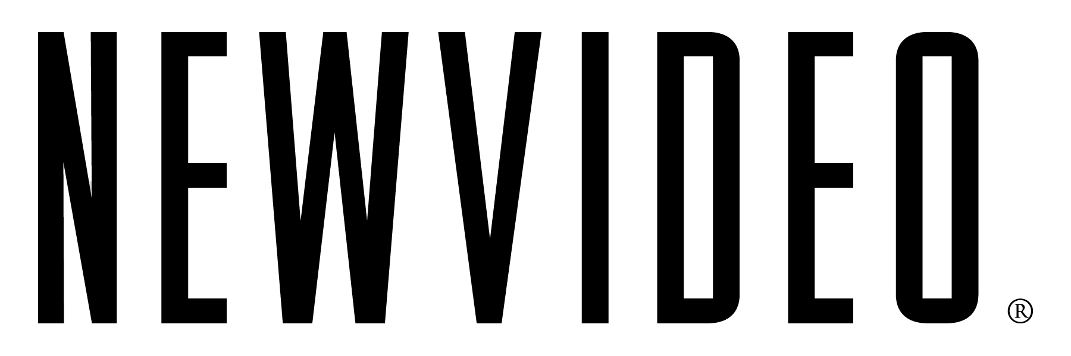

**NEW VIDEO’S FLATIRON FILM COMPANY ACQUIRES SAMUEL GOLDWYN FILMS’ HIT**

**“THE DOUBLE HOUR” (LA DOPPIA ORA), FOR HOME ENTERTAINMENT**

**Critically-Acclaimed Box Office Hit to Release Day and Date on Transactional VOD and Electronic Sell Through on December 2011;**

**The DVD Release Scheduled for April 2012**

*Wednesday, September 7, 2011 – New York, NY* – New Video’s **Flatiron Film Company** announced today that it has acquired U.S. home video distribution rights from **Samuel Goldwyn Films** to ***THE DOUBLE HOUR.*** ***THE DOUBLE HOUR*** (*La Doppa Ora*), directed by **Giuseppe Capotondi** from an original idea and screenplay by Alessandro Fabbri, Ludovica Rampoldi and Stefano Sardo, had its world premiere at the 2009 Venice Film Festival where Ksenia Rappoport won the best actress prize. Following a terrific reception there, the film went on to play the Toronto International Film Festival. Thus far, ***THE DOUBLE HOUR*** has generated more than $1.5 million in U.S. box office. A complex and suspenseful psychological thriller, ***THE DOUBLE HOUR*** is a *New York Times* Critics’ Pick and rates 95% “certified fresh” with top film critics nationwide, as reported on *Rotten Tomatoes*.

New Video’s Flatiron Film Company will release ***THE DOUBLE HOUR*** day-and-date on Cable VOD and premium transactional digital platforms as early as December 1, followed by a DVD and expanded digital release scheduled for April 2012.

"***THE DOUBLE HOUR*** has the one-two punch of critical acclaim and great storytelling," said Mark Kashden, New Video's Vice President of Acquisitions. "We're very excited to distribute this thrilling film, which deserves the widest audience possible."

“We love this film and are thrilled to be in business with New Video. ***THE DOUBLE HOUR*** delivers on all cylinders and we are confident that the home entertainment business will rival the strong theatrical,” said Meyer Gottlieb, President of Samuel Goldwyn Films.

The deal was negotiated by **Kashden** on behalf of New Video and by Ian Puente, VP, Business Development and General Counsel, on behalf of Goldwyn.

**About New Video**

Celebrating its 20th anniversary in 2011, New Video is a leading entertainment distributor and the largest aggregator of independent digital content worldwide. Headquartered in New York City, with an international presence in 45 territories, the company delivers feature films, TV programs and web originals via digital download, streaming media, video-on-demand, Blu-ray and DVD, and theatrical release. New Video streamlines the distribution and marketing process for filmmakers, producers and brand partners to bring a wide variety of fresh content to new audiences. The company’s library includes original TV series and movies from A+E® Home Entertainment, HISTORY™, and Lifetime®, unforgettable games and trophy sets from Major League Baseball®, storybook treasures from Scholastic®, award-winning documentaries from Docurama Films®, Arthouse Films, and Plexifilm, next-gen indies and web hits from Flatiron Film Company®, the best in Chinese cinema from China Lion, and festival picks from Tribeca Film. New Video is proud to distribute the 2011 Oscar®-nominated films Gasland, Waste Land and, on digital, Restrepo. New Video recently launched Flatiron Film Company as a distribution brand for out-of-the-ordinary, often risk-taking films and original content from an international cadre of creative talent. Recent titles have included the Oscar®-nominated animated film, *The Secret of Kells*, *True Adolescents*, starring Mark Duplass and Melissa Leo, *hitRECORD Volume 1*, directed by Joseph Gordon-Levitt, and José Padilha’s *Elite Squad: The Enemy Within*, opening in U.S. theaters this November.

**ABOUT SAMUEL GOLDWYN FILMS**

Samuel Goldwyn Films is a major, independently owned and operated motion-picture company that develops, produces and distributes innovative feature films and documentaries.  The company is dedicated to working with both world renowned and emerging writers/filmmakers and committed to filmed entertainment that offers original voices in uniquely told stories.  This is best exemplified by the Academy Award® nominated THE SQUID AND THE WHALE and SUPER SIZE ME, AMAZING GRACE and Julie Delpy's hit comedy 2 DAYS IN PARIS. Past Goldwyn titles include PRICELESS, a romantic comedy starring Audrey Tautou, Academy Award® winner Claude Lelouch's ROMAN DE GARE, the critically hailed ELEGY starring Academy Award® nominee Penélope Cruz and the box office smash FIREPROOF.  HARRY BROWN starring Michael Caine opened in April to stellar reviews and MAO’S LAST DANCER directed by Academy Award nominee Bruce Beresford was one of the top grossing independent films of 2010. In addition to THE DOUBLE HOUR, this year’s slate includes THE WHISTLEBLOWER, a powerful, ripped from the headlines thriller starring Academy Award® winner Rachel Weisz that premiered at this year’s Toronto Film Festival and A GOOD OLD FASHIONED ORGY starring Jason Sudeikis slated for a September 2nd release.

**For more information, please contact:**

Sommer Hixson

Media Relations, New Video

(646) 644-4138; [shixson@newvideo.com](mailto:shixson@newvideo.com)