**FOR IMMEDIATE RELEASE**



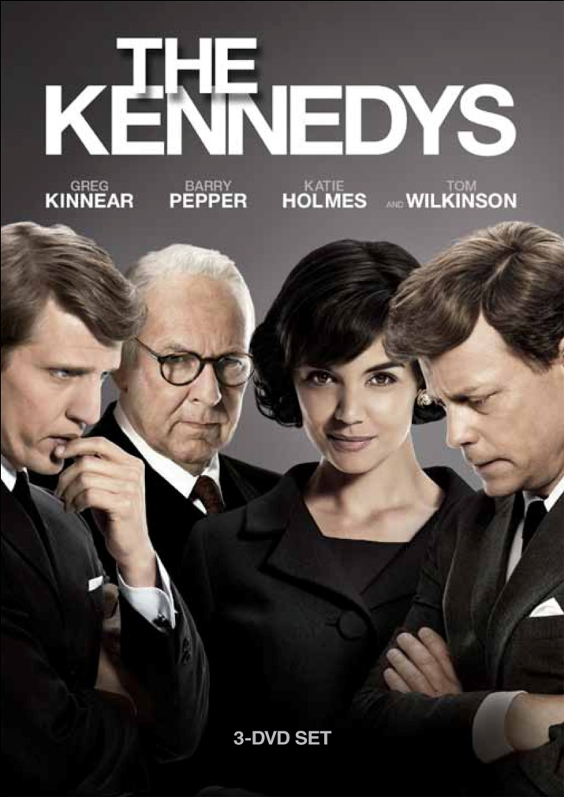

***THE KENNEDYS* AVAILABLE SEPTEMBER 20 ON DVD AND BLU-RAY**

**Winner of 2011 Emmy**® **Award for Outstanding Lead Actor**

**in a Miniseries or Movie – Barry Pepper**

**Nominated for 10 Emmy**® **Awards, including:**

* **Outstanding Miniseries or Movie**
* **Outstanding Lead Actor in a Miniseries or Movie – Greg Kinnear**
* **Outstanding Supporting Actor in a Miniseries or Movie – Tom Wilkinson**

**The most famous family in American history comes to life**

**in this epic 8-part miniseries event**

***September 19, 2011*** – From the producers of the megahit series *24*, this six-hour scripted drama/miniseries ventures upstairs at the White House during the 1960s to chronicle the saga of America’s first “royal” family. ***THE KENNEDYS*** provides an intimate look at how Joseph Kennedy, Sr. shaped his sons John and Robert to become two of the most influential men in U.S. history. The 8-part miniseries details how the two sons managed their father, whose ambition exceeded their own, and ultimately made them who they were. ***THE KENNEDYS*** recounts the scandal, tragedy, public greatness and private frailty of our nation’s most fabled political family during one of the most momentous decades in history.

***THE KENNEDYS*** premiered on Reelz Channel and features an all-star cast including: Oscar®-nominee Greg Kinnear (*As Good As It Gets*) as JFK; Katie Holmes (*Batman Begins*) as Jackie Kennedy; Emmy®-nominee Barry Pepper (*Saving Private Ryan*) as RFK and Emmy®-winner Tom Wilkinson (*John Adams*)as Joseph Kennedy Sr.

With political events such as World War II, the Cuban Missile Crisis, and the civil rights movement playing background to their personal stories, ***THE KENNEDYS*** dramatizes the family’s triumphs and tragedies while revisiting the historical period that played a significant role in American politics.

“The miniseries…is without a doubt one of the best, most riveting, historically accurate dramas about a time and place in American history that has ever been done for TV.” -- *NY Post*

***THE KENNEDYS*** is directed by Jon Cassar; produced by Jamie Paul Rock; written by Stephen Kronish; edited by David B. Thompson and Don Cassidy. The DVD and Blu-ray includes A 45-minute featurette: “The Kennedys: From Story to Film,” with behind-the-scenes footage, cast and crew interviews.

Pricing: $29.95US

Runtime: 6 hrs, 16 mins., plus extras

Rating: NR

Catalog #: NNVG243560

Language: English

Color: Color

Audio Format: Dolby Digital 5.1 Stereo

Genre: Miniseries

**Blu-Ray**

Pricing: $39.95US

Runtime: 6 hrs, 16 mins., plus extras

Rating: NR

Catalog #: NNVG243570

Language: English

Color: Color

Audio Format: Dolby Digital 5.1 Stereo

Genre: Miniseries

**For more information, please contact:**

Luis Garza; 646-259-4144; lgarza@newvideo.com

For box art, please visit:

<http://www.newvideo.com/new-video-nyc/the-kennedys-miniseries/>