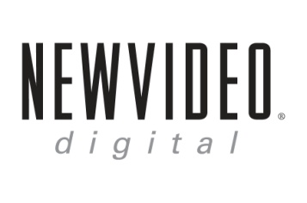

**NEW VIDEO…ALL TREATS AND NO TRICKS FOR HALLOWEEN:**

**VICIOUS BROTHERS’ “GRAVE ENCOUNTERS,” AND “TRANCERS” AND “SUBSPECIES” COLLECTOR’S EDITIONS RELEASE OCTOBER 18**

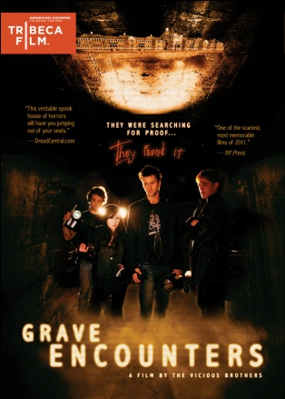  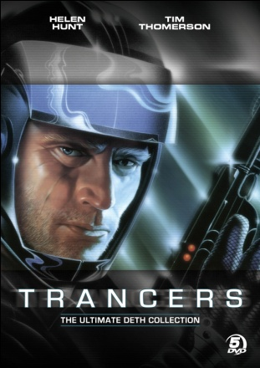

**GRAVE ENCOUNTERS—Tribeca Film**

*Ghost Hunters* meets *Paranormal Activity* in this horror film by the Vicious Brothers about a team of paranormal investigators spending the night locked inside an abandoned asylum.

Lance Preston and the crew of Grave Encounters, a ghost-hunting reality television show, are shooting an episode inside the abandoned Collingwood Psychiatric Hospital, where unexplained phenomena have been reported for years. On a quest to expose the truth and scare their viewers, the *Grave Encounters* crew conducts background interviews with current psychologists, as well as provides disturbing archival footage of patients in the earlier half of the century. All in the name of good television, they voluntarily lock themselves inside the building for the night and begin a paranormal investigation, capturing everything on camera. They quickly realize that the building is more than just haunted – it is alive – and it has no intention of ever letting them leave. They find themselves lost in a labyrinth of endless hallways and corridors, terrorized by the ghosts of former patients. They soon begin to question their own sanity, slipping deeper and deeper into the depths of madness, ultimately discovering the truth behind the hospital’s dark past…and taping what turns out to be their final episode.

SRP (U.S.): $26.95

Catalogue # NNVG253930

Extra include an Interview with the Vicious Brothers and Producer Shawn Angelski, Presented by American Express, and a “Making Of” film.

<http://www.newvideo.com/tribeca-film/grave-encounters/>

**SUBSPECIES: THE COMPLETE CHRONICLES – Flatiron Film Company**

This value-priced 5-disc collection includes all five films in the cult classic series about the evil vampire Radu, who returns to his ancestral Transylvania to obtain a life-giving bloodstone.

*Subspecies:*Three young students studying the folklore of Transylvania uncover an ancient clan of vampires ruled by the sadistic, monstrous Radu, who becomes obsessed with making them his fledglings.

*Subspecies II: Bloodstone:*Radu’s fledgling, Michelle, flees from his castle with the holy relic—the Bloodstone—and struggles with her emerging bloodlust while hiding in the basement of a theater in Bucharest, waiting for her sister to arrive from the U.S. to help her.

*Subspecies III: Bloodlust:*Radu kidnaps Michelle back to the castle he shares with his sorceress mother and teaches her to master her vampire powers, sacrificing everything in his obsession for her, while Michelle’s sister mounts an armed assault on his stronghold.

*Subspecies IV: Bloodstorm:*The vampire Radu returns to Bucharest in pursuit of his headstrong fledgling Michelle. He reclaims his underground stronghold from Ash, a powerful vampire who mingles with the world of mortals, while he devises a way into the secret clinic where Michelle is being held by the evil Doctor Niculescu.

*Vampire Journals:*A 19th-century vampire on a quest to destroy the vampires of his bloodline comes to modern-day Bucharest to battle the vampire master Ash—the music lover—using as his pawn the innocent soul of a beautiful concert pianist.

SRP (U.S.): $29.95

Catalogue # NNVG254381

<http://www.newvideo.com/flatiron-film-company/subspecies-the-complete-chronicles/>

**TRANCERS: THE ULTIMATE DETH COLLECTION—Flatiron Film Company**

Set in the year 2247, this 5-disc collection of all 5 classic sci-fi films directed by Charles Band (*Puppetmaster*, *Evil Bong*) centers on bounty hunter Jack Deth as he tries to stop the villainous Martin Whistler, a terrorist who uses mind control to wreak havoc on the city of Los Angeles. Featuring Tim Thomerson, Helen Hunt and Telma Hopkins.

***Trancers I:***Jack Deth (Tim Thomerson, *Near Dark*) is a trooper in Angel City circa 2247, mopping up the last of the disciples of the evil Whistler, who uses his psychic power to “trance” and control those with weak minds. Whistler is in 1985 hunting down and trancing the ancestors of the City Council and Jack is sent back in time by inhabiting the body of his ancestor. With the help of Leena (Academy Award® winner Helen Hunt, *As Good As It Gets*), he must find and face Whistler in a final confrontation.

***Trancers II: The Return of Jack Deth:***Stranded in the 20th century after chasing a villain from the year 2247, future-cop Jack Deth discovers that another baddie, Dr. E.D. Wardo (Richard Lynch, *Scarecrow*), has also traveled back in time— with a scheme to turn solid citizens into mindless trancers.

***Trancers III:***Jack, beginning to get his life back together, is time-jacked back to 2247, where he learns that the new trancer program is government-sponsored, and that his usual shoot-everything-that-moves attitude might not work this time.

***Trancers IV: Jack of Swords:***Jack finds himself in a whole new, more dangerous dimension, where he runs across a different version of trancers, who have taken control of this new planet.

***Trancers V: Sudden Deth:***In Jack’s final round with the trancers, he must find his way home from the other-dimensional world of Orpheus, where magic works and the trancers are the ruling class.

SRP (U.S.): $29.95

Catalogue # NNVG254390

Bonus features include Bloopers; Making of *Trancers II*; Making of *Trancers III;* Making of *Trancers IV*; Making of *Trancers V*. (Flatiron Film Company).

<http://www.newvideo.com/flatiron-film-company/trancers-the-ultimate-deth-collection/>

**About New Video**

Celebrating its 20th anniversary in 2011, New Video is a leading entertainment distributor and the largest aggregator of independent digital content worldwide. Headquartered in New York City, with an international presence in 45 territories, the company delivers feature films, TV programs and web originals via digital download, streaming media, video-on-demand, Blu-ray and DVD, and theatrical release. New Video streamlines the distribution and marketing process for filmmakers, producers and brand partners to bring a wide variety of fresh content to new audiences. The company’s library includes original TV series and movies from A&E® Home Video, HISTORY™, and Lifetime®, unforgettable games and trophy sets from Major League Baseball®, storybook treasures from Scholastic®, award-winning documentaries from Docurama Films®, Arthouse Films, and Plexifilm, next-gen indies and web hits from Flatiron Film Company®, the best in Chinese cinema from China Lion, and festival picks from Tribeca Film. New Video is proud to distribute the 2011 Oscar®-nominated films Gasland, Waste Land and, on digital, Restrepo.

**For more information, please contact:**

Sommer Hixson, Media Relations

[shixson@newvideo.com](mailto:shixson@newvideo.com); 646-259-4138