**FOR IMMEDIATE RELEASE**



presents

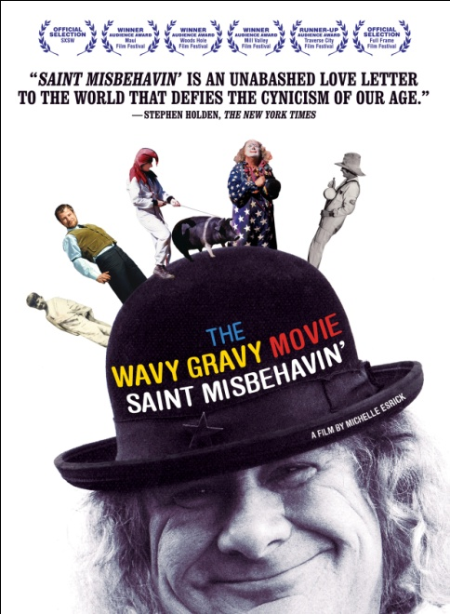

**A TESTAMENT TO THE SHEER JOY OF LIVING A LIFE OF SERVICE**

**TO HUMANKIND AND OUR PLANET**

***THE WAVY GRAVY MOVIE: SAINT MISBEHAVIN'***

**RELEASES NOVEMBER 15 ON DIGITAL AND DVD**

**An unforgettable trip through the extraordinary life of a**

**poet, clown, activist and FUNdraiser**

**“’Saint Misbehavin’’ is an unabashed love letter to the world that**

**defies the cynicism of our age.” – *The* *New York Times***

***September 19, 2011*** – **“*Some people tell me I’m a saint, I tell them I’m Saint Misbehavin’*.”** Poet, activist, entertainer, clown. These are a few ways to describe **Wavy Gravy**, an activist and prominent figure during the Woodstock era who continues to spread a message that we can make a difference in the world and have fun doing it!

***THE WAVY GRAVY MOVIE*** paints a moving and surprising portrait of his lifelong passion for peace, justice and understanding. The film features extensive verité footage and interviews with Wavy telling his own stories: from communal life with The Hog Farm, to his circus and performing arts camp, Camp Winnarainbow, to the epic cross-continent bus trip through Europe and South Asia that led to the founding of the Seva Foundation.

Award-winning director Michelle Esrick weaves together this compelling film with rare footage from key events: Greenwich Village beat poets and folk music, Woodstock, non-violent protests, and many seminal moments of the ‘60s and ‘70s, and Wavy’s present day life.

**The Gaslight Café**

The year was 1958. The Vietnam War had just begun. Born as Hugh Romney, Wavy commanded the stage as a poet, comedian “tongue dancer,” and MC at The Gaslight Café in New York City’s Greenwich Village. When folk musicians began to congregate in Washington Square Park, Wavy convinced the owner of The Gaslight, John Mitchell, to allow them to play between poetry sessions. His popularity grew, and he was invited to open shows for jazz legends including John Coltrane and Thelonious Monk and folk duo Ian & Sylvia. Esrick captures Wavy walking through today’s Village, where he reminisces about living with a young Bob Dylan in an apartment upstairs from The Gaslight, where Dylan wrote “A Hard Rain’s A-Gonna Fall” on Wavy’s typewriter.

**The Hog Farm**

In 1962, Wavy moved to California at the recommendation of his part-time manager, comedian Lenny Bruce, where he met his soon-to-be wife at her restaurant in Los Angeles. Shortly after Wavy and Jahanara moved to a one-bedroom cabin in Sunland, CA, a bus-full of Merry Pranksters stopped by for a visit and decided to stay after their driver left without them. When their landlord discovered Wavy and Jahanara were housing 45 people, they were evicted. On the same day, in what Wavy refers to as “kitchen sink-ronicity,” a neighbor came to their house with a message: “Old Saul from the mountain top had a stroke and we need someone to slop them hogs,” at which point Wavy and his friends moved to the mountain and lived there rent-free in exchange for taking care of the hogs. Their residence was soon coined by neighbors and the press as “The Hog Farm Commune.” In 1967, The Hog Farm painted a few old school busses psychedelic colors and outfitted them for living away from home. They traveled cross-country for 7 years, hosting open celebrations in communities and at colleges. They brought one hog with them, Pigasus, as a reminder of their humble beginnings, and ran her for President of the United States in 1968 as the “first black-and-white candidate for that high office,” according to Wavy.

**Woodstock**

Esrick reveals a new and fresh perspective on the infamous Woodstock Music & Art Fair of 1969, focusing on the influence Wavy and The Hog Farm had on this iconic event. The Hog Farm was asked by the festival’s promoters to assist with set up, crowd control and security, which they did as the festival’s “Please Force.” They also set up a free kitchen and, after the heavy rains, Wavy made his famous announcement from the Woodstock stage, "What we have in mind is breakfast in bed for 400,000!"

**“Journey to the East” and the SEVA Foundation**

In 1970, after hearing about the cyclone in East Pakistan that killed more than 1 million people, Wavy and 42 people from The Hog Farm, including his close friend, Dr. Larry Brilliant, packed two buses with food and medical supplies in London and traveled to the Himalayas. Their original plan was to drive to Pakistan and provide relief, but they were unable to enter the country because of the Indo-Pakistan War. Instead, they traveled to Tibet and distributed food and supplies to refugee camps. Never-before-seen, breathtaking film footage of Wavy and The Hog Farm’s epic "journey to the east" – including a drive through the Khyber Pass that would be unauthorized today – was discovered by Esrick in a storage unit that had been rented by The Hog Farm since 1971.

While in Nepal they were treated so well by people who essentially had nothing that they made a silent pledge to go back one day and help them, if they ever had the means. Through this promise, the SEVA Foundation was founded by Wavy, Dr. Brilliant and Ram Dass. Since 1979, Seva has brought sight to more than 3 million people in developing countries. Seva also creates and supports projects for Native American communities suffering from diabetes, poverty, and loss of culture and pride.

In May 2011, Wavy celebrated his 75th Birthday Show at The Beacon Theater, which benefited the SEVA foundation, where Crosby & Nash joined Jackson Browne, Dr. John, Ani DiFranco, Steve Earle, Bruce Hornsby and many others as guest performers.

**Camp WinnaRainbow**

In 1974, Wavy created a circus and performing arts camp in Northern California named Camp Winnarainbow, attended by 750 kids each summer – 30% of whom receive scholarships. Drawing from the circus world and theatrical arts, children learn timing and balance, and a sense of humor. Camp Winnarainbow nurtures leaders for a peaceful, harmonious and sustainable world by teaching responsibility for one’s own behavior, developing confidence, inner security and self-expression.

The film also features in-depth interviews with: Buffy Sainte-Marie, Ramblin’ Jack Elliott, Jackson Browne, the late Odetta, Ram Dass, Dr. Larry Brilliant, Bonnie Raitt, theatre artist Steven Ben Israel, Woodstock creator Michael Lang, Dr. Patch Adams, and Wavy’s family and friends.

***THE WAVY GRAVY MOVIE*** was a winner at the Maui, Woods Hole and Mill Valley Film Festivals, a runner-up at Michael Moore’s Traverse City Film Festival, and an official selection at SXSW and Full Frame, plus numerous other festivals. The film had its theatrical release in December of 2010 and screened in more than 35 theaters around the country. Following its debut in November on Showtime, New Video’s Docurama Films will release the film November 15 on digital and DVD.

Ripple Effect Films presents ***THE WAVY GRAVY MOVIE: SAINT MISBEHAVIN’***, a film by Michelle Esrick, directed and produced by Michelle Esrick; executive produced by D.A. Pennebaker and John Pritzker; produced by David Becker; edited by Karen K.H. Sim; director of photography, Daniel B. Gold; music by Emory Joseph. Packaging for the DVD is made of 100% plastic-free recycled material and environmentally-friendly ink. Bonus features include: 55-plus minutes of deleted scenes; an all-star cast, including Jackson Browne, Bob Weir, Dr. John, Taj Mahal and Bonnie Raitt, sings Wavy Gravy’s signature song, “Basic Human Needs.”

Pricing: $29.95

Runtime: 86 mins., plus extras

Rating: N/A

Catalog #: NNVG254440

Language: English

Color: Color

Audio Format: Dolby Digital 2.0 Stereo

Genre: Documentary

**About Docurama Films**

In 1999, **NEW VIDEO** launched **Docurama Films**® with the first feature documentary available on DVD: D.A. Pennebaker’s *Bob Dylan: Dont Look Back.* Twelve years and 300 award-winning, highly-acclaimed documentary titles later, Docurama continues to discover and release the greatest non-fiction films of our time while spreading the word about filmmakers who are taking the form to new heights.  Docurama’s catalog features an array of topics including the performing and visual arts, history, politics, the environment, ethnic and gender interests, and all-time favorites including *The Wild Parrots of Telegraph Hill*, *Andy Goldsworthy:* *Rivers and Tides* and *King Corn.* Recent releases include the 2011 Oscar®-nominated film*, Gasland,* the first-ever Blu-ray release of *Dont Look Back,* and the upcoming theatrical release of *Hell and Back Again* in October 2011.

[www.docuramafilms.com](http://www.docuramafilms.com)

**About New Video**

Celebrating its 20th anniversary in 2011, New Video is a leading entertainment distributor and the largest aggregator of independent digital content worldwide. Headquartered in New York City, with an international presence in 45 territories, the company delivers feature films, TV programs and web originals via digital download, streaming media, video-on-demand, Blu-ray and DVD, and theatrical release. New Video streamlines the distribution and marketing process for filmmakers, producers and brand partners to bring a wide variety of fresh content to new audiences. The company’s library includes original TV series and movies from A+E® Home Entertainment, HISTORY™, and Lifetime®, unforgettable games and trophy sets from Major League Baseball®, storybook treasures from Scholastic®, award-winning documentaries from Docurama Films®, Arthouse Films, and Plexifilm, next-gen indies and web hits from Flatiron Film Company®, the best in Chinese cinema from China Lion, and festival picks from Tribeca Film. New Video is proud to distribute the 2011 Oscar®-nominated films Gasland, Waste Land and, on digital, Restrepo.

[www.newvideo.com](http://www.newvideo.com).

**For more information, please contact:** Luis Garza; 646-259-4144; lgarza@newvideo.com