**FOR IMMEDIATE RELEASE**



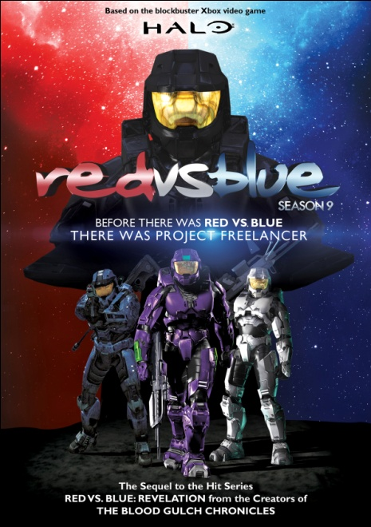

**THE SMASH-HIT COMEDY BASED ON HALO® IS BACK AND BETTER THAN EVER:**

**“RED VS. BLUE: SEASON 9” RELEASES ON DIGITAL AND DVD NOVEMBER 15**

Before the events of *Blood Gulch* there was Project Freelancer: an experimental military program which sought to create a new breed of warrior. This new soldier was to be faster, stronger, and smarter than any other we've seen before... which based on previous seasons of *Red vs. Blue* doesn't really take that much.

On November 15, Flatiron Film Company will release all 19 episodes of ***RED VS. BLUE:***

***SEASON 9*** on digital and DVD day-and-date with the release of Xbox’s *HALO***®***: Combat Evolved* anniversary edition. Adding an exciting new cast of characters to the classic ensemble, this innovative narrative - part amazing action prequel and part hilarious comedy sequel - unveils the mystery behind Project Freelancer and its dire consequences for the Reds and Blues. Rooster Teeth Productions, the creators of the series, have applied ground-breaking CGI animation to Machinima for the first time to produce enhanced action sequences and a complete cinematic experience.

Bonus material on the DVD includes director's commentary, special videos and PSAs, outtakes, deleted scenes, and cast interviews.

**DVD**

Pricing: $19.95 US; $22.95 CAN

Runtime: 120 minutes, plus extras

Rating: NR

Catalog #: NNVG254450

Language: English

Color: Color

Audio Format: Dolby Digital 2.0 Stereo

Genre: Comedy, Gaming

**About New Video**

Celebrating its 20th anniversary in 2011, New Video is a leading entertainment distributor and the largest digital aggregator of independent content worldwide. Headquartered in New York City, with an international presence in 45 territories, the company delivers feature films, TV programs and web originals via digital download, streaming media, video-on-demand, Blu-ray and DVD, and theatrical release. New Video streamlines the distribution and marketing process for filmmakers, producers and brand partners to bring a wide variety of fresh content to new audiences. New Video recently launched Flatiron Film Company as a distribution brand for out-of-the-ordinary, often risk-taking films and original content.  Recent titles have included the Oscar®-nominated animated film, The Secret of Kells, web hits *Dr. Horrible’s Sing-Along Blog* and Felicia Day’s *The Guild*, Joseph Gordon-Levitt’s *hitRECord RECollection*, andthe theatrical release of José Padilha’s Elite Squad: The Enemy Within. [www.newvideo.com](http://www.newvideo.com).

**For more information, please contact:**

Sommer Hixson; 646-259-4138;

shixson@newvideo.com

For box art, please visit:

http://www.newvideo.com/flatiron-film-company/red-vs-blue-season-9-2/