** **

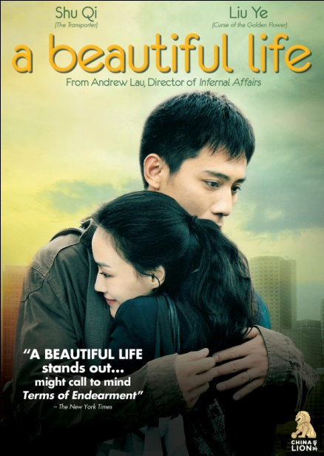

**“INFERNAL AFFAIRS” AND “LEGEND OF THE FIST” DIRECTOR ANDREW LAU TAKES ON ROMANCE WITH WORLD CINEMA STAR, SHU QI**

**“A Beautiful Life” Debuts Day-Date on VOD, Digital and DVD on December 13, following Theatrical Release in China, U.S. and Canada**

“A striking visual style that authentically conveys the woozy intoxication

of unexpected love.” – *Slant Magazine*

*November 16, 2011 – New York, NY* – When a Hong Kong girl (Shu Qi) looking to make her way in Beijing accidentally bumps into a police officer (Liu Ye), a friendship is born. But as that friendship progresses, feelings change and the various challenges of life – past, present and future – take hold of the intertwined destinies of two souls. ***A BEAUTIFUL LIFE*** will be available day-and-date on cable VOD, digital platforms and DVD on December 13, following its premiere in China and a wide theatrical release in the U.S. and Canada.

Andrew Lau is one of China’s top directors, having garnered notice by Western audiences for his film *Infernal Affairs* which won Best Director(s) at the Hong Kong Film Awards and the Golden Horse Awards, spawned two sequels and served as the impetus for Martin Scorsese’s Oscar-winning *The Departed*. Just as he did with *Infernal Affairs*, he took on co-directing duties with *Initial D*, based on the famous anime and manga series, and turned it too into a box office hit throughout Asia. The film later served as an “Official Selection” at the 2005 Venice Film Festival. He returned to Venice in 2010 with *Legend of the Fist: Return of Chen Zen*, considered the unofficial follow-up to Bruce Lee’s 1972 *Fist of Fury*.

Shu Qi has established herself throughout world cinema, having received critical praise for a number of roles. For her role in *Portland Street Blues* (a spin-off of Andrew Lau’s film series, *Young and Dangerous*), she won the Best Supporting Actress award at the Hong Kong Academy Awards and the Golden Horse Awards. *If You Are The One*, in which she stars, and its sequel both broke records at the box office during their initial Chinese releases. Western audience will recognize Shu Qi in the action film *The Transporter*, with Jason Statham, and in *New York, I Love You.* She also stars in Andrew Lau’s *Legend of the Fist: Return of Chen Zen.*

Liu Ye was nominated for Best Supporting Actor at China’s Golden Rooster Awards for his film debut, *Postmen in the Mountains,* in 1999, and went on to win Best Actor at Taiwan’s Golden Horse Awards for *Lan Yu* in 2001, later snagging the Best Actor at the Golden Rooster Awards for *The Foliage*. Since then, he has participated in many internationally acclaimed films by directors including Dai Sijie, Lou Ye, Chen Kaige, John Woo and Zhang Yimou, and worked alongside actresses including Ziyi Zhang, Gong Li and Meryl Streep (*Dark Matter*). Western audiences would be most familiar with him from the crossover Chinese hit, *Curse of the Golden Flower*.

***A BEAUTIFUL LIFE*** also stars Tian Lang, Feng Danying, Sa Rina, Zhang Songwen and Gao Tian with a special appearance by Anthony Wong. In addition to his director credit, Mr. Lau is also Producer and Director of Photography, Lai Yiu Fai; Eric Lam, Art Director; Dora Ng, Costume Design; Azrael Chung, Editor; Original Music by Chan Kwong Wing; Lorraine Ho and Ellen Chang, Associate Producers.

SRP: $26.95 US; $29.95 CAN  
Runtime: 122 minutes  
Rating: NR  
Catalog #: NNVG254510

Language: Mandarin, with Chinese and English subtitles  
Color: Color  
Audio Format: Dolby Digital 2.0 Stereo  
Genre: World Cinema, Romance

**About New Video**  
Celebrating its 20th anniversary in 2011, New Video is a leading entertainment distributor and the largest aggregator of independent digital content worldwide. Headquartered in New York City, with an international presence in 45 territories, the company delivers feature films, TV programs and web originals via digital download, streaming media, video-on-demand, Blu-ray and DVD, and theatrical release. New Video streamlines the distribution and marketing process for filmmakers, producers and brand partners to bring a wide variety of fresh content to new audiences. The company’s library includes original TV series and movies from A+E® Home Entertainment, HISTORY™, and Lifetime®, unforgettable games and trophy sets from Major League Baseball®, storybook treasures from Scholastic®, award-winning documentaries from Docurama Films®, Arthouse Films, and Plexifilm, next-gen indies and web hits from Flatiron Film Company®, the best in Chinese cinema from China Lion, and festival picks from Tribeca Film. New Video is proud to distribute the 2011 Oscar®-nominated films Gasland, Waste Land and, on digital, Restrepo.

**About China Lion**  
China Lion Film Distribution is a joint venture between China-based Jiang Yanming and New Zealand-based Milt Barlow (the latter via his company, Incubate) with Yanming, the majority shareholder, serving in the role of President and Barlow serving as CEO.  China Lion has distribution agreements with some of China’s leading studios including Huayi Bros, Shanghai Film Group and PolyBona, and exclusive exhibition agreements with AMC in the U.S. and Toronto, Cineplex in Vancouver and Consolidated Theatres in Hawaii.  China Lion will release up to fifteen films each year, and wherever possible, seek to release its films day-and-date with mainland China.

**For more information, please contact:**  
Sommer Hixson, Media Relations

646-259-4138; [shixson@newvideo.com](mailto:shixson@newvideo.com)