** **

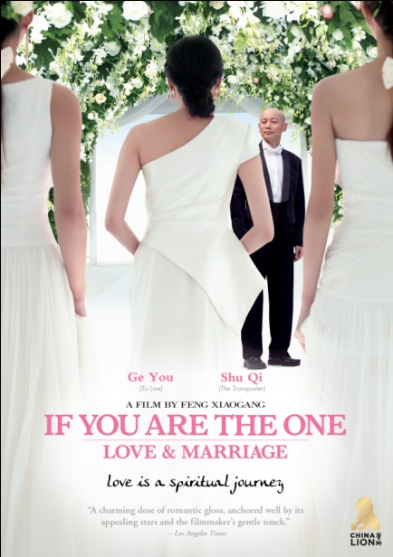

**ROMANCE LEADS TO MATRIMONY IN FENG XIAOGANG’S SEQUEL,**

**“IF YOU ARE THE ONE: LOVE AND MARRIAGE”**

**One of China’s Highest Grossing Films of All Time Releases Day-Date on VOD, Digital and DVD on December 13**

*November 16, 2011 – New York, NY* – ***IF YOU ARE THE ONE: LOVE AND MARRIAGE*** picks up where director **Feng Xiaogang**’s popular first romantic comedy ends: wealthy, middle-aged retiree, Qin Fen (**Ge You**), and serious-minded young airline attendant, Xiaoxiao (**Shu Qi**), enter into a “trial marriage” by living together full-time in a tropical villa. Here, in their seclusion, they learn more about each other, themselves and what it takes to make romance blossom. After opening in China, the U.S. and Canada during Christmas 2010 to stunning box office results, ***IF YOU ARE THE ONE: LOVE AND MARRIAGE*** will be available day-and-date on cable VOD, digital platforms and DVD in the U.S. and Canada on December 13.

**Feng Xiaogang** is considered China’s most successful commercial director, grossing more than $1 billion in aggregate sales on his films. In 2008, **If You Are the One** became China’s biggest box office hit ever at $52.6 million, followed by **Aftershock** in 2010 at $100 million. His 2009 drama, ***Assembly***, won numerous film awards, including the Hong Kong Film Award for Best Asian Film, a Shanghai Film Critics Award, and Golden Rooster Awards for Best Film and Best Director.

Shu Qi has established herself throughout world cinema, having received critical praise for a number of roles. For her role in *Portland Street Blues* (a spin-off of Andrew Lau’s film series, *Young and Dangerous*), she won the Best Supporting Actress award at the Hong Kong Academy Awards and the Golden Horse Awards. Western audiences will recognize Shu Qi in the action film *The Transporter*, with Jason Statham, and in *New York, I Love You.* She also stars in Andrew Lau’s *Legend of the Fist: Return of Chen Zen.*

One of mainland China’s best known actors, Ge You won the Best Actor award at the 1994 Cannes Film Festival for his role as Xu Fugui in Zhang Yimou’s *To Live*. He has been acting in Chinese films since 1985, including *Farewell My Concubine* and *After Separation*, for which he won a Golden Rooster Award for Best Actor. Other recent films include *The Founding of the Republic* and *Let the Bullets Fly*, starring Yun-Fat Chow.

***IF YOU ARE THE ONE: LOVE AND MARRIAGE*** also stars Honglei Sun and Yicong Wu. In addition to his director credit, Feng Xiaogang co-wrote the screenplay with Shuo Wang, and shares producer credit with Tongyuan Wang and Albert Yeung.

SRP: $26.95 US; $29.95 CAN  
Runtime: 123 minutes  
Rating: NR  
Catalog #: NNVG253270

Language: Mandarin, with Chinese and English subtitles  
Color: Color  
Audio Format: Dolby Digital 2.0 Stereo  
Genre: World Cinema, Comedy

**About New Video**  
Celebrating its 20th anniversary in 2011, New Video is a leading entertainment distributor and the largest aggregator of independent digital content worldwide. Headquartered in New York City, with an international presence in 45 territories, the company delivers feature films, TV programs and web originals via digital download, streaming media, video-on-demand, Blu-ray and DVD, and theatrical release. New Video streamlines the distribution and marketing process for filmmakers, producers and brand partners to bring a wide variety of fresh content to new audiences. The company’s library includes original TV series and movies from A+E® Home Entertainment, HISTORY™, and Lifetime®, unforgettable games and trophy sets from Major League Baseball®, storybook treasures from Scholastic®, award-winning documentaries from Docurama Films®, Arthouse Films, and Plexifilm, next-gen indies and web hits from Flatiron Film Company®, the best in Chinese cinema from China Lion, and festival picks from Tribeca Film. New Video is proud to distribute the 2011 Oscar®-nominated films Gasland, Waste Land and, on digital, Restrepo.

**About China Lion**  
China Lion Film Distribution is a joint venture between China-based Jiang Yanming and New Zealand-based Milt Barlow (the latter via his company, Incubate) with Yanming, the majority shareholder, serving in the role of President and Barlow serving as CEO.  China Lion has distribution agreements with some of China’s leading studios including Huayi Bros, Shanghai Film Group and PolyBona, and exclusive exhibition agreements with AMC in the U.S. and Toronto, Cineplex in Vancouver and Consolidated Theatres in Hawaii.  China Lion will release up to fifteen films each year, and wherever possible, seek to release its films day-and-date with mainland China.

**For more information, please contact:**  
Sommer Hixson, Media Relations

646-259-4138; [shixson@newvideo.com](mailto:shixson@newvideo.com)

**For Chinese press, please contact:**  
Cecilia Chen, China Lion  
213-785-5212; [Cecilia@chinalionentertainment.com](mailto:Cecilia@chinalionentertainment.com)