**FOR IMMEDIATE RELEASE**

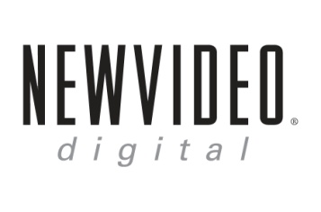 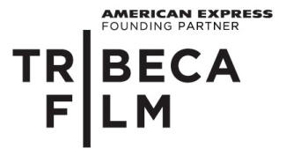

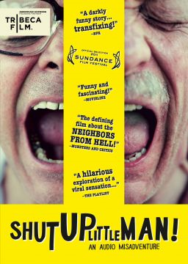

**“SHUT UP LITTLE MAN! AN AUDIO MISADVENTURE,”**

**RELEASES JANUARY 24 ON DIGITAL AND DVD**

**A dark-comedy documentary about the world’s first “viral” pop-culture sensation**

**“Alternately hilarious and discomfiting, and finally rather poignant." - *Variety***

***December 12, 2011*** – What do you get when two young punks move next door to violently noisy neighbors? The most important recording release of the 1990s grunge era. What started out as surreptitious tape recordings of two drunk men screaming, hitting and generally abusing each other became passed around underground cassette tapes that inspired CDs, comic artworks, stage plays, pop music and a Hollywood script war. Despite their popularity in the outside world, Peter Haskett and Raymond Huffman – the unwitting subjects – were not aware they had become a “viral” pop-culture sensation.

It all began in 1987 when Eddie Lee and Mitchell D. moved from the Midwest into a cheap apartment in San Francisco, only to experience their neighbors’ nightly rants through the paper-thin walls. Fearing for their lives, they began to tape record evidence of their disturbed neighbors and used the tapes to entertain their friends. The recordings soon spread like wildfire and created an underground culture obsessed with Peter and Raymond. After discovering the tapes and listening to them, artists began producing their own art, music and plays inspired by Peter and Raymond’s erratic behavior and verbal abuse towards each other.

A contemporary classic that uses creative storytelling techniques, ***SHUT UP LITTLE MAN! AN AUDIO MISADVENTURE*** captures the ultimate odd couple’s unexpected rise to fame and includes archival footage, new interviews with people involved in this cult phenomenon and humorous reenactments. The past unfolds as Eddie and Mitchell retell their story from 20 years ago of how they began recording Peter and Raymond’s horrifying, yet oddly catchy dialogue.

The film serves as a precursor to viral videos on the Internet, while examining the boundaries of privacy, art and exploitation as they slowly fade away.

***SHUT UP LITTLE MAN! AN AUDIO MISADVENTURE*** premiered at the 2011 Sundance Film Festival, followed by a well-received 20-city theatrical run. The film features interviews with fans and inspired artists, including Eddie and Mitchell; Comic Artists Daniel Clowes (Ghost World) and Ivan Brunetti (Schizo); Artist/Playwright Greg Gibbs; Film Director Mike Mitchell (*Shrek 4*); Radio Host Trademark G; Ursula and Bob Mothersbaugh from Devo and Doug Levy. Archival video footage of Peter is also included in the film after he is sought by people interested in making a film version of the Shut Up Little Man! story. Peter Neutman, a close friend of Peter and Raymond is interviewed by Mitchell while describing the nature of Peter and Raymond’s relationship.

Tribeca Film in partnership with American Express presents a Closer Production ***SHUT UP LITTLE MAN! AN AUDIO MISADVENTURE*** is directed and written by Matthew Bate; executive produced by Stephen Cleary and Julie Ryan; produced by Matthew Bate and Sophie Hyde; cinematography and edited by Bryan Mason. The DVD includes an extended interview with Ivan Brunetti, deleted/extended scenes and behind the scenes bonus features.

Pricing: $26.95 US

Runtime: 90 mins. + extras

Rating: N/A

Catalog #: NNVG261910

Language: English

Color: Color

Audio Format: Dolby Digital 2.0 Stereo

Genre: Documentary

**About Tribeca Film**  
Tribeca Film is a comprehensive distribution label dedicated to acquiring and marketing independent films across multiple platforms, including video-on-demand, theatrical and home video.  It is an initiative from Tribeca Enterprises designed to provide new platforms for how film can be experienced, while supporting filmmakers and introducing audiences to films they might not otherwise see. American Express continues its support of Tribeca and the independent film community by serving as the Founding Partner of Tribeca Film.

**About New Video**

Celebrating its 20th anniversary in 2011, New Video is a leading entertainment distributor and the largest digital aggregator of independent content worldwide. Headquartered in New York City, with an international presence in 45 territories, the company delivers feature films, TV programs and web originals via digital download, streaming media, video-on-demand, Blu-ray and DVD, and theatrical release. New Video streamlines the distribution and marketing process for filmmakers, producers and brand partners to bring a wide variety of fresh content to new audiences. The company’s library includes original TV series and movies from A+E® Home Entertainment, HISTORY™, and Lifetime®, unforgettable games and trophy sets from Major League Baseball®, storybook treasures from Scholastic®, award-winning documentaries from Docurama Films®, Arthouse Films, and Plexifilm, next-gen indies and web hits from Flatiron Film Company®, the best in Chinese cinema from China Lion, and festival picks from Tribeca Film. New Video is proud to distribute the 2011 Oscar®-nominated films Gasland, Waste Land and, on digital, Restrepo.

[www.newvideo.com](http://www.newvideo.com).

**For more information, please contact:**

Luis Garza; 646-259-4144; lgarza@newvideo.com

For Box Art:

<http://www.newvideo.com/new-video-digital/shut-up-little-man/>