**FOR IMMEDIATE RELEASE**



Presents

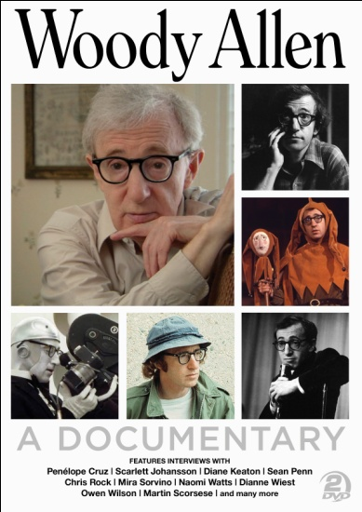

**DOCURAMA FILMS PRE-RELEASES**

**“WOODY ALLEN: A DOCUMENTARY”**

**IN TIME FOR THE HOLIDAYS**

**“AMERICAN MASTERS” TELEVISION SPECIAL**

**AVAILABLE DECEMBER 2 ON DVD AND DIGITAL PLATFORMS**

“WOODY ALLEN manages to astutely chronicle not only a career in film but to shed some light on the man behind the movies… there are plenty of moments when [Allen] seems at his most open and vulnerable.” – *The Hollywood Reporter*

*December 2, 2011 – New York, NY* – In 2010, iconic writer, director, actor, comedian, and musician Woody Allen allowed his life and creative process to be documented on-camera for the first time. With this unprecedented access, Emmy®-winning, Oscar®-nominated filmmaker Robert Weide (*Curb Your Enthusiasm*) followed the notoriously private film legend over a year and a half to create this ultimate film biography.

***WOODY ALLEN: A DOCUMENTARY***, the 2-part special that recently premiered on PBS’s *American Masters* series, debuts *today* on DVD at newvideo.com, ShopPBS.org and ShopThirteen.org, and digitally on iTunes. The full 2-disc DVD set with exclusive bonus material will be available at retail on February 14, 2012.

***WOODY ALLEN: A DOCUMENTARY*** chronicles the trajectory and longevity of Allen’s career: from his teenage years furnishing jokes for comics and publicists, his work in the 1950s-60s as a TV scribe for Sid Caesar, standup comedian and frequent TV talk show guest, to a writer-director averaging one film each year for more than 40 years.

Weide covers Allen’s earliest film work in *Take the Money and Run*, *Bananas*, *Sleeper*, and *Love and Death*; Oscar® favorites such as*Annie Hall*, *Manhattan*,*Zelig*, *Broadway Danny Rose*, *Purple Rose of Cairo*, *Crimes and Misdemeanors*, *Husbands & Wives*, *Bullets Over Broadway*, and *Mighty Aphrodite*; and his recent globetrotting phase with*Match Point*,*Vicky Cristina Barcelona*, and his latest critical and commercial success,

*Midnight in Paris*.  
  
Exploring the quintessential independent filmmaker’s writing habits, casting and directing styles, and relationship with his actors, Weide traveled with Allen from the London set of *You Will Meet a Tall Dark Stranger* to the Cannes premiere of*Midnight in Paris* this past May. He also filmed Allen at home, in the editing room, and touring his childhood haunts in the Midwood section of Brooklyn. New interviews provide insight and backstory: actors Antonio Banderas, Josh Brolin, Penelope Cruz, John Cusack, Larry David, Mariel Hemingway, Scarlett Johansson, Julie Kavner, Diane Keaton, Martin Landau, Louise Lasser, Sean Penn, Tony Roberts, Chris Rock, Mira Sorvino, Naomi Watts, Dianne Wiest, and Owen Wilson; writing collaborators Marshall Brickman, Mickey Rose and Doug McGrath; cinematographers Gordon Willis and Vilmos Zsigmond; Allen’s sister Letty Aronson; longtime manager Jack Rollins; casting director Juliet Taylor; pals Dick Cavett and director Martin Scorsese; and others.   
  
***WOODY ALLEN: A DOCUMENTARY*** also touches on Allen’s contributions as a writer for the theater and his humorous articles for *The New Yorker*, as well as his frequent moonlighting gig as a clarinet player with a New Orleans-style jazz band.

For more information and purchasing information:

New Video: <http://bit.ly/tjOrnC>

iTunes: <http://bit.ly/tlxSwU>

Shop PBS: <http://bit.ly/s7iKHS>

Shop Thirteen: <http://bit.ly/tJYsJ7>

**About Docurama Films**

In 1999, **NEW VIDEO** launched **Docurama Films**® with the first feature documentary available on DVD: D.A. Pennebaker’s *Bob Dylan: Dont Look Back.* Twelve years and 300 award-winning, highly-acclaimed documentary titles later, Docurama continues to discover and release the greatest non-fiction films of our time while spreading the word about filmmakers who are taking the form to new heights.  Docurama’s catalog features an array of topics including the performing and visual arts, history, politics, the environment, ethnic and gender interests, and all-time favorites including *The Wild Parrots of Telegraph Hill*, *Andy Goldsworthy:* *Rivers and Tides* and *King Corn.* Recent titles include the 2011 Oscar®-nominated film*, Gasland,* and the theatrical release of *Hell and Back Again*.

[www.docuramafilms.com](http://www.docuramafilms.com)

**About New Video**

Celebrating its 20th anniversary in 2011, New Video is a leading entertainment distributor and the largest aggregator of independent digital content worldwide. Headquartered in New York City, with an international presence in 45 territories, the company delivers feature films, TV programs and web originals via digital download, streaming media, video-on-demand, Blu-ray and DVD, and theatrical release. New Video streamlines the distribution and marketing process for filmmakers, producers and brand partners to bring a wide variety of fresh content to new audiences. The company’s library includes original TV series and movies from A+E® Home Entertainment, HISTORY™, and Lifetime®, unforgettable games and trophy sets from Major League Baseball®, storybook treasures from Scholastic®, award-winning documentaries from Docurama Films®, Arthouse Films, and Plexifilm, next-gen indies and web hits from Flatiron Film Company®, the best in Chinese cinema from China Lion, and festival picks from Tribeca Film. New Video is proud to distribute the 2011 Oscar®-nominated films Gasland, Waste Land and, on digital, Restrepo.

[www.newvideo.com](http://www.newvideo.com).

**For more information, please contact:**

Sommer Hixson; 646-259-4138; [shixson@newvideo.com](mailto:shixson@newvideo.com)