**FOR IMMEDIATE RELEASE**



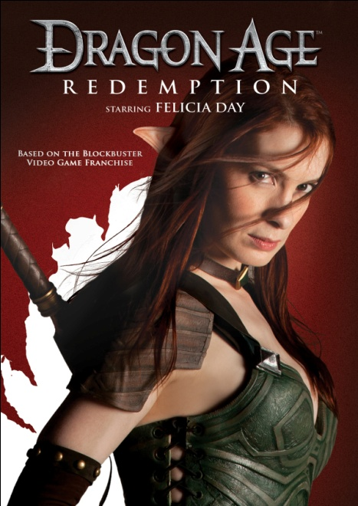

**FLATIRON FILM COMPANY RELEASES “DRAGON AGE: REDEMPTION,”**

**STARRING FELICIA DAY, FEBRUARY 14 ON DVD**

**Creator and Star of “The Guild” Brings Best-Selling Video Game to Life**

*January 18, 2012 – New York, NY* – In front of a packed panel at the 2011 San Diego Comic Con, *The Guild* creator **Felicia Day** unveiled the series’ trailer for the exciting new web original she wrote and produced, ***DRAGON AGE: REDEMPTION***. Following the premiere of the series in October 2011 on Machinima.com, all six episodes are now available on one DVD – with exclusive bonus material.

Set in the same time period as the hit Role-Playing Game (RPG), *Dragon Age II,* ***DRAGON AGE: REDEMPTION*** stars Day as Tallis, an Elven assassin hired by the Qunari to capture a rogue mage intent on wreaking havoc throughout the world. In her quest to find this dangerous mage, Tallis is joined by other companions who are not always aligned in their beliefs and goals, but who band together to defeat their foe, in an attempt to restore peace and balance to this dark fantasy universe.

***DRAGON AGE: REDEMPTION*** is a match made in gamer heaven. From Electronic Arts’ BioWare label, *Dragon Age II* sold 1 million copies in the first two weeks of its release in March 2011. *The Guild*, still going strong in its 5th season, is one of the most watched web series of all time and a valuable franchise for Ms. Day.

The cast also includesMarcia Battise, Masam Holden, Adam Rayner, Doug Jones. Peter Winther, director; John Bartley, director of photography; Greg Aronowitz, production designer; David Heinz, editor; Peter Winther, William Mesa, Emily Wallin, producers; Dan Kaplow, Kim Evey, Felicia Day and Greg Aronowitz, executive producers.

***DRAGON AGE: REDEMPTION***

Pricing: $14.95 US/$16.95 CAN

Runtime: 90 minutes, plus extras

Rating: Not Rated

Catalog #: NNVG262700

Language: English

Color: Color

Sound: Dolby Digital 2.0 Stereo

Genre: Drama, Web Series

More than 40 minutes of bonus material includes: Bioware TV’s “Working with Felicia”; Dragon Age Trailers and Premium Content; “Making Of” Stunts, Costumes and Characters; Audio Commentary with the Director and Producer; Bloopers.

**About New Video**

Celebrating its 20th anniversary in 2011, New Video is a leading entertainment distributor and the largest digital aggregator of independent content worldwide. Headquartered in New York City, with an international presence in 45 territories, the company delivers feature films, TV programs and web originals via digital download, streaming media, video-on-demand, Blu-ray and DVD, and theatrical release. New Video streamlines the distribution and marketing process for filmmakers, producers and brand partners to bring a wide variety of fresh content to new audiences. New Video recently launched Flatiron Film Company as a distribution brand for out-of-the-ordinary, often risk-taking films and original content.  Recent titles have included the Oscar®-nominated animated film, The Secret of Kells, web originals *Dr. Horrible’s Sing-Along Blog*, *Red vs. Blue*, and Kiefer Sutherland’s *The Confession*, Joseph Gordon-Levitt’s *hitRECord RECollection*, andthe theatrical release of José Padilha’s Elite Squad: The Enemy Within. [www.newvideo.com](http://www.newvideo.com).

**For more information, please contact:**

Sommer Hixson

646-259-4138

shixson@newvideo.com

**For box art and more product information, please visit:**

http://www.newvideo.com/new-video-digital/dragon-age-redemption-2/