**FOR IMMEDIATE RELEASE**



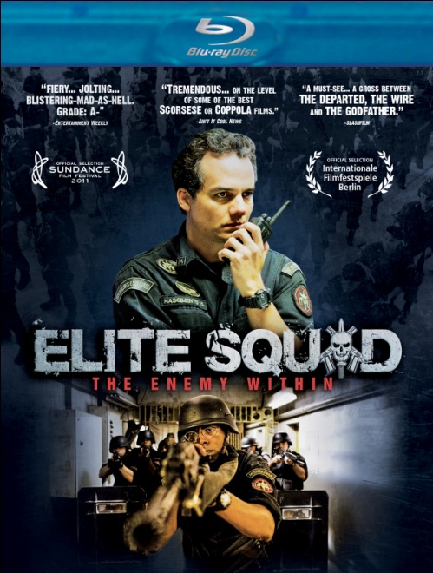

**NEW VIDEO’S FLATIRON FILM COMPANY RELEASES**

**JOSÉ PADILHA’S ACCLAIMED ACTION-THRILLER, “ELITE SQUAD: THE ENEMY WITHIN,”**

**FEBRUARY 14 ON VOD, DIGITAL AND DVD/BLU-RAY**

Brazil’s Highest-Grossing Film Available in Platform Release

Following U.S. Theatrical Tour

“A-. The pace is quick, the violence is rough, and the visual style is documentary.” -- *Entertainment Weekly*

“Wildy entertaining…ripped-from-the-headlines.” -- *Variety*

“Moving to its own throbbing beat…an exhilaratingly bleak vision.” – *A.V. Club*

*January 17, 2011 – New York, NY* – The sprawling slum that surrounds Rio de Janeiro is one of the most dangerous places on earth. As the head of Rio's Special Police Operations Battalion (BOPE), Captain Nascimento (**Wagner Moura**, *Elite Squad*) has seen his share of intense situations. When a BOPE mission to stop a jail riot ends in the violent death of a gang leader, Nascimento finds himself accused of a massacre...but the citizens of Rio, tired of the crime and drugs that plague their city, embrace him as a national hero.

On the heels of a successful U.S. theatrical tour, New Video’s Flatiron Film Company will release director José Padilha’s (*Elite Squad*, *Robocop*) acclaimed action-thriller, ***ELITE SQUAD: THE ENEMY WITHIN*** on Cable VOD, digital platforms, and on Blu-ray/DVD on February 14. Co-written by Padilha and Oscar® nominee Bráulio Mantovani (*City of God*), ***ELITE SQUAD: THE ENEMY WITHIN*** is Brazil’s highest-grossing film in more than 30 years and the country’s official submission for Best Foreign Picture in the 2012 Academy Awards®. Certified 95% Fresh on *Rotten Tomatoes*, the film received top critical reviews in the U.S. from *Entertainment Weekly*, *Variety*, *The Hollywood Reporter*, *The New York Times*, *The Chicago Sun-Times* and *The Onion A.V. Club*, among many others.

Since we last saw Nascimento, in Padilha’s original *Elite Squad*, he has been promoted to Sub-Secretary of Intelligence. In his powerful new post, he strengthens BOPE and brings the drug gangs who rule Rio’s *favelas* to their knees–only to come to the sobering realization that, by doing so, he’s made things easier for the corrupt cops and dirty politicians who are truly running the game. After years in the trenches Nascimento now finds that his new enemies are much more dangerous and, even worse, sitting at desks just down the hall.

Not as much a sequel as a reinvention, ***ELITE SQUAD: THE ENEMY WITHIN*** centers around the same themes of Brazil’s urban violence and mismanaged state institutions – the prison system, reformatories for petty criminals, and police departments – that Padilha addresses in *Elite Squad* and also in his acclaimed 2002 documentary, *Bus 174*. Says the director: “In this film, I didn't try to simply produce pure entertainment, but to approach a theme that is dear to me without turning away from the plot, taking the spectators' eyes off the action, or pausing for reflection.”

***ELITE SQUAD: THE ENEMY WITHIN***also stars **Irandhir Santos**, **André Ramiro**, **Maria Ribeiro** and internationally acclaimed musician, **Seu Jorge**; directed by **José Padilha**; written by **José Padilha** and **Bráulio Mantovani**; cinematography, **Lula Carvalho**; edited by **Daniel Rezende**; music by **Pedro Bromfman**; producers, **José Padilha** and **Marcos Prado**; executive producers, **James D’Arcy** and **Leonardo Edde**.

***ELITE SQUAD: THE ENEMY WITHIN***

Pricing: $34.95 US, $39.95 CAN – DVD/BD 2-pack

$29.95 US, $34.95 CAN – DVD single

Runtime: 116 minutes, plus extras

Rating: Not rated

Catalog #: NNVG257391

Language: Portuguese, with English subtitles

Color: Color

Sound: Dolby Digital 5.1 Surround

Genre: Action, Thriller

Bonus: 1-hour “Making Of” feature

**About New Video**

Celebrating its 20th anniversary in 2011, New Video is a leading entertainment distributor and the largest digital aggregator of independent content worldwide. Headquartered in New York City, with an international presence in 45 territories, the company delivers feature films, TV programs and web originals via digital download, streaming media, video-on-demand, Blu-ray and DVD, and theatrical release. New Video streamlines the distribution and marketing process for filmmakers, producers and brand partners to bring a wide variety of fresh content to new audiences. New Video recently launched Flatiron Film Company as a distribution brand for out-of-the-ordinary, often risk-taking films and original content.  Recent titles have included the Oscar®-nominated animated film, The Secret of Kells, web originals *Dr. Horrible’s Sing-Along Blog*, *Red vs. Blue*, and Felicia Day’s *The Guild* and *Dragon Age: Redemption*, Joseph Gordon-Levitt’s *hitRECord RECollection*, andthe theatrical release of José Padilha’s Elite Squad: The Enemy Within. [www.newvideo.com](http://www.newvideo.com).

**For more information, please contact:**

Sommer Hixson

646-259-4138

shixson@newvideo.com