** **

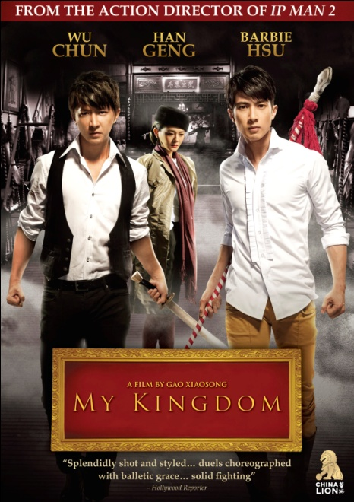

**NEW VIDEO AND CHINA LION PRESENT GAO XIAOSONG’S “MY KINGDOM,” STARRING YOUNG POP STARS WU CHUN, HAN GENG, AND BARBIE HSU**

**The Next Generation of Martial Arts Films, Choreographed by Hong Kong Movie Legend Sammo Hung, Releases February 14 on Digital and DVD**

“Splendidly shot and styled… duels choreographed with balletic grace.”

– *The Hollywood Reporter*

January XX, 2012 – New York, NY -- In the closing days of the 19th century, the Prince Regent of the crumbling Qing Dynasty orders the mass execution of the entire Meng clan. Before his beheading in a crowded Beijing marketplace, the Meng clan leader vows that his family will avenge this travesty of justice. Awaiting his death, a five-year-old Meng boy named Erkui bravely sings an aria. The power and purity of his voice touches the onlookers, including opera star Master Yu Shengying and his seven-year-old pupil Guan Yilong. Deeply moved, Master Yu rescues the boy and the two orphans, Yilong and Erkui, become brothers.

***MY KINGDOM*** releases on February 14 on digital platforms and DVD following a theatrical release through AMC Theaters in the U.S. and Canada.

A story of honor, love and revenge set against the backdrop of the Chinese opera during its heyday in 1920s Shanghai, ***MY KINGDOM*** centers on these two sworn brothers and their quest to regain their master’s honor. After years spent training in martial arts, Guan Yilong (Wu Chun, *14 Blades*) and Meng Erkui (Han Geng, *Beginning of the Great Revival*) pursue revenge and quickly succeed, establishing themselves as the newest sensations of the Shanghai opera scene. They experience fame and love with a beautiful actress, Xi Mulan (Barbie Hsu, *Future X-Cops*), but soon their collective pasts catch up with them and all three are tangled in a complex web of love, lust, deceit and betrayal.

Three of today’s biggest Asian pop stars are cast in this emotional and epic story about youth: Wu Chun, a member of the popular Taiwanese boy band, Fahrenheit, and former star in the hit Taiwanese TV series, *Romantic Princess;* Han Geng, former leader of the smash South Korean boy band, Super Junior; and Barbie Hsu, a revered singer and actress who started performing in the popular girl duo, A.S.O.S, and later starred in the popular Taiwanese TV drama, *Meteor Garden.*

Sammo Hung (*Ip Man 1 & 2*, *Detective Dee*) introduces a new genre of action choreography in ***MY KINGDOM*** by infusing his own signature style with a more dramatic flair for the powerful “wu sheng” roles of the Bejing Opera. Considered the voice of a new generation of Chinese filmmakers, Gao Xiaosong (*Rainbow*, *Where Have All the Flowers Gone*) directs an original screenplay by renowned writer Zou Jingzhi.

***MY KINGDOM***

SRP: $26.95 US; $29.95 CAN  
Runtime: 97 minutes  
Rating: NR  
Catalog #: NNVG262351

Language: Mandarin, with Chinese and English subtitles  
Color: Color  
Audio Format: Dolby Digital 5.1  
Genre: Martial Arts, World Cinema

**About New Video**  
Celebrating its 20th anniversary in 2011, New Video is a leading entertainment distributor and the largest aggregator of independent digital content worldwide. Headquartered in New York City, with an international presence in 45 territories, the company delivers feature films, TV programs and web originals via digital download, streaming media, video-on-demand, Blu-ray and DVD, and theatrical release. New Video streamlines the distribution and marketing process for filmmakers, producers and brand partners to bring a wide variety of fresh content to new audiences. The company’s library includes original TV series and movies from A+E® Home Entertainment, HISTORY™, and Lifetime®, unforgettable games and trophy sets from Major League Baseball®, storybook treasures from Scholastic®, award-winning documentaries from Docurama Films®, Arthouse Films, and Plexifilm, next-gen indies and web hits from Flatiron Film Company®, the best in Chinese cinema from China Lion, and festival picks from Tribeca Film. New Video is proud to distribute the 2011 Oscar®-nominated films Gasland, Waste Land and, on digital, Restrepo.

**About China Lion**  
China Lion Film Distribution specializes in the distribution of Chinese language films and entertainment outside Asia.  Its shareholders include founding partners Jiang Yanming (President),  Milt Barlow (CEO) and leading Chinese film studios Huayi Brothers Media Corporation and Bona Film Group Ltd.  China Lion has an exclusive exhibition agreement with AMC in the U.S. and Toronto.  China Lion aims to release the best of pan-Asian language films and, wherever possible, seeks to release day-and-date with mainland China and Asia.  China Lion has offices in Los Angeles, Toronto, Beijing, Sydney and Auckland.

**For more information, please contact:**  
Sommer Hixson, Media Relations

646-259-4138; [shixson@newvideo.com](mailto:shixson@newvideo.com)

**For Chinese press, please contact:**  
Cecilia Chen, China Lion  
213-785-5212; [Cecilia@chinalionentertainment.com](mailto:Cecilia@chinalionentertainment.com)