**FOR IMMEDIATE RELEASE**



presents

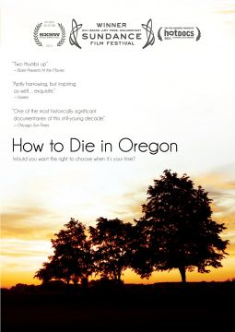

**“HOW TO DIE IN OREGON” RELEASES**

**FEBRUARY 14 ON DVD**

**Would You Want the Right to Choose When It’s Your Time?**

**“Will likely be viewed as one of the most historically significant documentaries of this still-young decade.”–*Chicago Sun-Times***

***January 12, 2012*** – In 1994, Oregon became the first state to legalize physician-assisted suicide. Since then, more than 500 Oregonians have ended their life using the law, known as the Death with Dignity Act. Despite the law’s controversy, there are many who support its power to end the suffering of either themselves or a loved one. ***HOW TO DIE IN OREGON*** follows the powerful stories of some of these people, as they grapple with their life circumstances and the concept of dying with dignity and control.

Director Peter Richardson’s film presents an emotional yet life-affirming look at death and dying through the eyes of the terminally ill as they consider whether to end their lives by lethal overdose. With the support and trust of his subjects and their families, Richardson is given unprecedented access to some of their most private and vulnerable moments as they share intimate stories and experiences with illness and their struggle in deciding whether to end their life.

The film provides a compassionate look at their lives and is clear-eyed and unflinching in its portrayal. ***HOW TO DIE IN OREGON*** features in-depth interviews with patients’ families and friends, activists, physicians and the patients themselves as they explore sensitive issues with courage and openness, despite the emotional turmoil it carries.

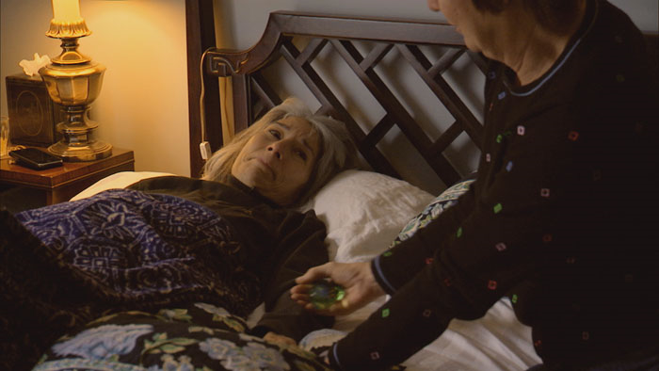

Taking a neutral stance, the film highlights:

* **“Compassion and Choices” Advocacy Group**—Sue Dessayer Porter has been an active member of the group for seven years and provides information and emotional support for terminally ill patients choosing to end their life. Volunteers from the group also assist in preparing patients before and during the aid-in-dying process.
* **Political Activists**—In the state of Washington, Nancy Niedzielski’s husband’s dying wish, following a battle with brain and spinal cord cancer, was that she help change the law. By campaigning intensely for the I-1000 initiative, she was part of the historic passing of the Death with Dignity Act in 2008, making Washington the second state to allow some terminally ill patients to end their lives.
* **Derek Humphry—**As the founder of the Hemlock Society in 1980, Humphry wrote the best-seller, *Final Exit,* and continues to advocate for other states to pass a law similar to the Death with Dignity Act in Oregon.
* **The Patients**—At the heart of the film are the terminally ill, who share their struggle while their family and friends stand by their side. Featured in the film are:
  + Cody Curtis, an eloquent and enlightened wife and mother suffering from liver cancer, who outlives her doctor’s expectations but is prepared to take matters into her own hands if the pain becomes unbearable.
  + Television and radio personality Ray Carnay, who recorded his eulogy in a studio after refusing to have his voice box removed due to throat cancer.
  + Randy Stroup, who was diagnosed with prostate cancer in 2006 and was outraged to learn that, while the Oregon health plan did not cover his cancer treatment, it offered comfort and palliative care options, which included physician aid-in-dying.

Today, the Death with Dignity Act remains a hot button issue in Capitol Hill as Massachusetts and Vermont are likely to include the controversial measure on the November 2012 ballot.

***HOW TO DIE IN OREGON*** won the Grand Jury Prize at the 2011 Sundance Film Festival, was a Top 10 Audience Favorite at Hot Docs, and won the Kathleen Bryan Edwards Award for Human Rights at the 2011 Full Frame Documentary Film Festival.

Following its cable premiere on HBO last May, ***HOW TO DIE IN OREGON*** will be released by Docurama Films on DVD on February 14.

***HOW TO DIE IN OREGON*** is directed and produced by Peter D. Richardson; executive produced by Melody Korenbrot and Sheila Nevins; edited by Peter D. Richardson and Greg Snider; music by Max Richter. The DVD includes closed captioning, deleted scenes, including Paul Darley’s story and a follow up with Nancy Niedzielski, theatrical trailer; filmmaker bio and Docurama trailers.

Pricing: $29.95 US

Runtime: 107 mins. + extras

Rating: NR

Catalog #: NNVG262670

Language: English

Color: Color

Audio Format: Dolby Digital 5.1 Stereo

Genre: Documentary

**About Docurama Films**

In 1999, **NEW VIDEO** launched **Docurama Films**® with the first feature documentary ever available on DVD: D.A. Pennebaker’s *Bob Dylan: Dont Look Back.* Twelve years and 300 award-winning, highly-acclaimed titles later, Docurama continues to discover and release the greatest non-fiction films of our time while spreading the word about filmmakers who are taking the form to new heights.  Docurama’s catalog features an topics including the performing and visual arts, history, politics, the environment, ethnic and gender interests, and all-time favorites including *The Wild Parrots of Telegraph Hill*, *Andy Goldsworthy:* *Rivers and Tides* and *King Corn.* Recent titles include the 2011 Oscar®-nominated film*, Gasland,* and the platform release of *Hell and Back Again*.

[www.docuramafilms.com](http://www.docuramafilms.com)

**About New Video**

Celebrating its 20th anniversary in 2011, New Video is a leading entertainment distributor and the largest digital aggregator of independent content worldwide. Headquartered in New York City, with an international presence in 45 territories, the company delivers feature films, TV programs and web originals via digital download, streaming media, video-on-demand, Blu-ray and DVD, and theatrical release. New Video streamlines the distribution and marketing process for filmmakers, producers and brand partners to bring a wide variety of fresh content to new audiences. The company’s library includes original TV series and movies from A+E® Home Entertainment, HISTORY™, and Lifetime®, unforgettable games and trophy sets from Major League Baseball®, storybook treasures from Scholastic®, award-winning documentaries from Docurama Films®, Arthouse Films, and Plexifilm, next-gen indies and web hits from Flatiron Film Company®, the best in Chinese cinema from China Lion, and festival picks from Tribeca Film. New Video is proud to distribute the 2011 Oscar®-nominated films Gasland, Waste Land and, on digital, Restrepo.

[www.newvideo.com](http://www.newvideo.com).

**For more information, please contact:**

Luis Garza; 646-259-4144;

lgarza@newvideo.com

For Box Art:

<http://www.newvideo.com/docurama/how-to-die-in-oregon/>