Plexifilm_Logo_Blk copy.jpg 

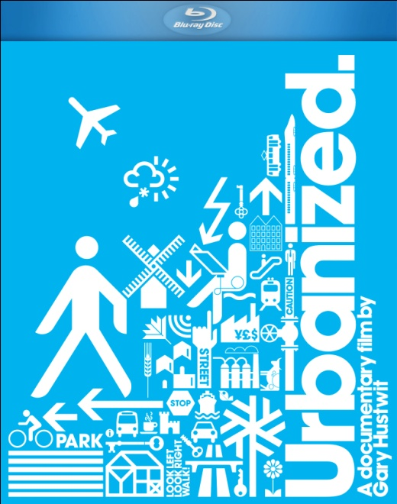

**PLEXIFILM AND NEW VIDEO RELEASE “URBANIZED” ON VOD AND DVD/BLU-RAY, FOLLOWING U.S. THEATRICAL TOUR AND DIGITAL LAUNCH**

January 20, 2012 – New York, NY -- Who is allowed to shape our cities, and how do they do it? And how does the design of our cities affect our lives? More than half the world’s population now lives in an urban area, and 75% will call a city home by 2050. But while some cities are experiencing explosive growth, others are shrinking. The challenges of balancing housing, mobility, public space, civic engagement, economic development and environmental policy are fast becoming universal concerns. Yet much of the dialogue on these issues is disconnected from the public domain.

By exploring a diverse range of urban design projects in dozens of cities around the world, from massive infrastructure initiatives to temporary interventions, ***URBANIZED*** frames a global discussion on the future of cities. Following a U.S. theatrical tour that began in October 2011, Plexfilm and New Video will wide release ***URBANIZED*** across cable VOD and Blu-ray/DVD. The film launched on digital platforms in December 2011.

The final documentary in director Gary Hustwit's design film trilogy (*Helvetica*, *Objectified*), *Urbanized* features some of the world's foremost architects, planners, policymakers, and thinkers, including Sir Norman Foster, Rem Koolhaas, Jan Gehl, Oscar Niemeyer, Amanda Burden, Enrique Peñalosa, Alejandro Aravena, Eduardo Paes, Rahul Mehrotra, Ellen Dunham-Jones, Ricky Burdett, James Corner, Michael Sorkin, Bruce Katz, Candy Chang, Edgar Pieterse, and many more, including extraordinary citizens who have affected change in their cities.

Says Hustwit: “Our cities struck me as the area of design that had the most impact on our lives. Ultimately I decided the best structure would be to look at specific issues that face all cities (housing, mobility, public space, sustainability, etc) and focus on projects in different cities around the world that addressed those issues. In that way we could make almost a composite city out of these projects, and showcase innovative thinking from both professionals and ordinary citizens.”

***URBANIZED*** is produced and directed by Gary Hustwit; Luke Geissbuhler, director of photography; Shelby Siegel and Michael Culyba, editors; Lucy Raven and Pamela Puchalski, associated producers; Shelby Siegel, associate producer.

Pricing: $34.95 US – BD single

$24.95 US – DVD single

Runtime: 85 minutes, plus extras

Rating: Not rated

Catalog #: NNVG268550 BD

NNVG265021 DVD

Language: English

Color: Color

Sound: Dolby Digital 5.1

Genre: Documentary

**About New Video**  
Celebrating its 20th anniversary in 2011, New Video is a leading entertainment distributor and the largest aggregator of independent digital content worldwide. Headquartered in New York City, with an international presence in 45 territories, the company delivers feature films, TV programs and web originals via digital download, streaming media, video-on-demand, Blu-ray and DVD, and theatrical release. New Video streamlines the distribution and marketing process for filmmakers, producers and brand partners to bring a wide variety of fresh content to new audiences. The company’s library includes original TV series and movies from A+E® Home Entertainment, HISTORY™, and Lifetime®, unforgettable games and trophy sets from Major League Baseball®, storybook treasures from Scholastic®, award-winning documentaries from Docurama Films®, Arthouse Films, and Plexifilm, next-gen indies and web hits from Flatiron Film Company®, the best in Chinese cinema from China Lion, and festival picks from Tribeca Film. New Video is proud to distribute the 2011 Oscar®-nominated films Gasland, Waste Land and, on digital, Restrepo.

**For more information, please contact:**  
Sommer Hixson, Media Relations

646-259-4138; [shixson@newvideo.com](mailto:shixson@newvideo.com)