**FOR IMMEDIATE RELEASE**



presents

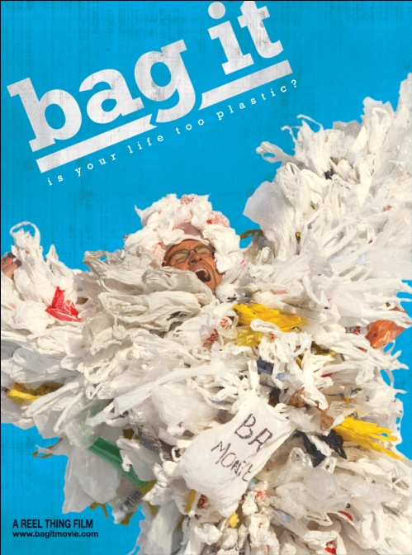

**REDUCE THE USE OF PLASTIC: “BAG IT”**

**RELEASES MARCH 13 ON DIGITAL AND ENVIRONMENTALLY-FRIENDLY DVD**

**Is Your Life Too Plastic?**

***February 13, 2012*** – Since plastic bags were introduced at grocery stores in 1977, people have been consuming nearly one million bags a minute. About 500 billion plastic bags are used in one year worldwide. Where does it all end up and what impact does it have on our environment, marine life and health?

In director Suzan Beraza’s award-winning documentary, ***BAG IT,*** host Jeb Berrier determines to answer this question as he takes a closer look at society’s addiction to plastic. He discovers that many of the products people use every day are made out of plastic and some contain potentially harmful chemical additives, such as Bisphenol A (BPA) and Phthalates, which are linked to illnesses and other health problems.

Berrier travels to Europe and several parts of the United States to meet with experts, activists, marine biologists, government officials and regular citizens who are concerned about the over-abundance of plastic and its disastrous impact on the environment and their health.

***BAG IT*** provides an entertaining but serious look at plastic bags while challenging their convenience and accessibility. Some of the key facts highlighted in the film include:

* The average American uses about 500 plastic bags each year, for an average of 12 minutes before they are discarded.
* Two million plastic bottles are consumed in the U.S. every five minutes; less than 25% are recycled.
* 14 million pounds of trash end up in the ocean each year.
* An estimated 100,00 marine mammals and sea birds die each year from becoming entangled in or ingesting plastic debris
* Plastic bags are made of fossil fuels such as petroleum and natural gas, which are non-renewable resources.
* Ireland and China significantly reduced their use of plastic bags:

1. Ireland reduced its plastic bag use by 90% after instituting a fee on single-use disposable plastic bags.
2. China banned “ultra thin” plastic bags in 2008. They reduced their use by 40 billion bags in the first year.

***BAG IT*** features in-depth interviews with actor and activist Peter Coyote, who is one of a handful of Americans to have a “body burden” test, New York City Council Speaker Christine Quinn, Seattle City Council president Richard Conlin, authors Annie Leonard (*The Story of Stuff*) and Dan Imhoff (*Paper or Plastic*), artist Chris Jordan and other individuals that are reducing the use of plastic in their lives and making the necessary changes to improve their environment.

The film received numerous film festival awards, including the Best of Festival at the Monterey Blue Oceans Film Festival, Best Documentary at the Durango International Film Festival and the Best Environmental Film at the Sedona International Film Festival. Packaging for the DVD is made of 100% plastic-free recycled material and environmentally-friendly ink.

***BAG IT*** is directed by Suzan Beraza; executive produced by Judith Kohin; produced by Michelle Hill and Suzan Beraza; and written by Michelle Curry Wright. Bonus features include Jeb in the Netherlands, Bioplastic pros and cons, an extended interview with Dr. Shanna Swan, Sylvia Earle talks about life before plastic, Wallace J. Nichols talks about the environmental movement, and Dr. Richard Thompson explains plastic and POPs.

Pricing: $29.95 US

Runtime: 78 mins. + extras

Rating: NR

Catalog #: NNVG262790

Language: English

Color: Color

Audio Format: Dolby Digital 2.0 Stereo

Genre: Documentary

**About Docurama Films**

In 1999, **NEW VIDEO** launched **Docurama Films**® with the first feature documentary ever available on DVD: D.A. Pennebaker’s *Bob Dylan: Dont Look Back.* Twelve years and 300 award-winning, highly-acclaimed titles later, Docurama continues to discover and release the greatest non-fiction films of our time while spreading the word about filmmakers who are taking the form to new heights.  Docurama’s catalog features an topics including the performing and visual arts, history, politics, the environment, ethnic and gender interests, and all-time favorites including *The Wild Parrots of Telegraph Hill*, *Andy Goldsworthy:* *Rivers and Tides* and *King Corn.* Recent titles include the 2011 Oscar®-nominated film*, Gasland,* and the platform release of *Hell and Back Again*.

[www.docuramafilms.com](http://www.docuramafilms.com)

**About New Video**

New Video is a leading entertainment distributor and the largest aggregator of independent digital content worldwide. Headquartered in New York City, with an international presence in 45 territories, the company delivers feature films, TV programs and web originals via digital download, streaming, video-on-demand, Blu-ray, DVD, and theatrical release. In 2011, New Video bowed Oscar®-nominated *Hell and Back Again* and South American blockbuster *Elite Squad: The Enemy Within* in US theaters. Through a new partnership with digital exhibitor Cinedigm Entertainment Group, New Video is poised to bring more independent films to theaters nationwide. New Video streamlines distribution and marketing for filmmakers and partners, bringing a wide variety of fresh content to new audiences. The company’s library includes original TV series and movies from A+E® Home Entertainment, HISTORY™, and Lifetime®, unforgettable games and trophy sets from Major League Baseball®, storybook treasures from Scholastic®, award-winning documentaries from Docurama Films®, next-gen indies from Flatiron Film Company®, and acclaimed independent films and festival picks through partnerships with the Sundance Institute and Tribeca Film. New Video is proud to distribute many Oscar®-nominated documentaries including Gasland, Waste Land, Paradise Lost 3: Purgatory and *Hell and Back Again*.

[www.newvideo.com](http://www.newvideo.com).

**For more information, please contact:**

Luis Garza; 646-259-4144;

lgarza@newvideo.com

For Box Art:

<http://www.newvideo.com/docurama/bag-it/>