**FOR IMMEDIATE RELEASE**



**Presents**

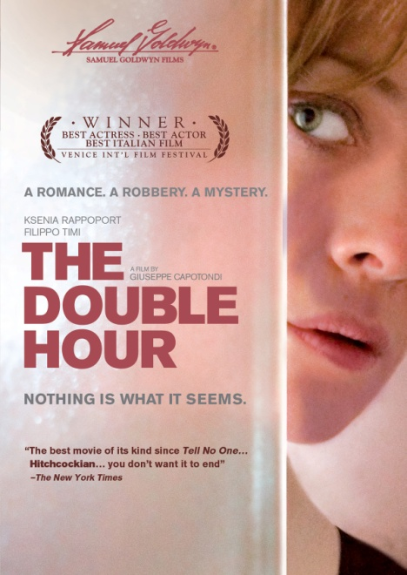

**SAMUEL GOLDWYN FILMS’ BOX OFFICE SENSATION**

**“THE DOUBLE HOUR” (La Doppia Ora),**

**RELEASES APRIL 3 ON DIGITAL AND DVD**

“The best movie of its kind since *Tell No One*… Hitchcockian… you don’t want it to end.”

—*The New York Times*

“Charismatic, nuanced performances that give an emotional resonance far beyond the

surprise twists.” *– Wall Street Journal*

“A suave, elliptically drawn neo-noir.” *– Movieline*

*February 16, 2012 – New York, New York* – Nothing is what it seems in Giuseppe Capotondi’s Italian thriller, ***THE DOUBLE HOUR***. Guido (Filippo Timi, *Vincere*), a former cop, is a luckless veteran of the speed-dating scene in Turin. But, much to his surprise, he meets Slovenian immigrant Sonia (Ksenia Rappoport), a chambermaid at a high-end hotel. The two hit it off and a passionate romance develops. After they leave the city for a romantic getaway in the country, things suddenly take a dark turn. As Sonia’s murky past resurfaces, her reality starts to crumble.  Everything in her life begins to change—questions arise and answers only arrive through a continuous twist and turn of events keeping viewers on edge until the film’s final moments.

At once a stark romance, a psychological thriller, and a story about possibilities, ***THE DOUBLE HOUR*** releases April 3 on DVD and digital platforms. The film had its world premiere at the 2009 Venice Film Festival, where Ksenia Rappoport won the best actress prize. Following a terrific reception there, the film went on to play the Toronto International Film Festival. ***THE DOUBLE HOUR*** has generated more than $1.5 million in U.S. box office. ***THE DOUBLE HOUR*** is a *New York Times* Critics’ Pick and rates 95% “certified fresh” with top film critics nationwide on *Rotten Tomatoes*. *The Hollywood Reporter* recently reported an American version of the film in the works to be written and directed by Joshua Marsten (*Maria Full of Grace*) and produced by **Roy Lee** (*The Departed*, *The Ring*) and **Nicola Giuliano, the latter of whom was a producer of the Italian version.**

Says Capotondi about his first feature film, “This film is aboutforgiveness and the capacity for forgiving yourself, all in the shape of a mystery. I was influenced by Italian film noir, or giallo, of the 70’s and 80’s, like the work of Dario Argento and Mario Bava. But, it also incorporates influences from Japanese horror. I was very interested in putting that on film: keeping in mind the Italian tradition but also looking for other inspiration.”

***THE DOUBLE HOUR*** also stars Antonia Truppo, Gaetano Bruno, Fausto Russo Alesi, and Michele Di Mauro; Giuseppe Capotondi, director; written by Alessandro Fabbri, Ludovica Rampoldi and Stefano Sardo; Tat Radcliffe, cinematographer; Guido Notari (A.M.C.), editor; Carlotta Calori, associate producer; Nicola Giuliano and Francesca Cima, producers; Viola Prestieri, executive producer; original music by Pasquale Catalano.

Pricing: $29.95 SRP

Runtime: 96 minutes, plus extras

Rating: N/A

DVD Catalog #: NNVG264441

Digital Catalog #: NNVG1558126687

Language: Italian, with English subtitles

Color: Color

Audio: Dolby Digital 2.0 Stereo

Genre: World Cinema, Suspense

**About New Video**

New Video is a leading entertainment distributor and the largest aggregator of independent digital content worldwide. Headquartered in New York City, with an international presence in 45 territories, the company delivers feature films, TV programs and web originals via digital download, streaming, video-on-demand, Blu-ray, DVD, and theatrical release. In 2011, New Video bowed Oscar®-nominated Hell and Back Again and South American blockbuster Elite Squad: The Enemy Within in US theaters. Through a new partnership with digital exhibitor Cinedigm Entertainment Group, New Video is poised to bring more independent films to theaters nationwide. New Video streamlines distribution and marketing for filmmakers and partners, bringing a wide variety of fresh content to new audiences. The company’s library includes original TV series and movies from A+E® Home Entertainment, HISTORY™, and Lifetime®, unforgettable games and trophy sets from Major League Baseball®, storybook treasures from Scholastic®, award-winning documentaries from Docurama Films®, next-gen indies from Flatiron Film Company®, and acclaimed independent films and festival picks through partnerships with the Sundance Institute and Tribeca Film. New Video is proud to distribute many Oscar®-nominated documentaries including GasLand, Waste Land, Paradise Lost 3: Purgatory and Hell and Back Again.

**About Samuel Goldwyn Films**

Samuel Goldwyn Films is a major, independently owned and operated motion-picture company that develops, produces and distributes innovative feature films and documentaries.  The company is dedicated to working with both world renowned and emerging writers/filmmakers and committed to filmed entertainment that offers original voices in uniquely told stories.  This is best exemplified by the Academy Award® nominated THE SQUID AND THE WHALE and SUPER SIZE ME, AMAZING GRACE and Julie Delpy's hit comedy 2 DAYS IN PARIS. Past Goldwyn titles include PRICELESS, a romantic comedy starring Audrey Tautou, Academy Award® winner Claude Lelouch's ROMAN DE GARE, the critically hailed ELEGY starring Academy Award® nominee Penélope Cruz, HARRY BROWN starring Michael Caine and the box office smash FIREPROOF.   MAO’S LAST DANCER, directed by Academy Award nominee Bruce Beresford was one of the top grossing independent films of 2010. In addition to THE DOUBLE HOUR, a revered thriller that was one of the top foreign language grossers of 2011, SGF released THE WHISTLEBLOWER, a powerful, ripped from the headlines thriller starring Academy Award® winner Rachel Weisz that premiered at last year’s Toronto Film Festival. Upcoming releases include THE ISLAND PRESIDENT, winner of this year’s Audience Award at Toronto about former President Mohamed Nasheed of the Maldives, a man confronting a problem greater than any other world leader has ever faced – the literal survival of his country and everyone in it, DIANA VREELAND THE EYE HAS TO TRAVEL, an acclaimed documentary about the late fashion icon which premiered at this year’s Venice Film Festival and ROBOT & FRANK starring Frank Langella and Susan Sarandon that was a huge a hit at this year’s Sundance Film Festival

**For more information, please contact:**

Sommer Hixson; 646-644-1546; [shixson@newvideo.com](mailto:shixson@newvideo.com)

**For box art, please visit:**

<http://www.newvideo.com/new-video-digital/double-hour/>