**FOR IMMEDIATE RELEASE**



**Presents**

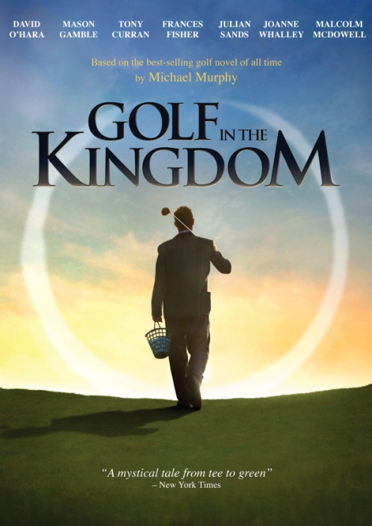

**“GOLF IN THE KINGDOM,” BASED ON MICHAEL MURPHY’S BEST-SELLING NOVEL, AVAILABLE MAY 15 ON DVD AND DIGITAL**

**Stellar Cast Includes Frances Fisher, David O’Hara, Joanne Whalley,**

**Julian Sands and Malcolm McDowell**

***March 23, 2012 – New York, New York*** – En route to India in 1956, a young American philosophy student, Michael Murphy (**Mason Gamble**, *Rushmore*), takes a detour to the legendary Links of Burningbush. Seeking to enjoy one last round before giving up his beloved game, he is unexpectedly paired with the mysterious, mischievous golf pro Shivas Irons (**David O’Hara**, *The Tudors,* *The Departed*). The wild adventure he shares with his enigmatic teacher over the next 24 hours will change Murphy’s perception of golf and life indelibly.

Directed by Susan Streitfeld (*Female Perversions*), **GOLF IN THE KINGDOM** is adapted from Michael Murphy’s 1972 classic novel of the same name – the best-selling work of fiction ever written about the game, deemed “a masterpiece on the mysticism of golf” by the *San Francisco Chronicle*. The film, in which **Frances Fisher** (*Titanic*), **Joanne Whalley** (*The Borgias*), **Julian Sands** (*Room with a View*) and **Malcolm McDowell** (*A Clockwork Orange*) round out the distinguished cast, premiered theatrically in July 2011 and will be available May 15 on standard digital platforms and DVD. ***GOLF IN THE KINGDOM*** is available now on-demand until April 14.

Penguin Books re-released *Golf in the Kingdom* in 2011 with a new forward and new artwork. Michael Murphy is the co-founder and chairman of the renowned [Esalen Institute](http://www.esalen.org/) in Big Sur. During his forty-year involvement in the human potential movement, Murphy and his work have been profiled in *The New Yorker* and featured in many magazines and journals worldwide. After graduating from Stanford University, he continued graduate work there in philosophy, practiced meditation at the Sri Aurobindo Ashram in South India in 1956 and 1957, and co-founded Esalen in 1962.

***GOLF IN THE KINGDOM*** features original music by **Dame Evelyn Glennie (*Touch the Sound*) and** a supporting cast that includes Tony Curran, Jim Turner and Catherine Kellner. Directed by Susan Streitfeld; screenplay by Michael Murphy based on his novel; Arturo D. Smith, director of photography; Kathryn Himoff, editor; Mindy Affrime, producer; Jonathan Dana, consulting producer; Frances Fisher and Catherine Kellner, co-executive producers; **George Stephanopoulos, Executive Producer. DVD bonus includes a** Behind the Scenes feature and interviews with Michael Murphy, Mason Gamble and Malcolm McDowell.

Pricing: $24.95 US/$29.95 CAN

Runtime: 87 minutes, plus extras

Rating: N/A

DVD Catalog #: NNVG256831

Digital Catalog #: NNVG6856

Language: English

Color: Color

Audio: Dolby Digital 2.0 Stereo

Genre: Drama, Spirituality, Sports

**About New Video**

New Video is a leading entertainment distributor and the largest aggregator of independent digital content worldwide. Headquartered in New York City, with an international presence in 45 territories, the company delivers feature films, TV programs and web originals via digital download, streaming, video-on-demand, Blu-ray, DVD, and theatrical release. In 2011, New Video bowed Oscar®-nominated Hell and Back Again and South American blockbuster Elite Squad: The Enemy Within in US theaters. Through a new partnership with digital exhibitor Cinedigm Entertainment Group, New Video is poised to bring more independent films to theaters nationwide. New Video streamlines distribution and marketing for filmmakers and partners, bringing a wide variety of fresh content to new audiences. The company’s library includes original TV series and movies from A+E® Home Entertainment, HISTORY™, and Lifetime®, unforgettable games and trophy sets from Major League Baseball®, storybook treasures from Scholastic®, award-winning documentaries from Docurama Films®, next-gen indies from Flatiron Film Company®, and acclaimed independent films and festival picks through partnerships with the Sundance Institute and Tribeca Film. New Video is proud to distribute many Oscar®-nominated documentaries including GasLand, Waste Land, Paradise Lost 3: Purgatory and Hell and Back Again.

**For more information, please contact:**

Sommer Hixson; 646-644-1546; [shixson@newvideo.com](mailto:shixson@newvideom.com)

**For box art, please visit:**

<http://www.newvideo.com/new-video-digital/golf-in-the-kingdom/>