**FOR IMMEDIATE RELEASE**



**Presents**

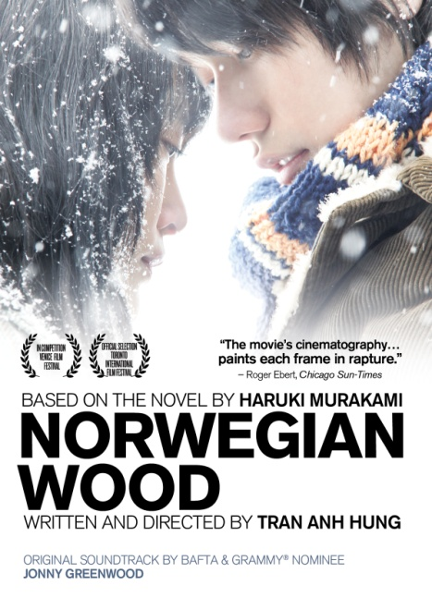

**“NORWEGIAN WOOD,” TRAN ANH HUNG’S ACCLAIMED FILM ADAPTION**

**OF MURAKAMI’S BELOVED NOVEL, AVAILABLE MAY 15 ON DVD AND DIGITAL**

“An elegant, immaculately shot meditation on survival and loss.” – *A.V. Club*

“A wonderful, passionate, well-nigh unforgettable adaptation of a great novel.” – *Salon*

***March 21, 2012 – New York, New York –*** Tokyo, the late 1960s…Students around the world are uniting to overthrow the establishment and Toru Watanabe’s personal life is similarly in tumult. At heart, he is deeply devoted to his first love, Naoko, a beautiful and introspective young woman. But their complex bond has been forged by the tragic death of their best friend years before. Watanabe lives with the influence of death everywhere. That is, until Midori, a girl who is everything that Naoko is not – outgoing, vivacious and extremely self-confident – marches into his life and Watanabe must choose between his past and his future.

Based on the bestselling novel of the same name by **Haruki Murakami** (*IQ84*, *The Wind-Up Bird Chronicle*), ***NORWEGIAN WOOD***, directed by Oscar®-nominated Vietnamese filmmaker **Tran Anh Hung** (*The Scent of Green Papaya, Cyclo*) releases on standard digital platforms and DVD on May 15. The film features rising stars **Kenichi Matsuyama** (*Death Note*, *Detroit Metal City*) as Toru, Oscar®-nominated **Rinko Kikuchi** (*Babel*) as Naoko, and newcomer **Kiko Mizuhara** as Midori. BAFTA and Grammy®-winning composer **Jonny Greenwood** (*There Will Be Blood*), of the band Radiohead, wrote the original music score. ***NORWEGIAN WOOD*** was nominated for the Golden Lion Award at the 2010 Venice Film Festival and was an official selection at the 2010 Toronto Film Festival. The film released theatrically by Soda Pictures and Red Flag Releasing in January 2012.

Says Tran Anh Hung: “*Norwegian Wood* is a fantastic novel that brilliantly portrays the radical inner lives of youth, seeking to define their lives and accepting the consequences as they fall in love and honestly confront their emotions. The story is told in a nostalgic voice, looking back at the past, but I wanted to recreate the raw painfulness of fresh wounds.”

The upwards of 10 million copies of *Norwegian Wood* sold worldwide since the novel was published in 1987 is a testament to its popularity. Murakami’s book (published by Random House) is now available in 36 countries and is translated into 33 different languages.

***NORWEGIAN WOOD*** also stars Reika Kirishima, Kengo Kora, Eriko Hatsune, and Tetsuji Tamayama; written and directed by Tran Anh Hung, based on the novel by Haruki Murakami; Mark Lee Ping Bin, director of photography; Mario Battistel, editor; Kaoru Matsuzaki and Joe Ikeda, associate producers; Shinji Ogawa, producer; Michael J. Werner and Wouter Barendrecht, co-executive producers; Masao Teshima and Chihiro, executive producers; original music by Jonny Greenwood. DVD bonus features include “The Making of *NORWEGIAN WOOD*” and a featurette on the film’s premiere at the Venice Film Festival.

Pricing: $29.95 SRP

Runtime: 113 minutes, plus extras

Rating: N/A

DVD Catalog #: NNVG269200

Digital Catalog #: NNVG6856

Language: Japanese, with English subtitles

Color: Color

Audio: Dolby Digital 5.1 Stereo

Genre: Drama, World Cinema

**About New Video**

New Video is a leading entertainment distributor and the largest aggregator of independent digital content worldwide. Headquartered in New York City, with an international presence in 45 territories, the company delivers feature films, TV programs and web originals via digital download, streaming, video-on-demand, Blu-ray, DVD, and theatrical release. In 2011, New Video bowed Oscar®-nominated Hell and Back Again and South American blockbuster Elite Squad: The Enemy Within in US theaters. Through a new partnership with digital exhibitor Cinedigm Entertainment Group, New Video is poised to bring more independent films to theaters nationwide. New Video streamlines distribution and marketing for filmmakers and partners, bringing a wide variety of fresh content to new audiences. The company’s library includes original TV series and movies from A+E® Home Entertainment, HISTORY™, and Lifetime®, unforgettable games and trophy sets from Major League Baseball®, storybook treasures from Scholastic®, award-winning documentaries from Docurama Films®, next-gen indies from Flatiron Film Company®, and acclaimed independent films and festival picks through partnerships with the Sundance Institute and Tribeca Film. New Video is proud to distribute many Oscar®-nominated documentaries including GasLand, Waste Land, Paradise Lost 3: Purgatory and Hell and Back Again.

**For more information, please contact:**

Sommer Hixson; 646-644-1546; [shixson@newvideo.com](mailto:shixson@newvideom.com)

**For box art, please visit:**

<http://www.newvideo.com/new-video-digital/norwegian-wood/>