**FOR IMMEDIATE RELEASE**



Presents

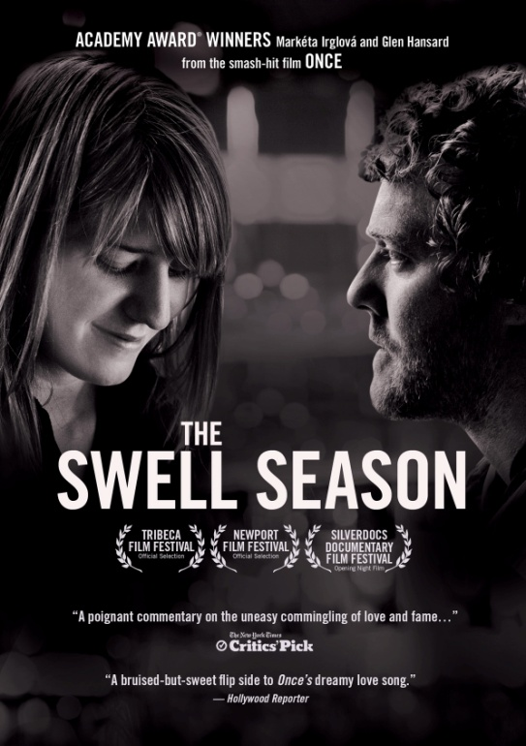

**A TRUE STORY OF LOVE, MUSIC AND THE PRICE OF FAME,**

**“THE SWELL SEASON,” PREMIERES MARCH 13 ON VOD, DIGITAL AND DVD**

"A poignant commentary on the uneasy co-mingling of love and fame.”

– *The New York Times Critics Pick* 

**"A bruised-but-sweet flip side to *Once*'s dreamy love song."**

**– *The Hollywood Reporter***

**"A documentary every bit as intimate and disarming as the movie that made them famous." – *The Washington Post***

**February 10, 2012 – New York, NY –** Singer-songwriters **Glen Hansard** (*The Commitments*) and **Markéta Irglová** were catapulted into the spotlight when they won the 2007 Oscar® for Best Original Song (“Falling Slowly”). The world fell in love with them as the two musicians fell in love with each other. But behind the scenes, where Glen and Markéta’s on-screen romance became reality, a grueling two-year world tour threatened to fracture their fated bond. ***THE SWELL SEASON***, directed by **Nick August-Perna**, **Chris Dapkins**, and **Carlo Mirabella-Davis**, is a story of lovers, the burden of dreams, dark family legacies, and in the end, the eternal bond between two searching souls forever linked by their music.

In 2005, Hansard, the lead singer of The Frames, and Irglova recorded an album together in Prague while working together on the soundtrack of Jan Hrebejk's movie, *Beauty In Trouble*. Their first album together, “The Swell Season,” was released in April 2006 and was partially the inspiration for John Carney’s 2007 Irish indie film, *Once*. The pair not only wrote the songs for the movie but starred in it as well. Since then, Glen and Marketa toured extensively as The Swell Season and, in 2009, released a new album, “Strict Joy.”

***THE SWELL SEASON*** follows the two artists through a period of extraordinary post-Oscar® intensity and pressure while on tour. Their experiences during this time drive both musicians to question their ambitions, identities and, ultimately, their relationship.

From the directors: “We had always wanted ***THE SWELL SEASON***to stand alone as an intensely personal film. We also knew that to do this right we would need complete access and unlimited time. To their credit, Glen and Markéta were brave enough to agree to both, and so we began what turned into a three-year filmmaking odyssey. From the outset we wanted to forge a strong visual language based on a verité, fly on the wall approach. And since *Once* was a fiction film leaning towards documentary, we designed our documentary to tack towards a classic fiction film language.”

Glen and Markéta now actively tour as solo artists and the film *Once* lives on in a new musical opening on Broadway in March. Gorgeously filmed in black and white and overflowing with live music and performances,***THE SWELL SEASON***is an intimate look at the exhilaration and turmoil created by both love and fame. The film premiered at the 2011 Tribeca Film Festival and was the opening night film at Silverdocs Documentary Film Festival, followed by several other film festivals and a critically-praised U.S. theatrical debut in October 2011.

In addition to co-directing the film, Chris Dapkins is cinematographer, Nick August-Perna is editor, and Carlo Mirabella-Davis is producer; additional music by Iron & Wine (Samuel Beam). Bonus features include deleted scenes and extended live concert footage.

Pricing: $29.95 US

Runtime: 90 mins. + extras

Rating: NA

Catalog #: NNVG262771

Language: English

Color: Black & White

Audio Format: Dolby Digital 2.0 Stereo

Genre: Documentary, Music

**About Once the Musical**

**ONCE**, an acclaimed new musical based on the 2007 Academy Award-winning film, will open Sunday, March 18 at the Bernard B. Jacobs Theatre (242 West 45th Street).  **ONCE** features a book by award-winning Irish playwright & screenwriter, **Enda Walsh**, the Academy Award-winning music and lyrics of **Glen Hansard** and **Markéta Irglová**, direction by the acclaimed **John Tiffany**,movement by **Steven Hoggett** and music supervision and orchestrations by **Martin Lowe**. Tickets for the Broadway production are now on sale via Telecharge.com or by phone at 212-239-6200.  For more information, please visit [www.oncemusical.com](http://www.oncemusical.com).

**About Docurama Films**

In 1999, **NEW VIDEO** launched **Docurama Films**® with the first feature documentary ever available on DVD: D.A. Pennebaker’s *Bob Dylan: Dont Look Back.* Twelve years and 300 award-winning, highly-acclaimed titles later, Docurama continues to discover and release the greatest non-fiction films of our time while spreading the word about filmmakers who are taking the form to new heights.  Docurama’s catalog features an topics including the performing and visual arts, history, politics, the environment, ethnic and gender interests, and all-time favorites including *The Wild Parrots of Telegraph Hill*, *Andy Goldsworthy:* *Rivers and Tides* and *King Corn.* Recent titles include the 2011 Oscar®-nominated film*, Gasland,* and the platform release of *Hell and Back Again*. [www.docuramafilms.com](http://www.docuramafilms.com)

**About New Video**

New Video is a leading entertainment distributor and the largest aggregator of independent digital content worldwide. Headquartered in New York City, with an international presence in 45 territories, the company delivers feature films, TV programs and web originals via digital download, streaming, video-on-demand, Blu-ray, DVD, and theatrical release. In 2011, New Video bowed Oscar®-nominated Hell and Back Again and South American blockbuster Elite Squad: The Enemy Within in US theaters. Through a new partnership with digital exhibitor Cinedigm Entertainment Group, New Video is poised to bring more independent films to theaters nationwide. New Video streamlines distribution and marketing for filmmakers and partners, bringing a wide variety of fresh content to new audiences. The company’s library includes original TV series and movies from A+E® Home Entertainment, HISTORY™, and Lifetime®, unforgettable games and trophy sets from Major League Baseball®, storybook treasures from Scholastic®, award-winning documentaries from Docurama Films®, next-gen indies from Flatiron Film Company®, and acclaimed independent films and festival picks through partnerships with the Sundance Institute and Tribeca Film. New Video is proud to distribute many Oscar®-nominated documentaries including GasLand, Waste Land, Paradise Lost 3: Purgatory and Hell and Back Again.

**For more information, please contact:**

Sommer Hixson

[shixson@newvideo.com](mailto:shixson@newvideo.com)

(646) 259-4138

**For more product information:**

http://www.newvideo.com/docurama/the-swell-season/