**FOR IMMEDIATE RELEASE**

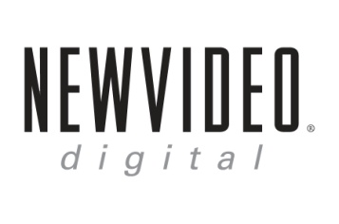 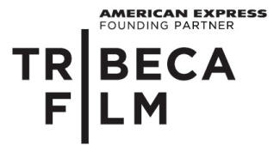

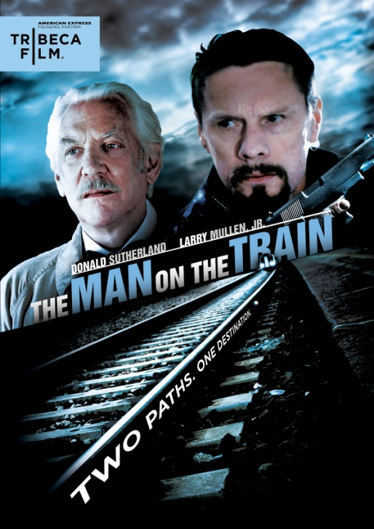

**“THE MAN ON THE TRAIN,” STARRING DONALD SUTHERLAND AND MUSICIAN**

**LARRY MULLEN, JR., DEBUTS APRIL 17 ON DIGITAL & DVD**

“Donald Sutherland offers one of his finest performances.”—*Variety*

*March 8, 2012 – New York, NY –* A mysterious criminal rolls into a small town planning to knock off the local bank, assuming it will go off without a hitch. But when he encounters a retired poetry professor, his plans take an unlikely turn. With no place to stay, the professor generously welcomes him into his home. As the two men talk, a bond forms between these two polar opposites, and surprising moments of humor and compassion emerge. As they begin to understand each other more, they each examine the choices they’ve made in their lives – secretly longing to live the type of lifestyle the other man has lived, based on the desire to escape their own.

An English language adaption of Patrice Leconte’s acclaimed French crime drama “L’Homme du Train,” ***THE MAN ON THE TRAIN*** stars Donald Sutherland as The Professor and Larry Mullen, Jr. in his acting debut as The Thief. The original version, which won awards and critical praise when it premiered in 2002, starred Jean Rochefort and Johnny Hallyday (a renowned musician widely known as the “French Elvis Presley.”)

***THE MAN ON THE TRAIN*** also stars Kate O’Toole, Tony Nardi, Carlo Rota, and Graham Greene. Adapted by Mary McGuckian from a screenplay by Patrice Leconte and Claude Klot; Stefan von Bjorn, cinematography; Mary McGuckian, Larry Mullen, Jr. and Martin Katz, producers. The DVD includes deleted scenes.

Pricing: $26.95 US

Runtime: 90 minutes

Rating: NR

Catalog #: NNVG265111

Language: English

Color: Color

Audio Format: Dolby Digital 5.1 Stereo

Genre: Drama, Thriller

**About Tribeca Film**  
Tribeca Film is a comprehensive distribution label dedicated to acquiring and marketing independent films across multiple platforms, including video-on-demand, theatrical and home video.  It is an initiative from Tribeca Enterprises designed to provide new platforms for how film can be experienced, while supporting filmmakers and introducing audiences to films they might not otherwise see. American Express continues its support of Tribeca and the independent film community by serving as the Founding Partner of Tribeca Film.

**About New Video**

New Video is a leading entertainment distributor and the largest aggregator of independent digital content worldwide. Headquartered in New York City, with an international presence in 45 territories, the company delivers feature films, TV programs and web originals via digital download, streaming, video-on-demand, Blu-ray, DVD, and theatrical release. In 2011, New Video bowed Oscar®-nominated Hell and Back Again and South American blockbuster Elite Squad: The Enemy Within in US theaters. Through a new partnership with digital exhibitor Cinedigm Entertainment Group, New Video is poised to bring more independent films to theaters nationwide. New Video streamlines distribution and marketing for filmmakers and partners, bringing a wide variety of fresh content to new audiences. The company’s library includes original TV series and movies from A+E® Home Entertainment, HISTORY™, and Lifetime®, unforgettable games and trophy sets from Major League Baseball®, storybook treasures from Scholastic®, award-winning documentaries from Docurama Films®, next-gen indies from Flatiron Film Company®, and acclaimed independent films and festival picks through partnerships with the Sundance Institute and Tribeca Film. New Video is proud to distribute many Oscar®-nominated documentaries including GasLand, Waste Land, Paradise Lost 3: Purgatory and Hell and Back Again.

**For more information, please contact:**

Luis Garza; 646-259-4144; lgarza@newvideo.com

For Box Art:

<http://www.newvideo.com/new-video-digital/man-on-the-train/>