**FOR IMMEDIATE RELEASE**

 

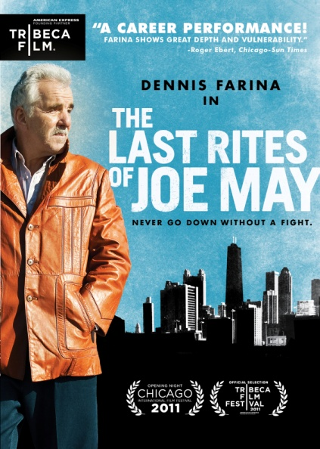

**“THE LAST RITES OF JOE MAY,” STARRING DENNIS FARINA,**

**RELEASES APRIL 17 ON DIGITAL & DVD**

“Mr. Farina has never been more in control of his ‘instrument’… or more convincing.”

– *The Wall Street Journal*

“One of the best performances of the year.” – *The New York Post*

“The film belongs to Farina, whose history as an actor given to tough-guy roles adds poignancy to a character whose last days are a lesson in humility and grace.” – *AV Club*

*March 8, 2012 – New York, NY* – Despite all evidence to the contrary, aging short-money hustler Joe May (Dennis Farina, *Get Shorty*, HBO’s *Luck*) always believed he had a glorious future ahead of him. Now in his sixties, Joe is released from the hospital after a long battle with pneumonia and forced to confront the harsh reality of his legacy: everyone he knew had assumed he was dead, and life had gone on around him without missing a beat.

Returning to his old neighborhood in Chicago’s “Patch” district, he finds his car gone, all his worldly possessions pawned by his landlord, and the apartment he’s lived in his entire adult life rented out to a single mother named Jenny and her eight year-old daughter Angelina . After a rough night’s sleep outdoors, Joe reluctantly moves in with the new tenants of his home – at least until he is able to get back on his feet.

The fifth feature film from writer and director Joe Maggio (*Virgil Bliss*, *Bitter Feast*), ***THE LAST RITES OF JOE MAY*** releases April 17 on standard digital platforms and DVD, following a theatrical and cable VOD release by Tribeca Film last fall.

Says Maggio: “I began writing more specific notes for ***THE LAST RITES OF JOE MAY*** shortly after seeing Di Sica’s *Umberto D* for the first time. The hero in his film had worked hard his entire life and now, in his retirement, when all he wanted was a warm place to sleep, a little food for himself and his dog, and perhaps a kind word now and then from an old acquaintance – somehow, even this was too much to ask for. Joe’s trouble isn’t that he fails to live up to this code, it’s that the world has changed to such a degree that in obeying these rules Joe is, in a sense, holding devalued currency.” When ***JOE MAY*** premiered in theaters last fall, *The New York Times* wrote “Mr. Maggio’s strengths are a sense of intimacy and textured place.” Film critic Roger Ebert praised Maggio as “a sure-handed director with a good eye.”

The film also stars Jamie Ann Allman (AMC’s *The Killing*), Ian Barford (*The Road to Perdition*), Meredith Droeger (*Extraordinary Measures*), Chelcie Ross (AMC’s *Mad Men*), and Gary Cole (*Office Space*, *Dodgeball*). Written and directed by Joe Maggio; Jay Silver, director of photography; Seth Anderson, editor; Lindsay Marcus, composer; Bill Straus and Stephanie Striegel, producers; Tim Evans and Dennis Mastro, executive producers. Bonus material includes an Interview with Director Joe Maggio, Presented by American Express, and outtakes.

Pricing: $26.95 US

Runtime: 107 minutes, plus extras

Rating: NR

Catalog #: NNVG267570

Language: English

Color: Color

Audio Format: Dolby Digital 5.1 Stereo

Genre: Drama

**About Tribeca Film**  
Tribeca Film is a comprehensive distribution label dedicated to acquiring and marketing independent films across multiple platforms, including video-on-demand, theatrical and home video.  It is an initiative from Tribeca Enterprises designed to provide new platforms for how film can be experienced, while supporting filmmakers and introducing audiences to films they might not otherwise see. American Express continues its support of Tribeca and the independent film community by serving as the Founding Partner of Tribeca Film.

**About New Video**

New Video is a leading entertainment distributor and the largest aggregator of independent digital content worldwide. Headquartered in New York City, with an international presence in 45 territories, the company delivers feature films, TV programs and web originals via digital download, streaming, video-on-demand, Blu-ray, DVD, and theatrical release. In 2011, New Video bowed Oscar®-nominated Hell and Back Again and South American blockbuster Elite Squad: The Enemy Within in US theaters. Through a new partnership with digital exhibitor Cinedigm Entertainment Group, New Video is poised to bring more independent films to theaters nationwide. New Video streamlines distribution and marketing for filmmakers and partners, bringing a wide variety of fresh content to new audiences. The company’s library includes original TV series and movies from A+E® Home Entertainment, HISTORY™, and Lifetime®, unforgettable games and trophy sets from Major League Baseball®, storybook treasures from Scholastic®, award-winning documentaries from Docurama Films®, next-gen indies from Flatiron Film Company®, and acclaimed independent films and festival picks through partnerships with the Sundance Institute and Tribeca Film. New Video is proud to distribute many Oscar®-nominated documentaries including GasLand, Waste Land, Paradise Lost 3: Purgatory and Hell and Back Again.

**For more information, please contact:**

Luis Garza; 646-259-4144; lgarza@newvideo.com

For Box Art:

<http://www.newvideo.com/new-video-digital/the-last-rites-of-joe-may/>