**FOR IMMEDIATE RELEASE**



presents

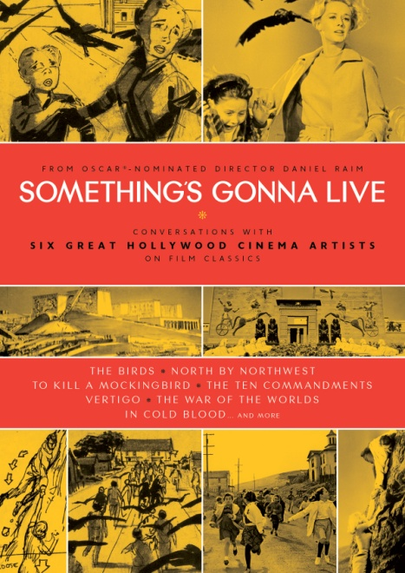

**“*SOMETHING’S GONNA LIVE*,” OSCAR®-NOMINATED DIRECTOR DANIEL RAIM’S CRITICALLY ACCLAIMED “Love Letter” to old Hollywood, RELEASES JUNE 12 ON DIGITAL & DVD**

***SOMETHING’S GONNA LIVE* honors six master artisans who worked with – and influenced – legendary filmmakers, including Alfred Hitchcock, Norman Jewison and Clint Eastwood.**

“Splendid…deeply moving.” *Los Angeles Times* Critics’ Pick

“An essential clear-eyed view of Hollywood – as a city, an industry, an idea.” – *IndieWire*

*April XX, 2012 – New York, New York* – Some of the best known works in American cinema –*North by Northwest*, *To Kill a Mockingbird* and *The Graduate* – are the legacy of the last great generation of production designers, cinematographers and storyboard illustrators whose techniques, wisdom and philosophies constitute a “master class” for today’s filmmakers.

From Academy Award®-nominated director **Daniel Raim** (*The Man on Lincoln’s Nose*), ***SOMETHING’S GONNA LIVE*** is an intimate portrait of life, death, friendship and the movies, as recalled by some of Hollywood’s greatest cinema artists: renowned art directors **Robert Boyle** (*North by Northwest, The Birds*), **Henry Bumstead** (*To Kill a Mockingbird, The Sting*) and **Albert Nozaki** (*The War of the Worlds, The Ten Commandments*), storyboard illustrator **Harold Michelson** (*The Graduate, Star Trek: The Motion Picture*), master cinematographers **Haskell Wexler** (*Who’s Afraid of Virginia Woolf?, Medium Cool*) and **Conrad Hall** (*In Cold Blood, Butch Cassidy and the Sundance Kid*).  These prolific artists have worked on a total of 400 films, garnering 25 Academy Award® nominations and 8 wins.

The film’s title is drawn from a remark made by Haskell Wexler regarding the passing on of knowledge to future generations of filmmakers and filmgoers. 10 years in the making, ***SOMETHING’S GONNA LIVE*** is a moving and thought-provoking celebration of craftsmanship and humanity; a film that addresses fundamental issues that artists face in today’s film industry.

“These men, most of them in their mid-80s and early 90s when I met them, inspired me,” said Raim. “Robert Boyle continued teaching at the American Film Institute until he passed away at the age of 100. My challenge was to recount their legacy while at the same time avoiding a purely nostalgic look at the ‘good old days.’”

From snapshots, sketches, and vintage footage interwoven with in-depth interviews and contemporary footage of these artists visiting former studios and locations, we get a behind-the-scenes look at movie making in the golden age of cinema. As iconic scenes of our collective imagination emerge from drawings, models, matte paintings, and sets, we hear tales of Mae West, “Hitch,” and DeMille, and experience their longing for the sense of community that made working on these films so great.

***SOMETHING’S GONNA LIVE***

Written and directed by Daniel Raim; Gerald Chamales, Jennifer Raim, Daniel Raim, producers; Jennifer Raim, Daniel Raim, editors; cinematography by Haskell Wexler, A.S.C, Guido Verweyen and Daniel Raim; Assaf Rinde, music; Tommy G. Warren, executive producer.

Pricing: $29.95 US/$34.95 CAN

Runtime: 78 mins. + extras

Rating: NA

Catalog #: NNVG270762

Language: English

Color: Color

Audio Format: Dolby Digital 2.0 Stereo

Genre: Documentary

DVD bonus features include: *The Man on Lincoln’s Nose*, Raim’s Oscar®-nominated short film; “Production Design Checklist and Working with Hitchcock,” an excerpt from Boyle’s AFI master class; “Life After Film School, ” a conversation between Boyle and Conrad Hall; Haskell Wexler discussing *Something's Gonna Live*on Los Angeles radio station KPFK; deleted scenes; original theatrical trailer; artists’ biographies; PDF of Boyle’s production design checklist.

**About Docurama Films**

In 1999, **NEW VIDEO** launched **Docurama Films**® with the first feature documentary ever available on DVD: D.A. Pennebaker’s *Bob Dylan: Dont Look Back.* Twelve years and 300 award-winning, highly-acclaimed titles later, Docurama continues to discover and release the greatest non-fiction films of our time while spreading the word about filmmakers who are taking the form to new heights.  Docurama’s catalog features the performing and visual arts, history, politics, the environment, ethnic and gender interests, and all-time favorites including *The Wild Parrots of Telegraph Hill*, *Andy Goldsworthy:* *Rivers and Tides* and *King Corn.* Recent titles include the Oscar®-nominated films *Gasland* and *Hell and Back Again*.

[www.docuramafilms.com](http://www.docuramafilms.com)

**About New Video**

New Video is a leading entertainment distributor and the largest aggregator of independent digital content worldwide. Headquartered in New York City, with an international presence in 45 territories, the company delivers feature films, TV programs and web originals via digital download, streaming, video-on-demand, Blu-ray, DVD, and theatrical release. In 2011, New Video bowed Oscar®-nominated *Hell and Back Again* and South American blockbuster *Elite Squad: The Enemy Within* in US theaters. Through a new partnership with digital exhibitor Cinedigm Entertainment Group, New Video is poised to bring more independent films to theaters nationwide. New Video streamlines distribution and marketing for filmmakers and partners, bringing a wide variety of fresh content to new audiences. The company’s library includes original TV series and movies from A+E® Home Entertainment, HISTORY™, and Lifetime®, unforgettable games and trophy sets from Major League Baseball®, storybook treasures from Scholastic®, award-winning documentaries from Docurama Films®, next-gen indies from Flatiron Film Company®, and acclaimed independent films and festival picks through partnerships with the Sundance Institute and Tribeca Film. New Video is proud to distribute many Oscar®-nominated documentaries including Gasland, Waste Land, Paradise Lost 3: Purgatory and *Hell and Back Again*.

[www.newvideo.com](http://www.newvideo.com).

**For more information, please contact:**

Luis Garza; 646-259-4144; lgarza@newvideo.com

For Box Art:

<http://www.newvideo.com/docurama/somethings-gonna-live/>