**FOR IMMEDIATE RELEASE**



presents

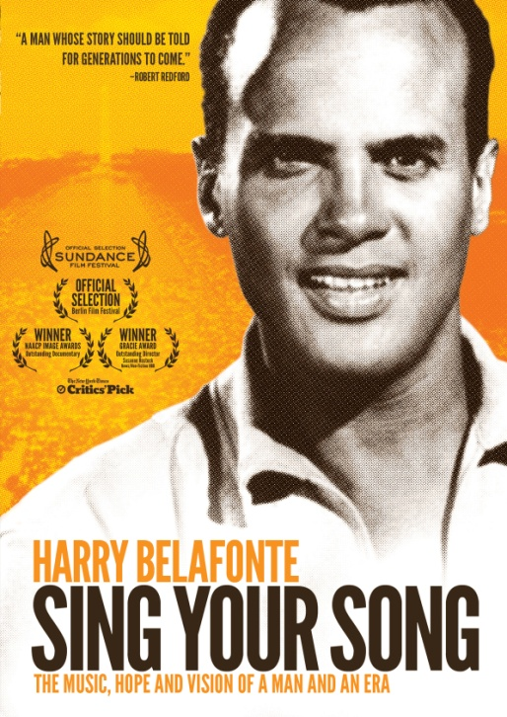

**“SING YOUR SONG,” A SURVEY OF THE LIFE AND TIMES OF HARRY BELAFONTE, RELEASES MAY 29 ON DVD**

*The New York Times* Critic’s Pick

“Moving and enlightening…It isn’t just the story of a man, but the story of a country and a century.” – *Variety*

“A motivational look at an important figure in history who inspired change.”

– *Los Angeles Times*

*April 12, 2012 – New York, New York –* Over the past half century, hardly a day has gone by when some clever stranger on the street has not called out, "Day-o!" upon recognizing Harry Belafonte, wherever he might be in the world. From his rise to fame as an international calypso star and his experiences touring a segregated country, and his provocative crossover into Hollywood, Belafonte’s groundbreaking career personifies the American civil rights movement and impacted many other social-justice movements.

***SING YOUR SONG***, a feature documentary about of the life and times of the beloved singer, actor and activist, releases May 29 on DVD, following a critically acclaimed theatrical run in more than 50 cities and an HBO premiere. InSusanne Rostock’s award-winning documentary, Belafonte is revealed as a tenacious hands-on activist who worked intimately with Dr. Martin Luther King Jr., mobilized celebrities for social justice, participated in the struggle against apartheid in South Africa, and took action to counter gang violence, imprisonment, and the incarceration of youth.

Because of his beliefs, Belafonte drew unwarranted invasions by the FBI into both his personal life and career, which led to years of struggle. But an indomitable sense of optimism motivates his path even today as he continues to ask, "What do we do now?"

Distilled from more than seventy hours of interviews, eyewitness accounts, movie clips, excerpts from FBI files, news, and archival film footage and stills, ***SING YOUR SONG*** features a “who’s who” of personalities associated with Belafonte over the years, including Eleanor Roosevelt, Nelson Mandela, John F. and Robert F. Kennedy, J. Edgar Hoover, Marlon Brando, Nina Simone, Ed Sullivan, Bishop Desmond Tutu, The Muppets, and many, many more. Also featured is a collection of Belafonte's home movies with footage of his early family life and his children Adrienne, Shari, David and Gina.

In addition to opening the U.S. Documentary Competition of the 2011 Sundance Film Festival, ***SING YOUR SONG*** was an official selection at the Berlin Film Festival, Tribeca Film Festival, SXSW, among many other festivals, and won the 2012 NAACP Image Award for Outstanding Documentary. The film premiered theatrically in January 2012. Belafonte’s memoir, *My Song*, released from Random House, Inc. in October 2011, alongside a companion album, ***Sing Your Song: The Music*, from Sony Masterworks.**

***SING YOUR SONG*** is directed by Susanne Rostock (2012 Gracie Award); Michael Cohl, Gina Belafonte, Jim Brown, William Eigen and Julius R. Nasso, producers. Sage Scully, co-producer; Susanne Rostock and Jason L. Pollard, editors; Hahn Rowe, composer; Karol Martesko-Fenster, consultant.

***SING YOUR SONG: HARRY BELAFONTE***

Pricing: $29.95 US/$34.95 CAN

Runtime: 104 mins. + extras

Rating: NA

Catalog #: NNVG269071

Language: English

Color: Color

Audio Format: Dolby Digital 5.1, Stereo

Genre: Documentary

DVD bonus features include: Interview with Harry Belafonte; full-length musical performances; theatrical trailer.

**About Docurama Films**

In 1999, **NEW VIDEO** launched **Docurama Films**® with the first feature documentary ever available on DVD: D.A. Pennebaker’s *Bob Dylan: Dont Look Back.* Twelve years and 300 award-winning, highly-acclaimed titles later, Docurama continues to discover and release the greatest non-fiction films of our time while spreading the word about filmmakers who are taking the form to new heights.  Docurama’s catalog features the performing and visual arts, history, politics, the environment, ethnic and gender interests, and all-time favorites including *The Wild Parrots of Telegraph Hill*, *Andy Goldsworthy:* *Rivers and Tides* and *King Corn.* Recent titles include the Oscar®-nominated films *Gasland* and *Hell and Back Again*.

[www.docuramafilms.com](http://www.docuramafilms.com)

**About New Video**

New Video is a leading entertainment distributor and the largest aggregator of independent digital content worldwide. Headquartered in New York City, with an international presence in 45 territories, the company delivers feature films, TV programs and web originals via digital download, streaming, video-on-demand, Blu-ray, DVD, and theatrical release. In 2011, New Video bowed Oscar®-nominated *Hell and Back Again* and South American blockbuster *Elite Squad: The Enemy Within* in US theaters. Through a new partnership with digital exhibitor Cinedigm Entertainment Group, New Video is poised to bring more independent films to theaters nationwide. New Video streamlines distribution and marketing for filmmakers and partners, bringing a wide variety of fresh content to new audiences. The company’s library includes original TV series and movies from A+E® Home Entertainment, HISTORY™, and Lifetime®, unforgettable games and trophy sets from Major League Baseball®, storybook treasures from Scholastic®, award-winning documentaries from Docurama Films®, next-gen indies from Flatiron Film Company®, and acclaimed independent films and festival picks through partnerships with the Sundance Institute and Tribeca Film. New Video is proud to distribute many Oscar®-nominated documentaries including Gasland, Waste Land, Paradise Lost 3: Purgatory and *Hell and Back Again*.

[www.newvideo.com](http://www.newvideo.com).

**About S2BN Entertainment / S2BN Films**

S2BN is a diversified international family show and event entertainment company specializing in the acquisition, development and production of high caliber touring exhibitions, unique live music tours, arena events, theatrical performances, feature films and multimedia product offerings. The core team at S2BN has been together for over three decades working in live entertainment and have created some of the most endearing and best loved spectacles ranging from the Rolling Stones, Barbra Streisand, U2, to Walking With Dinosaurs, Spider-Man, Yo Gabba Gabba and many others.  The company and/or its principals have developed a wide range of live attractions and award winning theatre, opera, television programs, and feature films, Recent projects include Emmy Award winning *LENNONNYC* and *Pete Seeger: Power of Song,* and the critically acclaimed feature documentaries, *Phil Ochs: There But For Fortune*, *Sing Your Song* and *Big Easy Express*.

www.s2bnent.com

**For more information, please contact:**

Luis Garza; 646-259-4144; lgarza@newvideo.com

For Box Art:

http://www.newvideo.com/docurama/sing-your-song-harry-belafonte/