**FOR IMMEDIATE RELEASE**

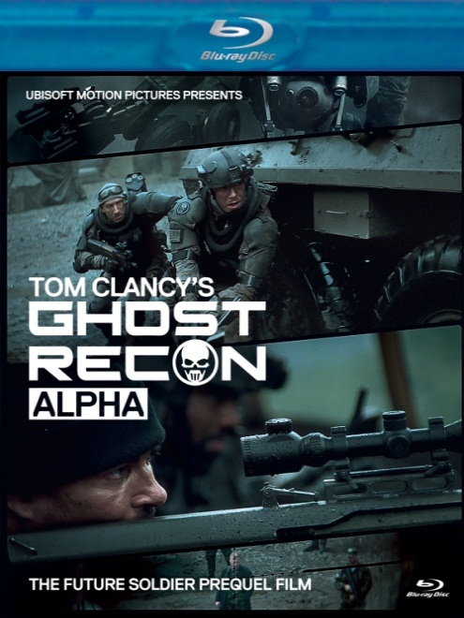

**FLATIRON FILM COMPANY RELEASES UBISOFT MOTION PICTURES’**

**“TOM CLANCY’S GHOST RECON ALPHA**®**” DAY-AND-DATE WITH THE VIDEO GAME**

**“TOM CLANCY’S GHOST RECON FUTURE SOLDIER”**

**Live-Action/CGI Prequel Film Produced by Little Minx, a Ridley Scott & Associates company, Releases in the U.S. and Canada on May 22 for the First Time on Blu-ray (HD) and DVD**

**“**A sharp-looking little action film…gorgeously shot.” *Kotaku*

**May 3, 2012 – New York** – After a decade-long manhunt, U.S. Intelligence has received new intel on Chevchenko, a mastermind of the world’s most heinous war crimes. Linked to Russian ultranationalists, Chevchenko is about to deliver a dirty bomb large enough to contaminate Moscow for centuries. Enter the Ghosts, the U.S. Army’s most elite Future Soldiers. These precision-trained and lethal human weapons are armed with the most devastating high-tech combat systems, and they are tasked with taking out Chevchenko and stopping this international catastrophe before it erupts.

On May 22, New Video’s Flatiron Film Company will release Ubisoft Motion Pictures’ ***TOM CLANCY’S GHOST RECON ALPHA****®* on DVD and DVD/Blu-ray combo day-and-date with the release of Ubisoft’s highly-anticipated*Tom Clancy’s Ghost Recon Future Soldier* video game for Xbox 360® video game and entertainment system from Microsoft and the Sony PlayStation®3 computer entertainment system.

***TOM CLANCY’S GHOST RECON ALPHA\**** boasts a line-up of top Hollywood talent. The film was directed by Academy Award winners Hervé de Crécy and François Alaux, who won an Oscar in 2010 for *Logorama*, and produced by Rhea Scott for Little Minx. Tim Sexton, 2010 Academy Award nominee for *Children of Men*, and Gregory Pruss, longtime writing collaborator with David Fincher, wrote the gripping script. The film was shot by *District 9* cinematographer Trent Opaloch; edited by Pietro Scalia, two-time Academy Award winner for *Black Hawk Down* and *JFK*; with sound effects and sound effects editing by Per Hallberg, two-time Academy Award winner for *The Bourne Ultimatum* and *Braveheart* as well as Michael Mann’s *Heat*; production design by Jan Roelfs (*Gattaca*, *Alexander*); and costume design by Sammy Sheldon (*V for Vendetta, Kick-Ass, X-Men: First Class, Black Hawk Down*). Military Weapons Specialist Harry Humphries, consultant on such notable action films such as *Transformers, Thor, Iron Man* and *Armageddon*, ensured that the futuristic weaponry in the film was entirely realistic.

***TOM CLANCY’S GHOST RECON ALPHA\**** is the 25-minute prequel film to the video game *Tom Clancy’s Ghost Recon Future Soldier* andfollows the Ghosts as they are dropped deep behind enemy lines in order to eliminate one of the world’s most sought-after war criminals. DVD/BD bonus features include the producers’ 2010 Comic-Con teaser and a “Making Of” featurette.

Ubisoft’s Tom Clancy’s Ghost Recon brand launched in 2001 and the franchise has sold more than 18 million video game units worldwide. This is Flatiron Film Company’s second Ubisoft release, following *ASSASSIN’S CREED: LINEAGE* (November 2011).

**DVD/Blu-Ray**

Pricing: $14.95 US/$16.95 CAN

Runtime: 50 mins., inc. extras

Rating: NR

Catalog #: NNVG262360

Language: English

Color: Color

Audio Format: Dolby Digital 2.0 Stereo

Genre: Action

**DVD Single**

Pricing: $7.95 US/$9.95 CAN

Runtime: 50 mins., inc. extras

Rating: NR

Catalog #: NNVG262370

Language: English

Color: Color

Audio Format: Dolby Digital 2.0 Stereo

Genre: Action

**About New Video:**

New Video is a leading entertainment distributor and the largest aggregator of independent digital content worldwide. Headquartered in New York City, with an international presence in 45 territories, the company delivers feature films, TV programs and web originals via digital download, streaming, video-on-demand, Blu-ray, DVD, and theatrical release. In 2011, New Video bowed Oscar®-nominated *Hell and Back Again* and South American blockbuster *Elite Squad: The Enemy Within* in US theaters. Through a new partnership with digital exhibitor Cinedigm Entertainment Group, New Video is poised to bring more independent films to theaters nationwide. New Video streamlines distribution and marketing for filmmakers and partners, bringing a wide variety of fresh content to new audiences. The company’s library includes original TV series and movies from A+E® Home Entertainment, HISTORY™, and Lifetime®, unforgettable games and trophy sets from Major League Baseball®, storybook treasures from Scholastic®, award-winning documentaries from Docurama Films®, next-gen indies from Flatiron Film Company®, and acclaimed independent films and festival picks through partnerships with the Sundance Institute and Tribeca Film. New Video is proud to distribute many Oscar®-nominated documentaries including *GasLand, Waste Land*, *Paradise Lost 3: Purgatory* and *Hell and Back Again*.

**For more information, please contact:**

Luis Garza; 646-259-4144; lgarza@newvideo.com

For box art, please visit:

<http://www.newvideo.com/flatiron-film-company/tom-clancys-ghost-recon-alpha/>

*© 2012 Ubisoft Entertainment. All Rights Reserved. Tom Clancy's, Ghost Recon, the Soldier Icon, Ubisoft and the Ubisoft logo are trademarks of Ubisoft Entertainment in the US and/or other countries.*